**A comparative study of influence of developmental and non-developmental factors on the spread of coronavirus disease.**

**Hakyong Kim1*, Catherine Apio2*, Yeonghyeon Ko3,4*, Taewan Goo2, Gyujin Heo2, Kyulhee Han2, Taehyun Kim3, Hyewon Chung5, Doeun Lee2, Jisun Lim6, Taesung Park3†**

1Department of Industrial Engineering, Seoul National University, Seoul 08826, Republic of Korea

2Interdisciplinary Program in Bioinformatics, Seoul National University, Seoul 08826, Republic of Korea

3Department of Statistics, Seoul National University, Seoul 08826, Republic of Korea

4Department of Archeology and Art History, Seoul National University, Seoul 08826, Republic of Korea

5Department of Chemistry, Seoul National University, Seoul 08826, Republic of Korea

6The Research Institute of Basic Sciences, Seoul 08826, Republic of Korea; jslim1@snu.ac.kr (J.L.)

*Both authors contributed equally to this work as co-first authors.

†Corresponding author, Tel: 82-2-880-8924, Fax: 82-2-883-6144, E-mail: taesungp@stats.snu.ac.kr

**ABSTRACT**

The outbreak of the novel COVID-19 declared a global pandemic by WHO, is most serious public health threat seen in respiratory virus since the 1918 H1N1 influenza pandemic. Person-to-person contact is the main route of transmission. Here, we employed segmented growth-curve models (Logistic and Gompertz) to model the transmission of COVID-19 of 134 countries from January 1, 2020 to August 31, 2020. Linear regression was employed to investigate the relationship of selected national indicator variables related to maximum predicted cumulative confirmed cases, $α$ and the rate of transmission of COVID -19, $γ$ estimated from the growth curve models. Our objective is determining whether the spread of COVID-19 is significantly influenced by life expectancy, aging index, population, median age, etc. We used a 5% significance level. Maximum predicted cumulative confirmed cases is significantly influenced by population while rate of transmission of COVID-19 by aging index, cardiovascular death rate, extreme poverty, median age, percentage of population aged 65, 70 and older and so forth. Our results provide evidence of the influence of age, health, travel, economy and environmental factors in the spread of COVID-19. We hope with consideration of a country’s resources and population dynamics; our results will help in making informed decisions that make the most impact against similar infectious diseases.

**INTRODUCTION**

The novel corona virus disease 2019 (COVID-19), a highly transferable viral disease is a respiratory illness caused by novel severe acute respiratory syndrome coronavirus 2 (SARS-CoV-2) which has person-to-person contact as the main route of transmission causes flu like symptoms and in severe cases death (1,2). The spread of COVID-19 became a global threat and the World Health Organization declared it a global pandemic on March 11, 2020 (3). The public health threat it represents is the most severe seen in respiratory viruses since the 1918 H1N1 influenza pandemic (4) with a total of 98, 904, 224 confirmed cases and 2, 119, 935 deaths worldwide, as of January 23, 2021 (5).

Many factors can influence the epidemiological characteristics and contribute to the increased mortality rates of COVID 19. Therefore, understanding the potential affecting factors involved in COVID-19 transmission will be of great significance in containing the spread of the epidemic and was the focus of many studies (6). There are several theories suggesting the impact of environmental factors like, temperature and humidity along with international travel and lack of proper social consciousness for isolation as causes of the global spread of COVID 19 (1). A few investigations have also considered social aspects potentially associated with the spread of COVID-19, such as population density, metropolitan population, intra-provincial traffic, and national lockdown, indicating that the social distancing measures have been successful in reducing new cases (7-10).

Furthermore, several studies have investigated the impact of weather on the COVID-19 transmission, with special attention to temperature and humidity, indicating that temperature is inversely related to COVID-19 incidence (11). Moreover, each 1 °C increase in temperature has been associated with decreases in daily new cases at different extents. Significant studies on the impacts of climatic predictors on COVID-19 transmission were also conducted in China, the United States, and Europe (12-13).

A look at history tells that pandemics and epidemics have consistently and significantly affected human history, and governments have continually tried to find ways of slowing down the spread of these diseases like quarantines employed during the Ebola outbreak (14-15). The objective of this study is to assess environmental, social, economic, health, population, age factors, etc., in influencing the spread of SARS-CoV-2 virus around the globe.

Here, we applied segmented growth-curve models (Logistic and Gompertz Models) to the cumulative confirmed cases of 134 countries. As the spread of COVID-19 prolongs, several countries experience more than one wave (a wave implies a rising number of sick individuals, a defined peak, and then a decline) of the pandemic so that the cumulative confirmed cases cannot be analyzed by conventional growth model since they cannot adopt the sigmoid curve. So, the study period of each country was divided into several segments using the segmentation algorithm (see Materials and Methods) which systematically partitions COVID-19 cumulative confirmed cases for each country into several segments of times series cases corresponding to a wave which can then be modeled by the growth curve models in to a sigmoid curve (Fig. 1).

The segmented growth curve models summarizes the spread of COVID-19 into sets of three parameters $α$, $β$ and $γ$, where $α$ is the maximum number of predicted cumulative confirmed cases, $β$ is the time when we start to see a rise in the number of confirmed cases and $γ$ is the rate of spread of COVID-19. Linear regression model was then employed to investigate the relationship between selected national indicator variables like life expectancy, average annual temperature, aging index, human development index, percentage of malnourished people in the population, extreme poverty, etc., (Table 1) and the spread of COVID-19 using the above parameters estimated from the segmented growth curve models. Significant relationship provides evidence that these variables may influence the spread of the novel SARS-COV-2 virus across the globe.

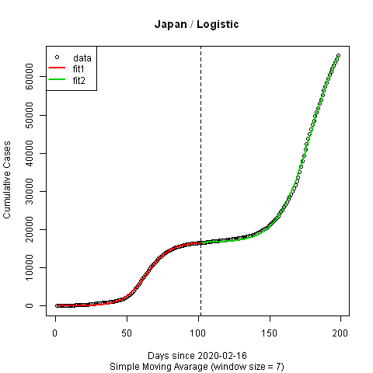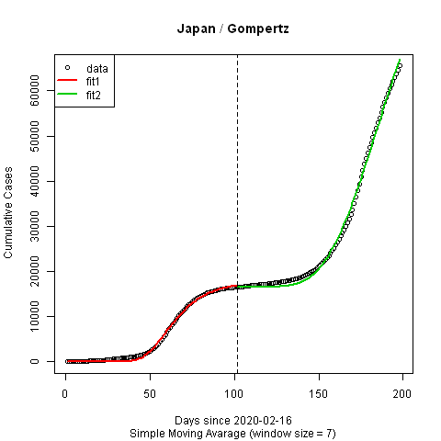

**Fig. 1.** **Cumulative confirmed cases divided into two segments (red and green) using the Segmentation Algorithm.** Japan is the typical country with two waves. Using segmented growth curve models, Japan’s cumulative confirmed cases were fitted with low MSSE which implies high accuracy. Estimated parameters of segmented logistic model were $(α_{1}, β_{1}, γ_{1}, α_{2}, β_{2}, γ_{2}$) = (16549.7588, 7.8244, 0.1231, 58877.8030, 6.7353, 0.0859 respectively) and estimated parameters of segmented logistic model were $(α_{1}, β_{1}, γ_{1}, α_{2}, β_{2}, γ_{2}$) = (17531.5024, 89.4251, 0.0760, 98622.3568, 15.6933, 0.0325 respectively).

**RESULTS**

**Growth curve models shows the rate of transmission of COVID-19 varies across countries**

In this study, we adapted and applied segmented growth curve models (Logistic and Gompertz models) for modeling COVID-19 transmission among countries around the globe using the cumulative confirmed cases of the 134 countries (see Materials and Methods).Here, the trends of parameters estimated from the segment Logistic and Gompertz models among the countries are discussed (Table S1 and Table S2).

Summary statistics from segmented Logistic model and Gompertz model for the countries show USA, India, Brazil and Philippines having the highest values of predicted maximum cumulative confirmed cases ($α$) for the Gompertz (Fig. 2d) and Logistic model (Fig. 2b) while Malawi, Democratic Republic of Congo and Djibouti have the highest rate of transmission $(γ$) of SARS-COV-2 virus as of August 31, 2020 in the two segments (Fig. 2c and 2d). We observe that countries with high value of maximum predicted cumulative confirmed cases have the smallest rate of transmission and vice versa, across the two models and segments (see Fig. S7 of log10 $α Vs γ)$. The correlation studies to determine the similarity between the parameters across the two models (Fig. S3- S6) confirms that the parameters have similar interpretation across models and segments but a strong negative correlation (-0.5 and -0.55 for Logistic, -0.66 and 0.7 for Gompertz) between $α$ and $γ$ parameters (Fig. S5 and Fig. S6) was observed. This may explain the relationship observed between maximum predicted cumulative confirmed cases and the rate of spread of COVID-19.

Among the parameters estimated from growth curve models, time when we start to see a rise in the number of confirmed cases ($β$) shows little to no correlation with (-0.089 for Logistic and 0.15 for Gompertz) between the two segments of the model and with other parameters (e.g. -0.069 and 0.19 for Logistic, 0.077 and 0.10 for Gompertz) but a strong positive correlation between the models (0.88 and 0.95). Though its interpretation is the same between the models, it produces inconsistent results between the two segments and in the linear regression analysis, making it very difficult to assign logical interpretation to its results. Therefore, its results and any analysis concerning it was not the focus in our study, so its results are relegated to the Supplementary Materials for those interested.

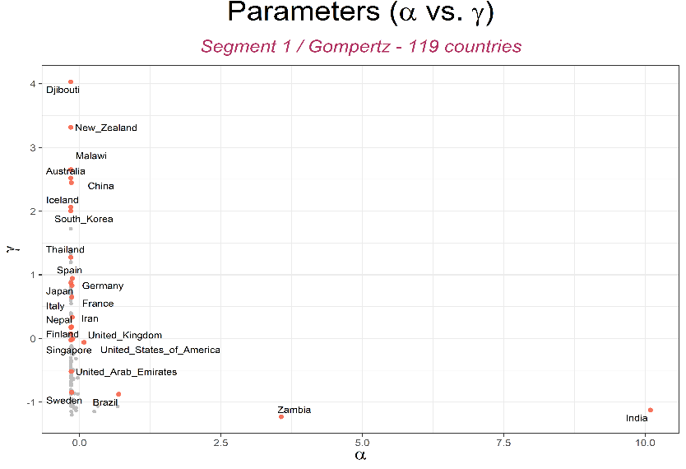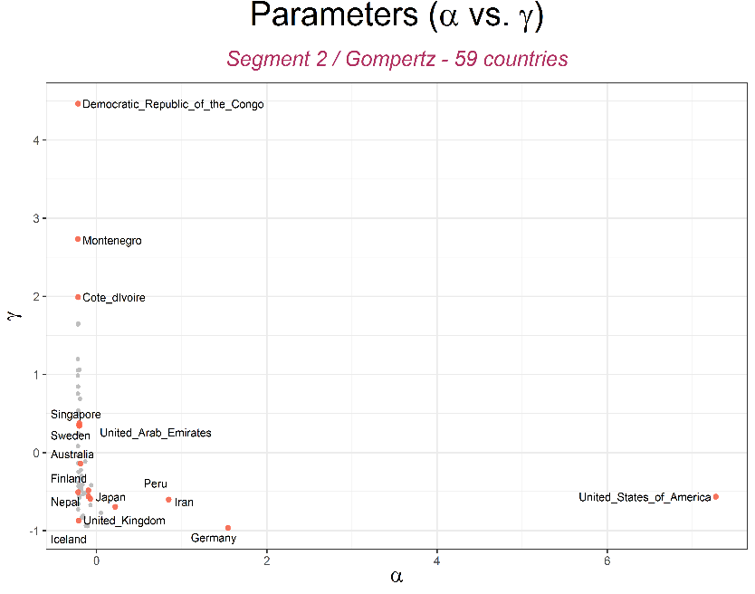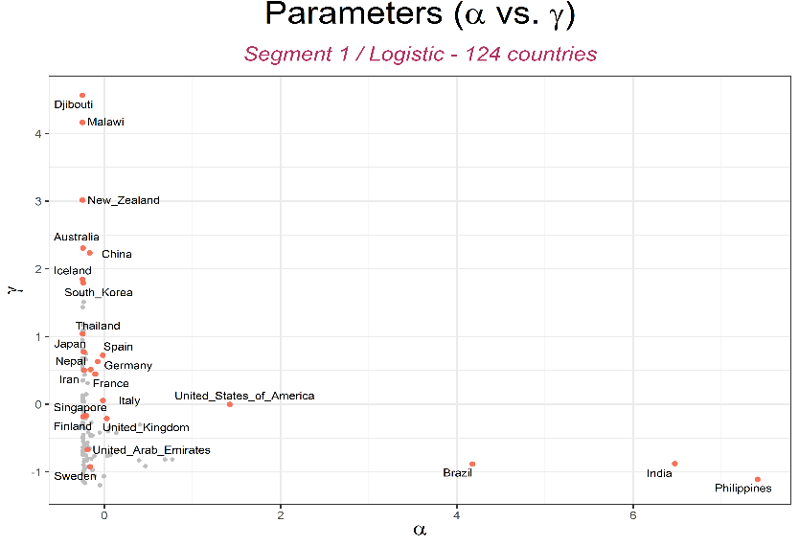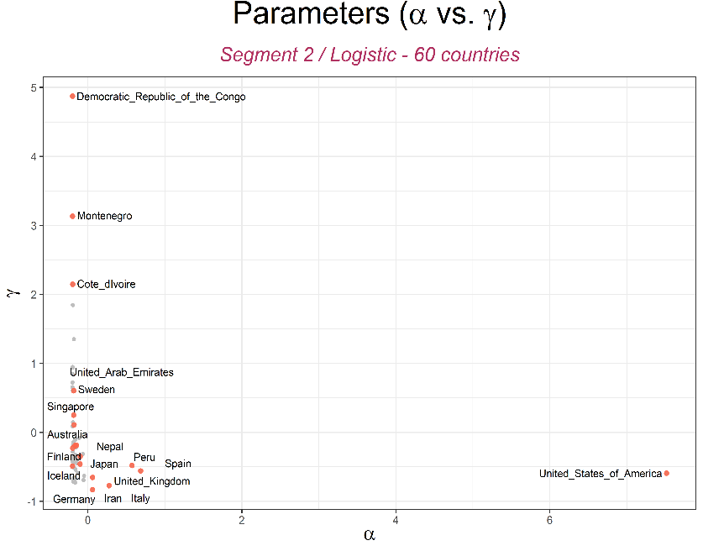

**a**

**c**

**b**

**d**

**Fig. 2. Variation of maximum predicted cumulative cases ($α$) and rate of spread of COVID-19 among countries.**

**The relationship between national indicator variables and the transmission of COVID-19**

Linear regression model was employed to investigate the relationship between selected national indicator variables (Table 1) believed to be related to COVID-19 and the transmission of COVID-19 using the maximum predicted confirmed cases, $α$ and the rate of spread of the pandemic, $γ$ estimated from the segmented growth curve models. The national indicator variables include developmental (called World Development Indicators by World Bank (16)) and non-developmental variables related to population, age, health, economy, environment, etc.

The objective of our analysis was to determine whether these variables have significant relationships with the transmission of COVID-19. From the 1st segment to the 2nd segment in each growth curve model, for each national indicator variable and parameter, our focus was on whether 1) the size of the estimated coefficients are maintained, and 2) the estimated coefficients are statistically significant between segments. We used a 5% significance level. Statistically significant results provide evidence for the possibility of these factors having influence on the transmission of COVID-19.

Population. annual precipitation, pharmaceutical sales and imports to GDP ratio are the only variables statistically significantly related to maximum predicted cumulative confirmed cases with population being significant in both models and segments (Fig. 3a and 3c). While, the rate of transmission of COVID-19 is significantly related with age-related variables like aging index, share of population aged 65 and older, share of population aged 70 and older, median age and life expectancy, health, welfare and society related variables like life cardiovascular death rate, share of female smokers and male smokers in the population and percentage of malnourished people in the population, hospital beds per thousand, extreme poverty and human development index, cultural variables like of international travelers from a country and number of foreign visitors to a country and environmental factors like average annual temperature (Fig. 3b and 3d). (see Fig. S8 for the relationship of national indicator variables with $β$)

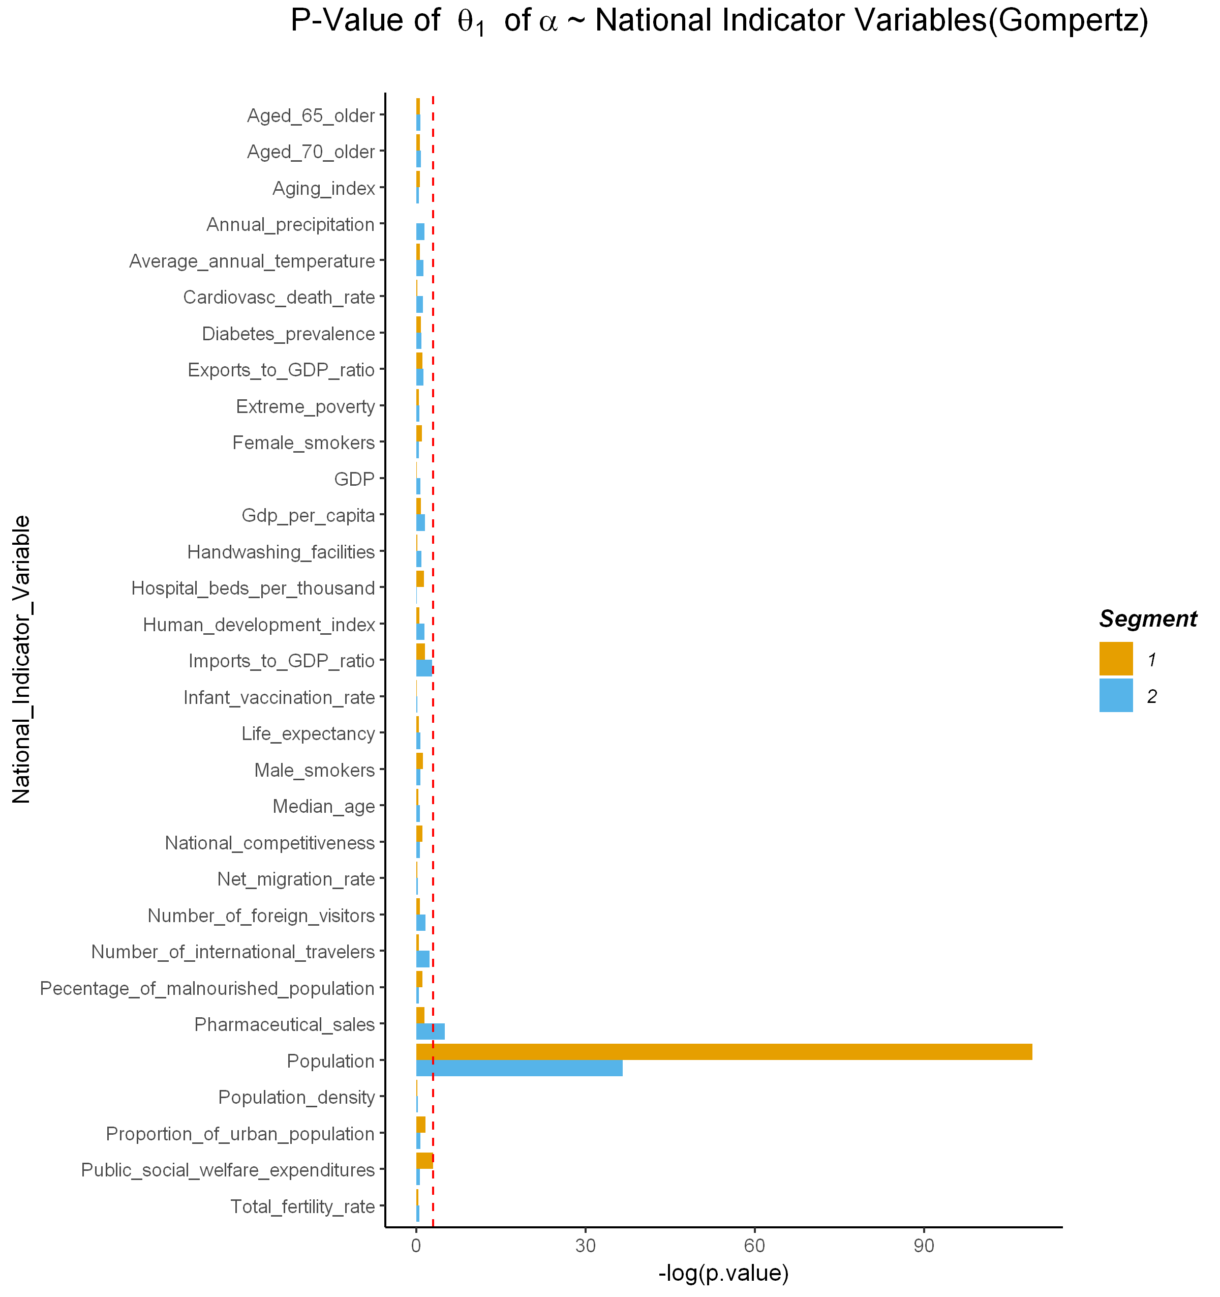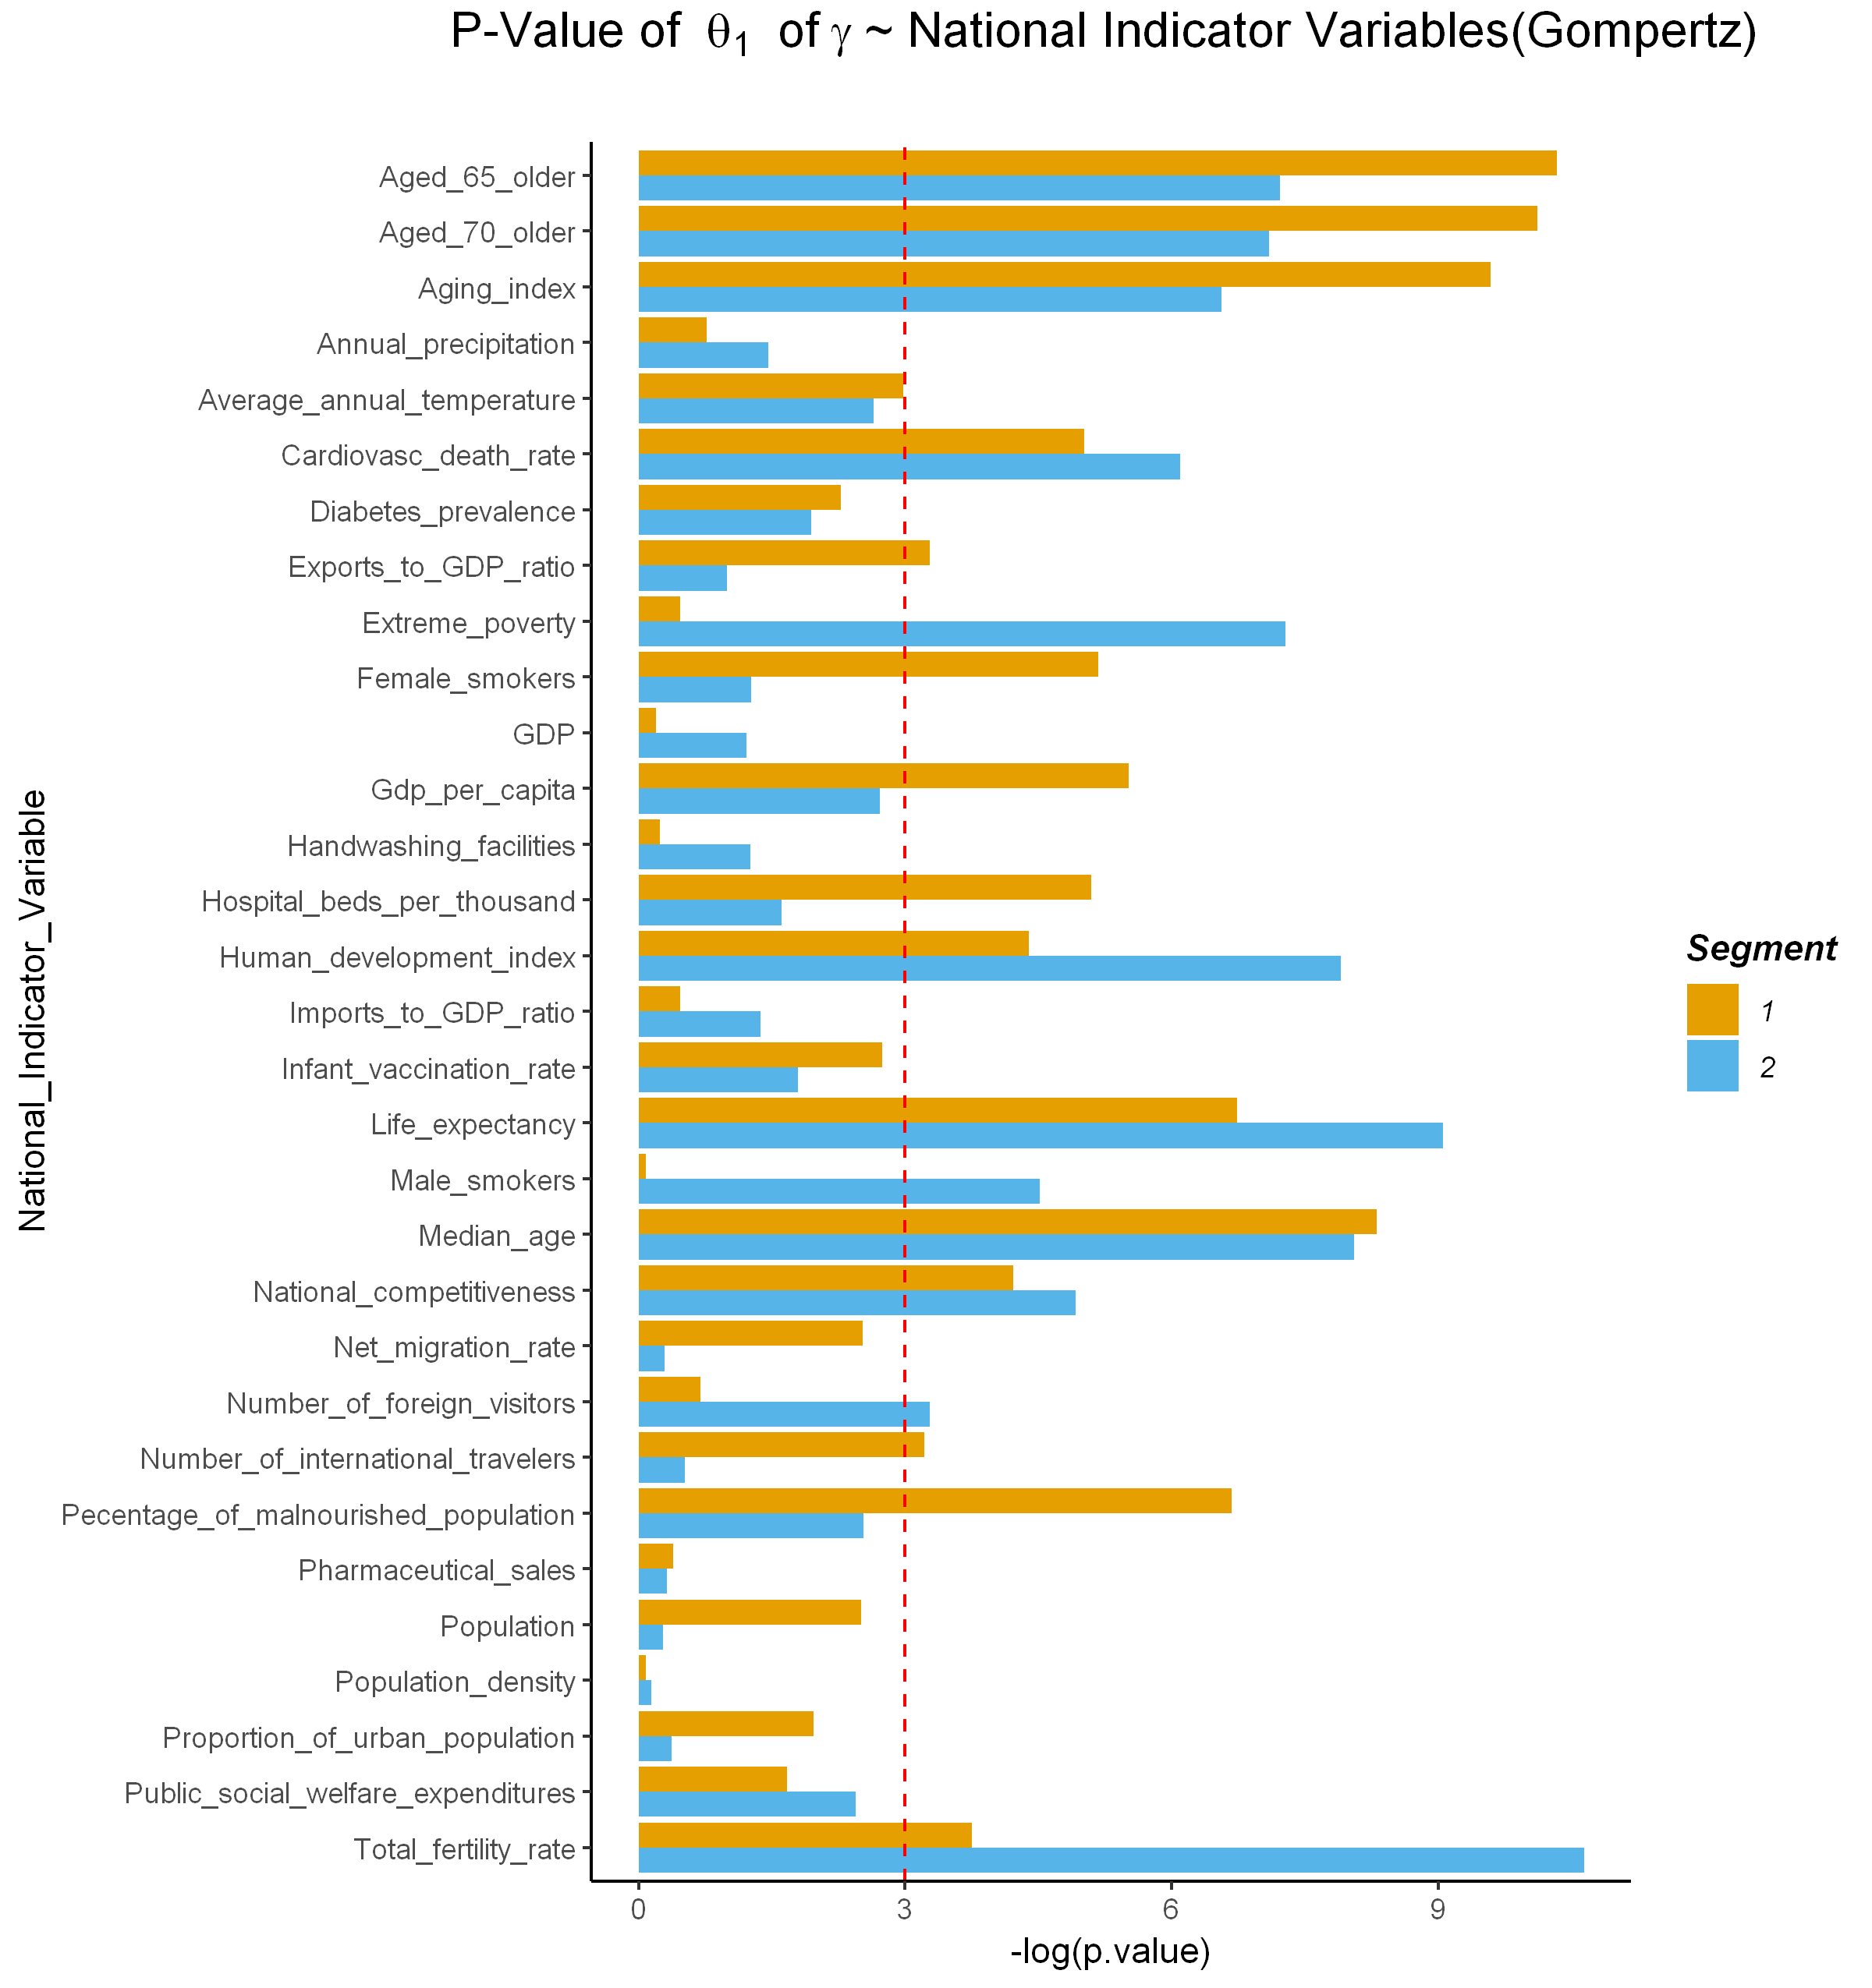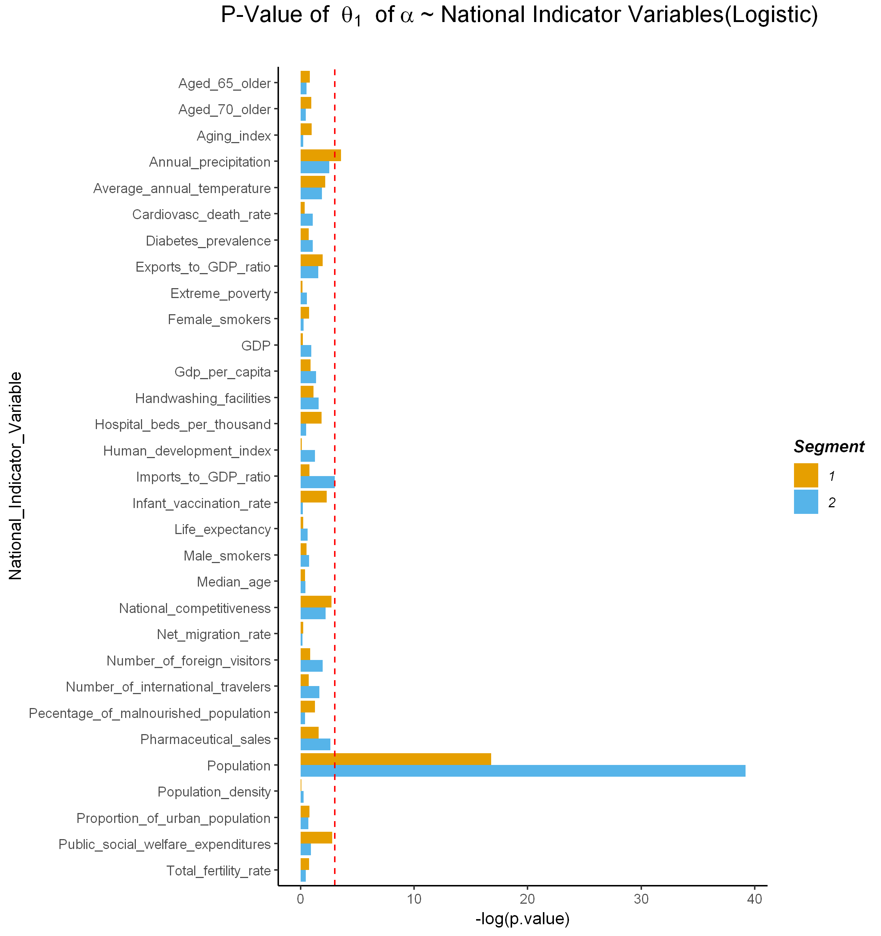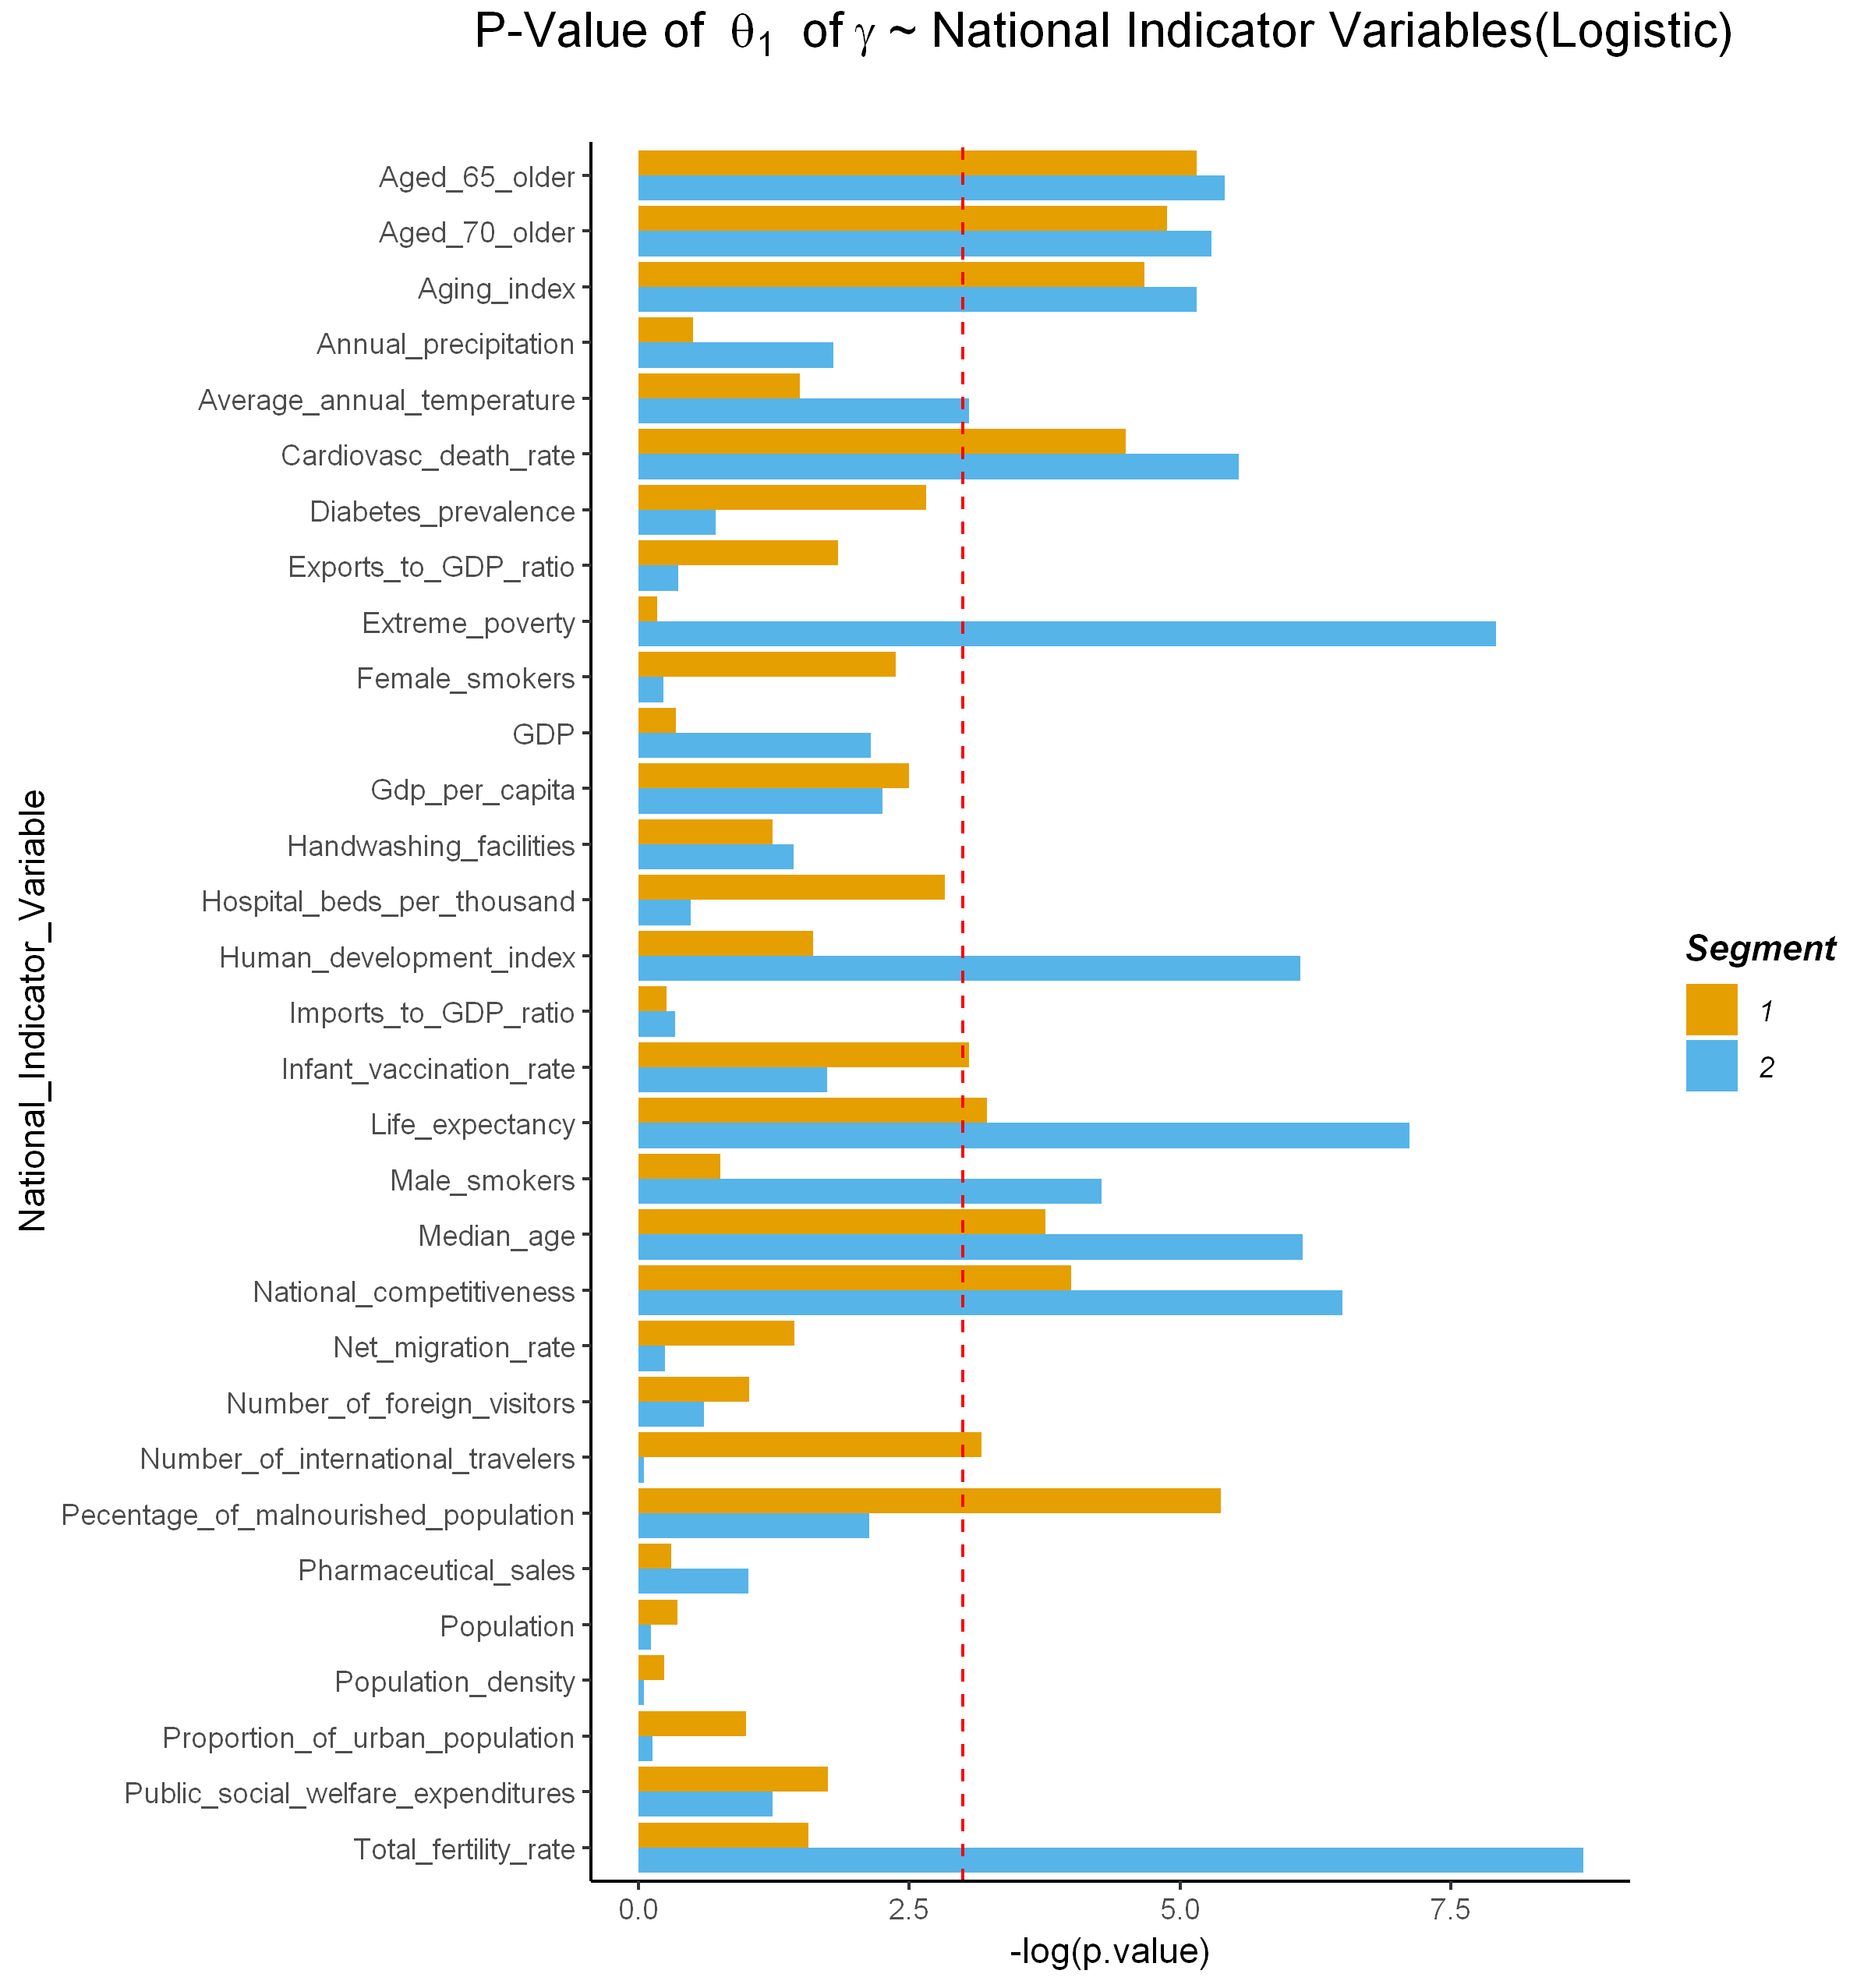

**a**

**c**

**b**

**d**

**Fig. 3. *P*-values of the relationship of national indicator variables with $α$ and $γ$.** Population, annual precipitation, pharmaceutical sales and imports to GDP ratio are statistically significant with maximum predicted confirmed cases (Fig. 3a and 3c). Age related variables, population, percentage of malnourished population, life expectancy, temperature, etc. are significantly related with rate of spread of COVID-19 (Fig. 3b and 3d).

In addition, the relationship between the size of coefficients ( $θ_{1})$ and significance of a national indicator variables is observed whereby significant variables generally had larger coefficient values than non-significant variables (Fig. 4, Fig. S9 and Fig. S10). Our results provide evidence that the significant variables influence the transmission of COVID-19 among the population of the investigated countries.

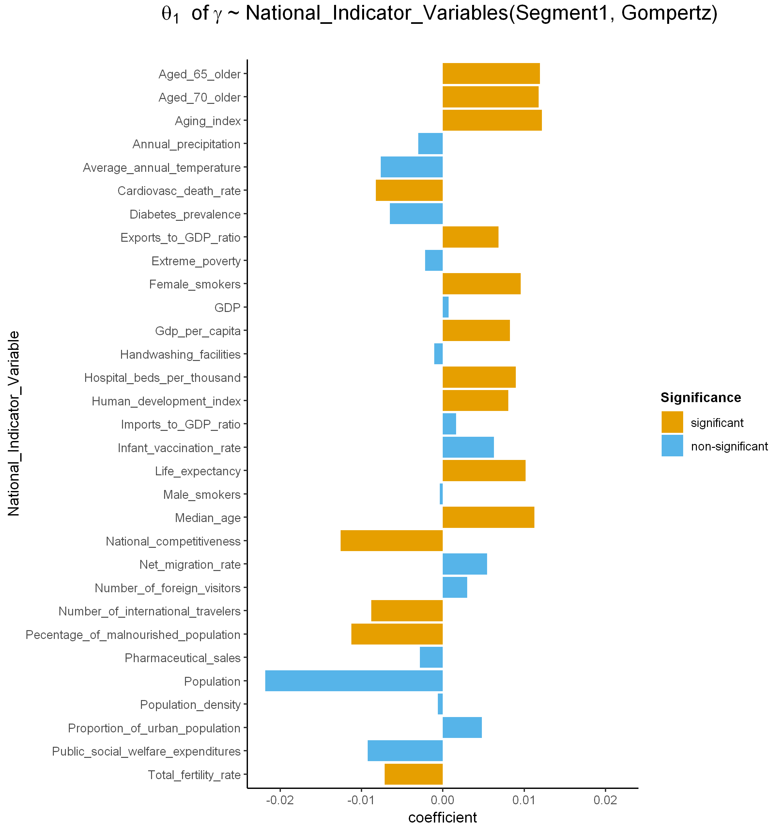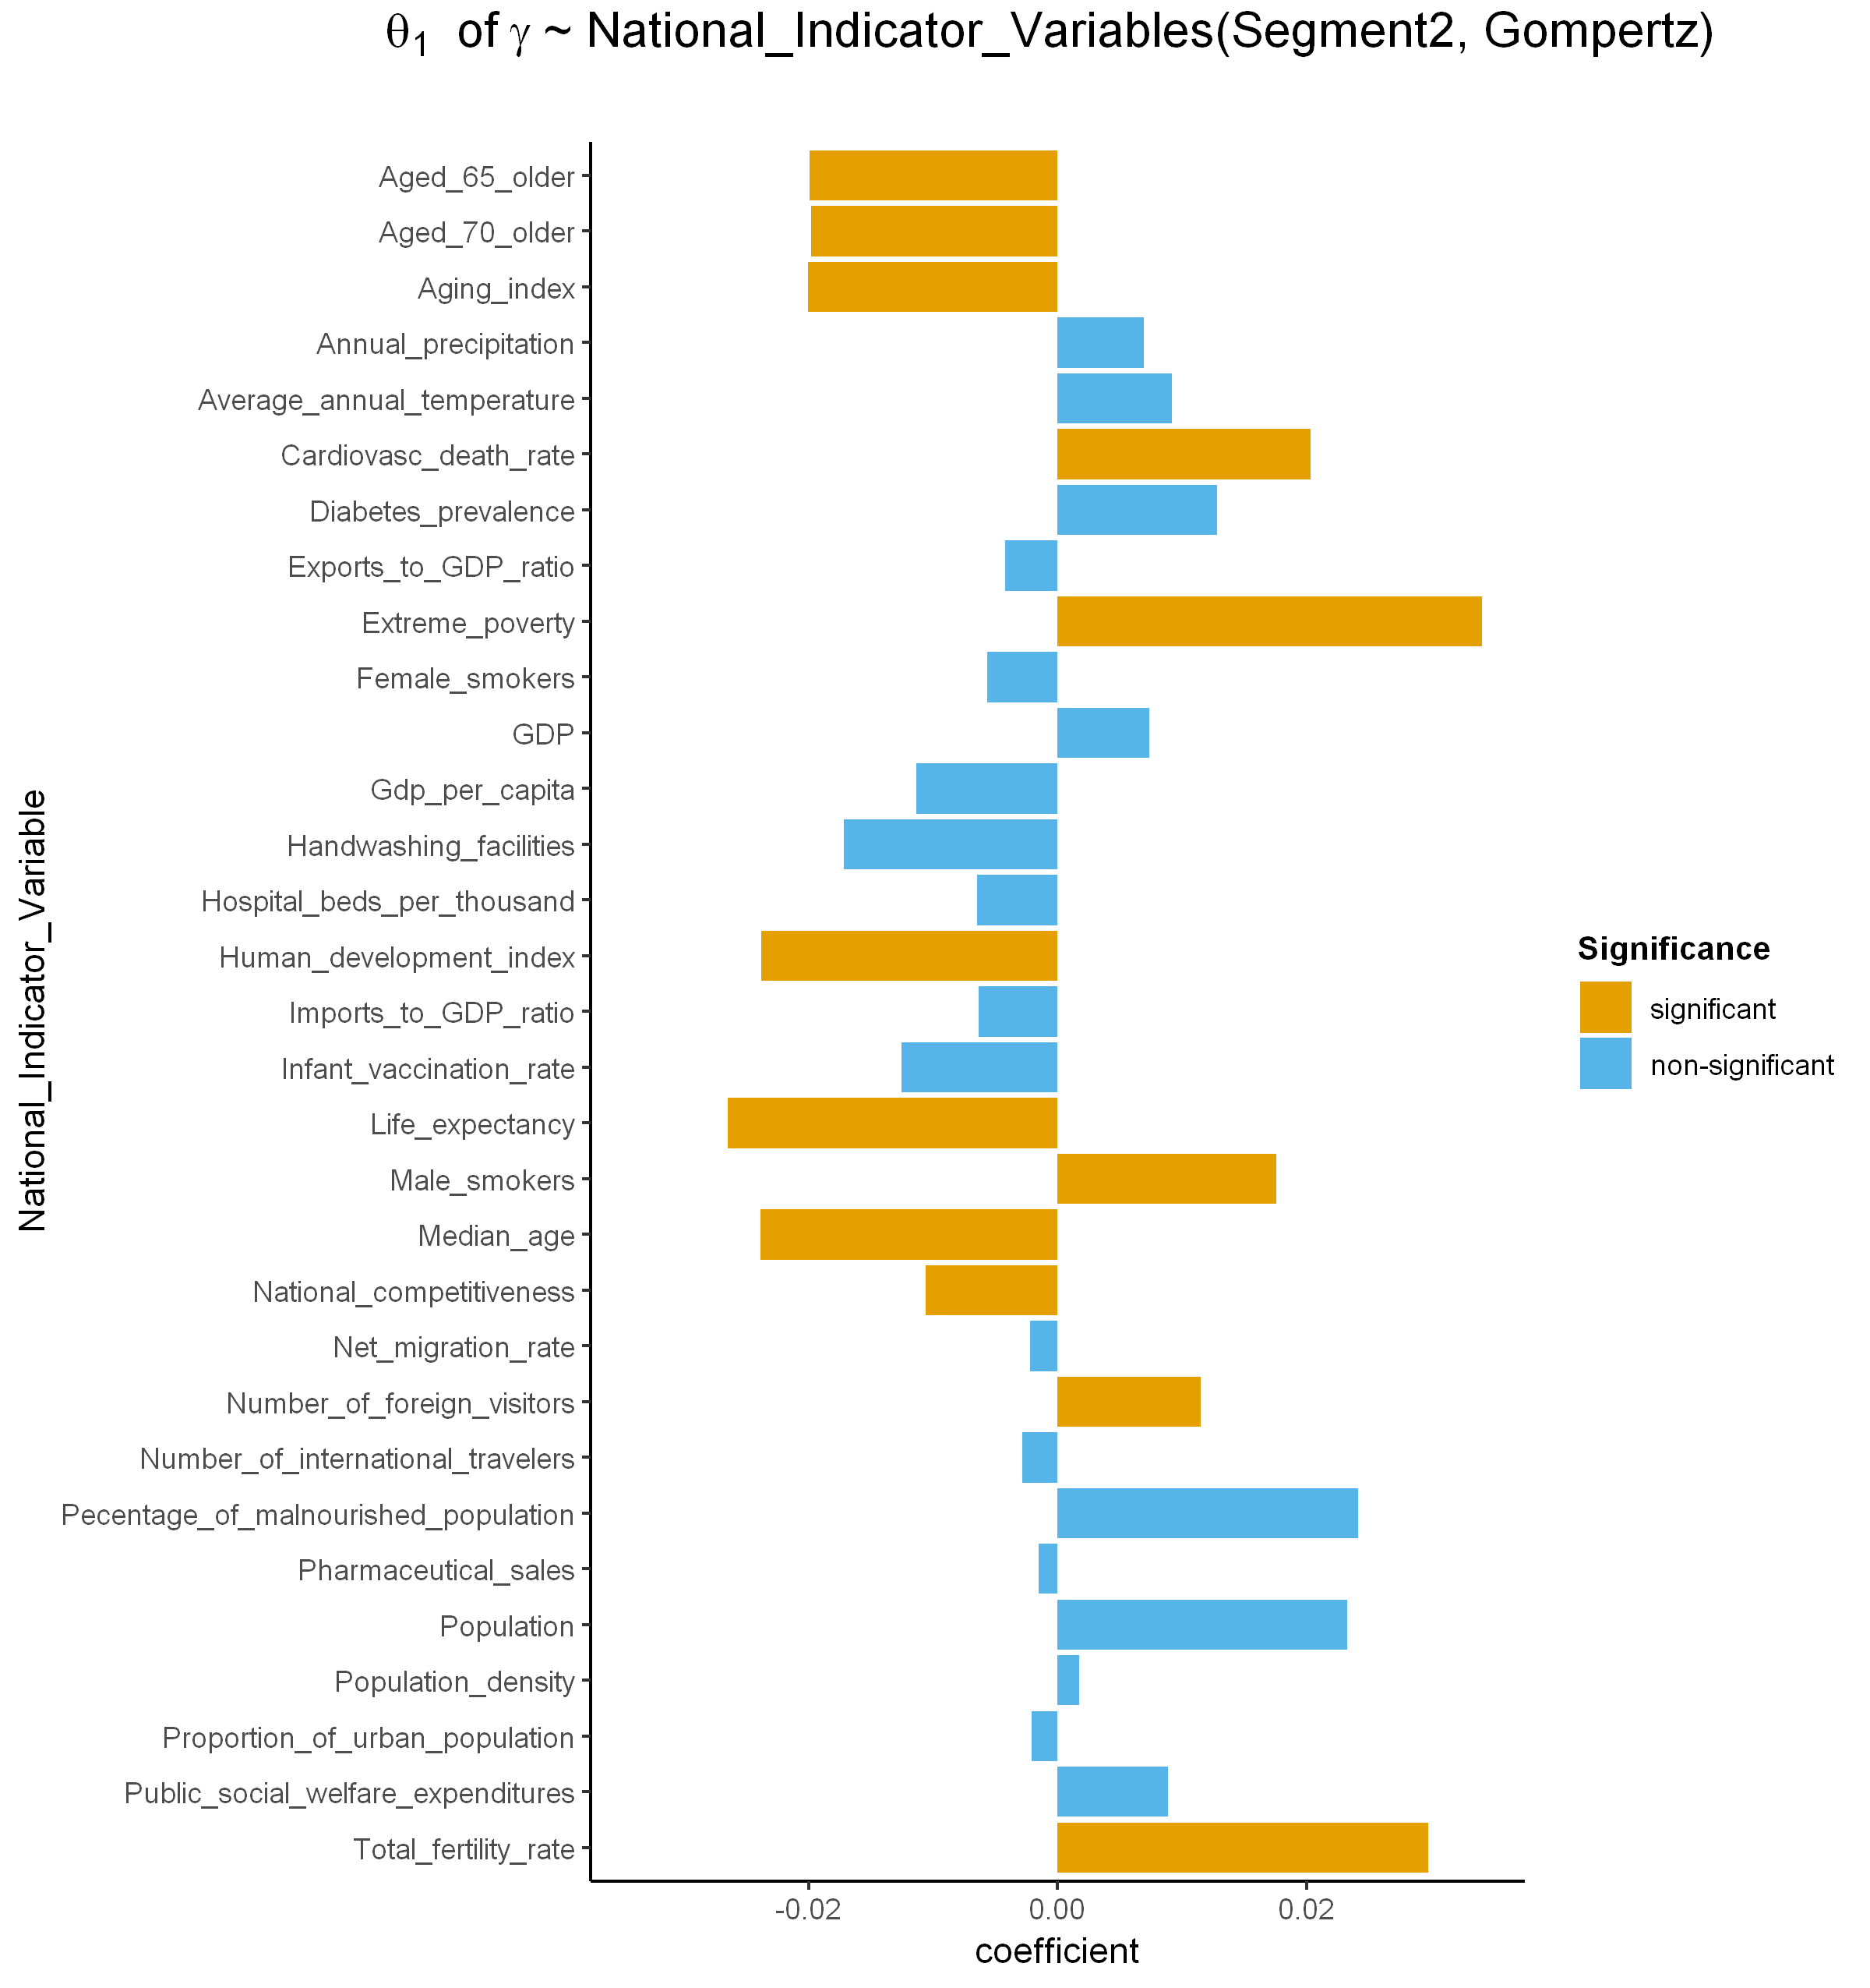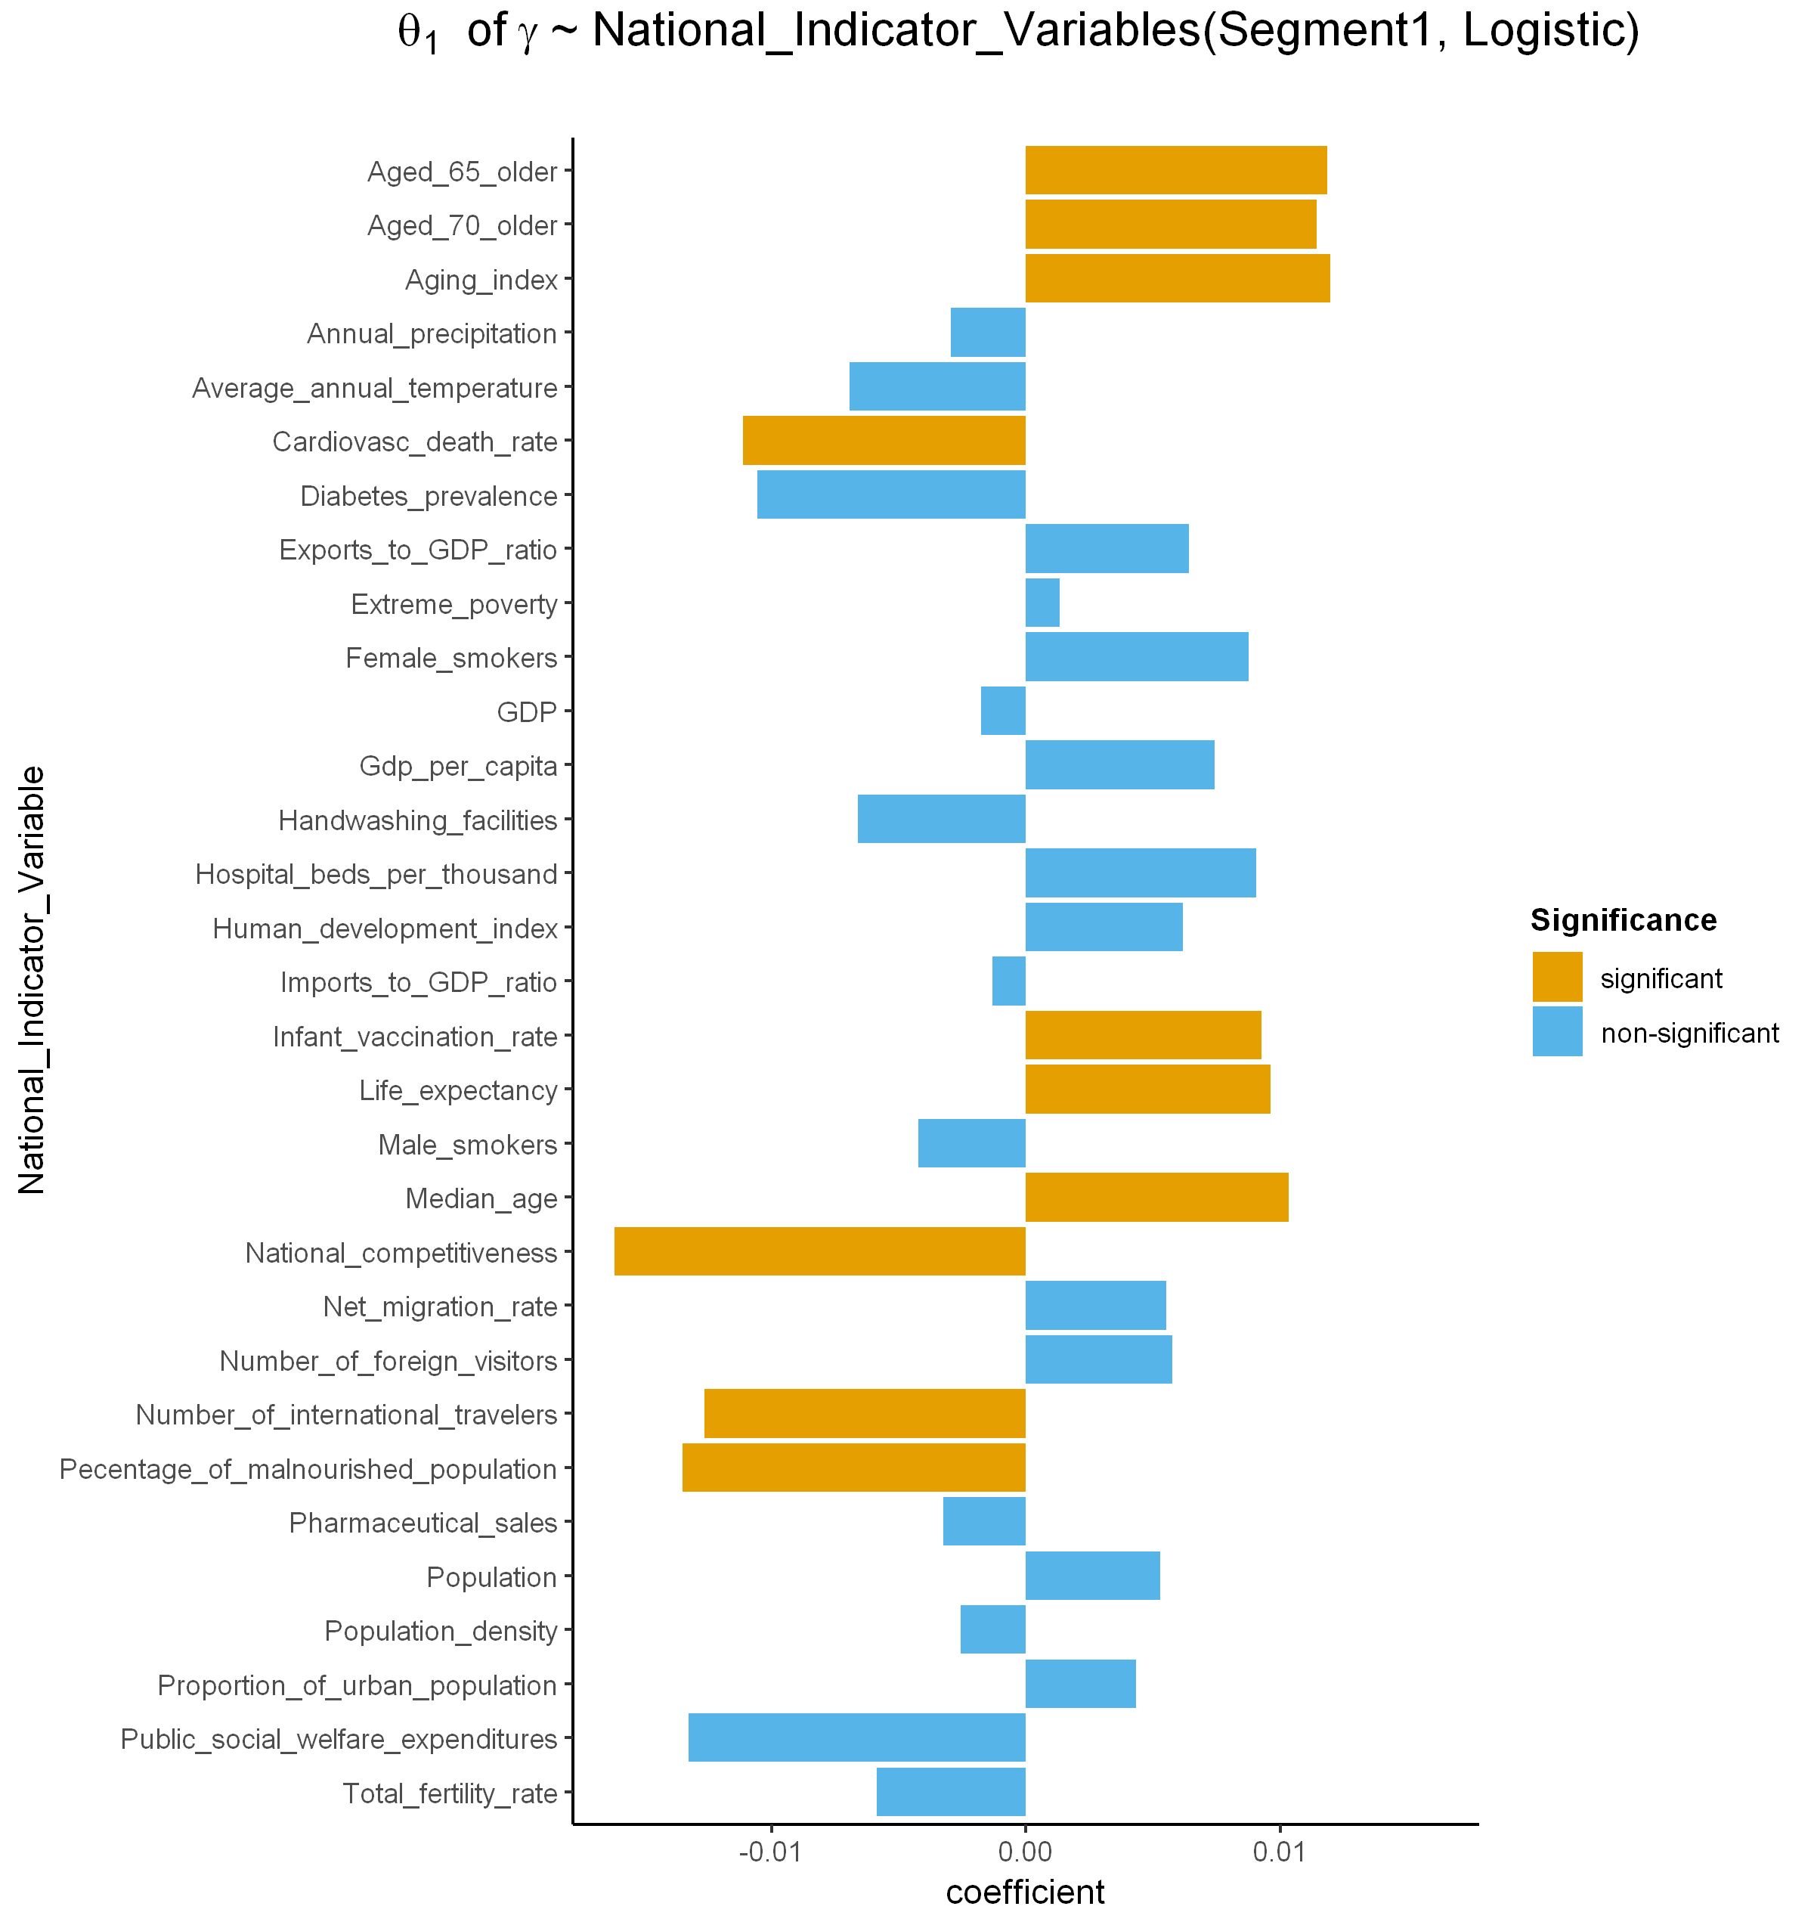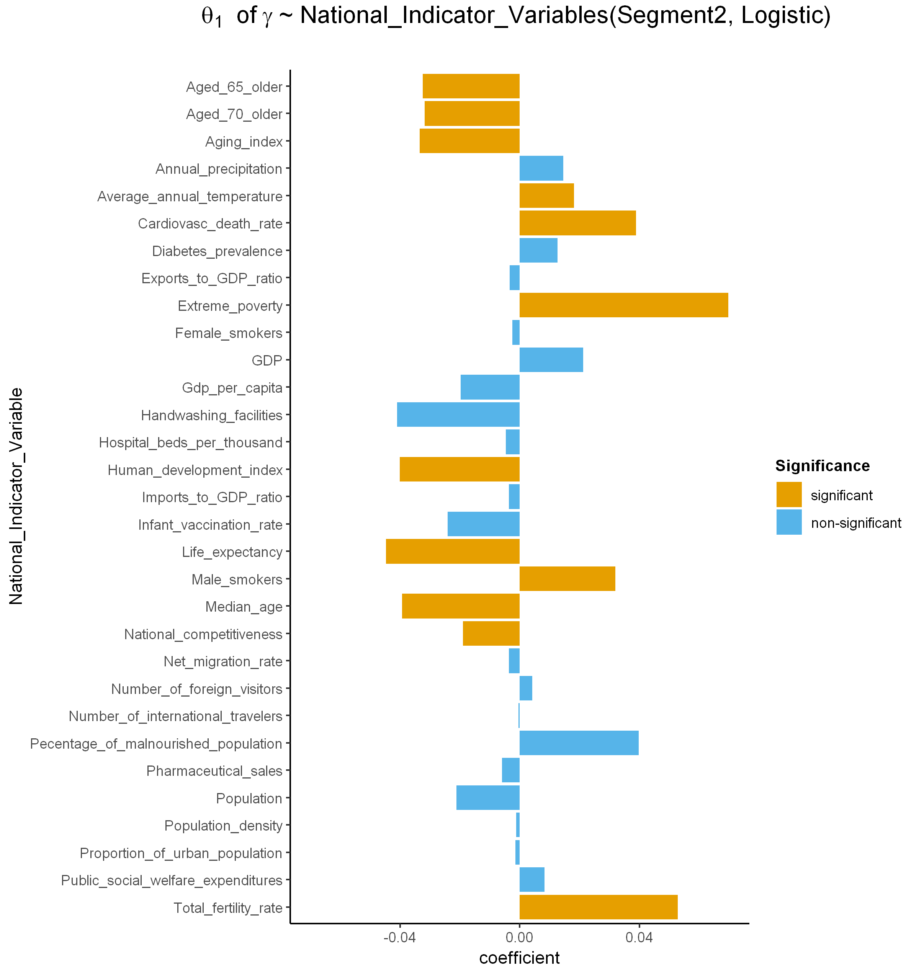

**a**

**b**

**c**

**d**

**Fig. 4. Coefficients of the relationship between national indicator variables and $γ$.** Significant national indicator variables(orange) have large coefficients compared with non-significant variables (blue) for both Gompertz (Fig. 4a and 4c) and Logistic models (Fig. 4b and 4d).

**DISCUSSION**

COVID-19, a contact-transmissible infectious disease, is said to spread through a population via direct contact between individuals (2, 17-18). Control measures aimed at reducing the amount of mixing in the population have already been shown to mitigate the pandemic (19-20). It was determined that highly effective contact tracing and case isolation is enough to control a new outbreak of COVID-19 within three months in most scenarios (21). So, we focused on several factors that may have influenced the spread of novel COVID-19 disease in the population and across the world. Firstly, we modelled the transmission of COVID-19 using segmented Logistic and Gompertz models, mathematical models that use sigmoid function to model population growth. The maximum predicted cumulative confirmed cases and rate of transmission of COVID-19 estimated from the growth curve models were then used to investigate the influence of national indicator variables on the transmission of COVID-19 among the population using Linear regression model.

**Logistic ($γ$)/ Segment 1**

Percentage of malnourished population

Number of international travelers

Infant vaccination rate

**Gompertz ($γ$)/ Segment 1**

Exports to GDP ratio

GDP per capita

Female smokers

Hospital beds per thousand

**Logistic ($γ$)/ Segment 2**

**Gompertz ($γ$)/ Segment 2**

Average annual temperature

Number of foreign visitors

Median age

Aged 65 older

Aged 70 older

Aging index

Cardiovascular death rate

Life expectancy

National competitiveness

Extreme poverty

Male smokers

Human development index

Total fertility rate

**Fig. 5.** **Variation of significant national indicator variables with rate of spread of COVID-19 (γ).** Median age, aged 65 older, aged 70 older aging index, cardiovascular death rate life expectancy and national competitiveness are the only national indicator variables significant across the two models and segments. (see Fig. S12 for significant national indicator variables with β)

At 5% significance level, Linear regression showed significant relationship between some national indicator variables and growth curve parameters. Maximum predicted cumulative confirmed cases was only significantly influenced by population in both the 1st and 2nd segment of the two models (Fig. S11). The countries with the highest value of maximum predicted cumulative confirmed cases (India, USA, Brazil, Philippines and Zambia) have the highest population in the world as of August 31, 2020 (22). In addition, USA, India and Brazil respectively are the hardest hit countries with the pandemic in the world (23, 24) showing a relationship between population and number of cases. High population may bring about congestion of people and higher rate of person-to-person contacts among the people in public places.

Of the two models, transmission rate of COVID-19, has more significant variables with the Gompertz model (16 variables) than with the Logistic model (10 variables) making it the most influenced parameter among the two (Fig. 5). Age related variables. i.e. aging index, median age, percentage of the population aged 65, 70 and older and life expectancy are significant in all two models and segments. Aging is linked mainly with deteriorating immune system (25) and other common conditions like hearing loss, cataracts and refractive errors, back and neck pain and osteoarthritis, chronic obstructive pulmonary disease, diabetes, depression, dementia to mention but a few where several of these conditions can be experienced at the same time (26-27). Older people are more at risk of contracting and dying of COVID-19 than younger people due to already a deteriorating immune system, pre-existing conditions and underlying medical problems like cardiovascular disease, diabetes, chronic respiratory disease, and cancer making them more likely prone to new infections (28-31). This includes other variables like cardiovascular death rate and the percentage of female and male smoker in the population. Smoking has been linked to increased risk of contracting COVID-19 mainly due to the complications it wrecks on the immune system (32-34).

Extreme poverty impairs rapid response of the government to newer pandemics leaving its people highly susceptible to the infections. It interferes with health system response like drugs, protective gears, information campaign and the inability of poor health systems to handle newer pandemics. Malnourished people is highly susceptible to new infections especially viral infections mainly from a weak immune system because of poor development. A large percentage of malnourished populations are mainly found in developing countries that also experience extreme poverty (35-36). Number of international travelers and foreign visitors increases the chance of spreading and catching the SARS-COV-2 virus among the population (37) mainly due to importation and exportation of cases leading to many domestic travel restrictions and flight suspensions between countries (38-39). All the above discussed variables have been proven to lead to an increased rate of transmission of infectious diseases especially viral infections including SARS-COV-2 virus (COVID-19 disease).

One recent review has addressed the role of climate change in the emergence and re-emergence of infectious diseases worldwide, indicating that temperature is an important environmental condition determining the success of infectious agents (40). Average annual temperature affects the rate of transmission of COVID-19 in the first segment of confirmed cases.

A key limitation of this analysis that though we modeled the transmission of COVID-19 for 134 countries, the growth curve models still produce a lot of missing parameter values between the segments and models for some which is due to failure of convergence, which may have affected downstream analysis and therefore, interpretation of the results. Also, we would only fit the model up to August 31, 2020 because beyond that more than two segments will have to be modeled which is highly complicated and difficult. A lot is yet not known about the clinical and epidemiological characteristics of COVID-19, such as individual risk factors for contracting the virus and infections from asymptotic cases. We hope these studies will provide important information for policy makers and governments in making informed scientific decisions while considering a country’s resources and capabilities, population dynamics, health and coming up with intervention policies that would likely make the most impact in future prevention work against similar infectious diseases.

**REFERENCES**

1. S. Lakshmi Priyadarsini & M. Suresh (2020) Factors influencing the epidemiological characteristics of pandemic COVID 19: A TISM approach, International Journal of Healthcare Management, 13:2, 89-98, DOI: 10.1080/20479700.2020.1755804
2. Q Li, X Guan, P Wu, et al. Early transmission dynamics in Wuhan, China of the novel Coronavirus- infected pneumonia. N Engl J Med (2020) published online Jan 29. DOI:10.1056/NEJMoa2001316
3. WHO director-general’s opening remarks. [https://www.who.int/dg/speeches/detail/whComing soono-director-general-s-opening-remarks-at-the-media-briefing-on-covid-19-11-march-2020](https://www.who.int/dg/speeches/detail/who-director-general-s-opening-remarks-at-the-media-briefing-on-covid-19-11-march-2020)
4. <https://www.worldometers.info/coronavirus/>
5. Bootsma MCJ, Ferguson NM. The effect of public health measures on the 1918 influenza pandemic in U.S. cities. Proc Natl Acad Sci U S A 2007;104(18):7588–93.
6. Hao Xu, Chonghuai Yan, Qingyan Fu, Kai Xiao, Yamei Yu, Deming Han, Wenhua Wang, Jinping Cheng. Possible environmental effects on the spread of COVID-19 in China. Science of The Total Environment. Volume 731, 2020, 139211, ISSN 0048-9697. <https://doi.org/10.1016/j.scitotenv.2020.139211>.
7. Nakada, L.Y.K., Urban, R.C. COVID-19 pandemic: environmental and social factors influencing the spread of SARS-CoV-2 in São Paulo, Brazil. Environ Sci Pollut Res (2020). <https://doi.org/10.1007/s11356-020-10930-w>
8. Ahmadi M, Sharifi A, Dorosti S, Ghoushchi SF, Ghanbari N (2020) Investigation of effective climatology parameters on COVID-19 outbreak in Iran. Sci Total Environ 729:138705. <https://doi.org/10.1016/j.scitotenv.2020.138705>
9. Hamidi S, Sabouri S, Ewing R (2020) Does density aggravate the COVID-19 pandemic? J Am Plan Assoc 1–15. <https://doi.org/10.1080/01944363.2020.1777891>
10. Tobías A (2020) Evaluation of the lockdowns for the SARS-CoV-2 epidemic in Italy and Spain after one month follow up. Sci Total Environ 725:138539. https://doi.org/10.1016/j.scitotenv.2020.138539Return to ref 2020 in article
11. Harmooshi NN, Shirbandi K, Rahim F (2020) Environmental concern regarding the effect of humidity and temperature on 2019-nCoV survival: fact or fiction. Environ Sci Pollut Res 27:36027–36036. https://doi.org/10.1007/s11356-020-09733-w
12. Malay Pramanik, Parmeshwar Udmale, Praffulit Bisht, Koushik Chowdhury, Sylvia Szabo & Indrajit Pal (2020) Climatic factors influence the spread of COVID-19 in Russia, International Journal of Environmental Health Research, DOI: 10.1080/09603123.2020.1793921
13. Prata DN, Rodrigues W, Bermejo PH (2020) Temperature significantly changes COVID-19 transmission in (sub)tropical cities of Brazil. Sci Total Environ 729:138862. <https://doi.org/10.1016/j.scitotenv.2020.138862>
14. Cheng, C., Barceló, J., Hartnett, A.S. et al. COVID-19 Government Response Event Dataset (CoronaNet v.1.0). Nat Hum Behav (2020). https://doi.org/10.1038/s41562-020-0909-7
15. Institute of Medicine (US) Forum on Microbial Threats. Ethical and Legal Considerations in Mitigating Pandemic Disease: Workshop Summary. Washington (DC): National Academies Press (US); 2007. 1, Learning from Pandemics Past. Available from: <https://www.ncbi.nlm.nih.gov/books/NBK54171/>
16. <https://databank.worldbank.org/home>
17. J Riou, CL Althaus. Pattern of early human-to-human transmission of Wuhan 2019 novel coronavirus (2019-nCoV), December 2019 to January 2020. Euro Surveill, 25 (2020), Article 2000058
18. JFW Chan, S Yuan, KH Kok, et al. A familial cluster of pneumonia associated with the 2019 novel coronavirus indicating person-to-person transmission: a study of a family cluster. Lancet, 395 (2020), pp. 514-523
19. Zhang, Xiaolei, Renjun Ma, and Lin Wang. Predicting turning point, duration and attack rate of COVID-19 outbreaks in major Western countries. Chaos, Solitons & Fractals (2020): 109829.
20. Singh, Rajesh, and R. Adhikari. Age-structured impact of social distancing on the COVID-19 epidemic in India. arXiv preprint arXiv:2003.12055 (2020).
21. Hellewell, J., Abbott, S., Gimma, A., Bosse, N. I., Jarvis, C. I., Russell, T. W., Munday, J. D., Kucharski, A. J., Edmunds, W. J., Sun, F. et al. (2020) Feasibility of controlling covid-19 outbreaks by isolation of cases and contacts, The Lancet Global Health.
22. <https://www.worldometers.info/world-population/population-by-country/>
23. <https://www.worldometers.info/coronavirus/#countries>
24. <http://ncov.mohw.go.kr/en/>
25. Gemma Alderton. Aging immunity. Science. Vol. 369, Issue 6501, pp. 264-266. DOI: 10.1126/science.369.6501.264-k
26. <https://www.who.int/news-room/fact-sheets/detail/ageing-and-health>
27. Hirokawa, K., Utsuyama, M., Kasai, M. and Kurashima, C. (1992), Aging and Immunity. Pathology International, 42: 537-548. <https://doi.org/10.1111/j.1440-1827.1992.tb03103.x>
28. <https://www.cdc.gov/coronavirus/2019-ncov/need-extra-precautions/older-adults.html>
29. Mueller, A. L., McNamara, M. S., & Sinclair, D. A. (2020). Why does COVID-19 disproportionately affect older people? Aging, 12(10), 9959–9981. <https://doi.org/10.18632/aging.103344>
30. Davies, N.G., Klepac, P., Liu, Y. et al. Age-dependent effects in the transmission and control of COVID-19 epidemics. Nat Med **26**, 1205–1211 (2020). <https://doi.org/10.1038/s41591-020-0962-9>
31. Ho FK, Petermann-Rocha F, Gray SR, Jani BD, Katikireddi SV, Niedzwiedz CL, et al. (2020) Is older age associated with COVID-19 mortality in the absence of other risk factors? General population cohort study of 470,034 participants. PLoS ONE 15(11): e0241824. https://doi.org/10.1371/journal.pone.0241824
32. <https://www.who.int/westernpacific/news/q-a-detail/coronavirus-disease-covid-19-tobacco#:~:text=Tobacco%20smokers%20(cigarettes%2C,communal%20and%20social%20settings>.
33. Askin Gülsen, Burcu Arpinar Yigitbas, Berat Uslu, Daniel Drömann, Oguz Kilinc, "The Effect of Smoking on COVID-19 Symptom Severity: Systematic Review and Meta-Analysis", Pulmonary Medicine, vol. 2020, Article ID 7590207, 11 pages, 2020. <https://doi.org/10.1155/2020/7590207>
34. Wenzl, T., Smoking and COVID-19 - A review of studies suggesting a protective effect of smoking against COVID-19, EUR 30373 EN, Publications Office of the European Union, Luxembourg, 2020, ISBN 978-92-76-22062-6 (online), doi:10.2760/564217 (online), JRC121837.
35. Müller O, Krawinkel M. Malnutrition and health in developing countries. CMAJ. 2005 Aug 2;173(3):279-86. doi: 10.1503/cmaj.050342. PMID: 16076825; PMCID: PMC1180662.
36. Saunders J, Smith T. Malnutrition: causes and consequences. Clin Med (Lond). 2010 Dec;10(6):624-7. doi: 10.7861/clinmedicine.10-6-624. PMID: 21413492; PMCID: PMC4951875.
37. <https://www.cdc.gov/coronavirus/2019-ncov/travelers/travel-during-covid19.html>
38. Anzai A, Kobayashi T, Linton NM, Kinoshita R, Hayashi K, Suzuki A, Yang Y, Jung S-m, Miyama T, Akhmetzhanov AR, Nishiura H. Assessing the Impact of Reduced Travel on Exportation Dynamics of Novel Coronavirus Infection (COVID-19). Journal of Clinical Medicine. 2020; 9(2):601. <https://doi.org/10.3390/jcm9020601>
39. Siegenfeld, A.F., Bar-Yam, Y. The impact of travel and timing in eliminating COVID-19. Commun Phys 3, 204 (2020). <https://doi.org/10.1038/s42005-020-00470-7>
40. El-Sayed A, Kamel M (2020) Climatic changes and their role in emergence and re-emergence of diseases. Environ Sci Pollut Res 27:22336–22352. https://doi.org/10.1007/s11356-020-08896-wReturn to ref 2020 in article
41. European Centre for Disease Prevention and Control. <https://www.ecdc.europa.eu/en/covid-19-pandemic>
42. <https://www.ecdc.europa.eu/en/publications-data/download-todays-data-geographic-distribution-covid-19-cases-worldwide>.
43. <https://opendata.ecdc.europe.eu/covid19/casedistribution/csv.>
44. <https://ourworldindata.org/>
45. <http://kosis.kr/eng/>
46. <https://github.com/owid/covid-19-data/tree/master/public/data>
47. Lin Jia, Kewen Li, Yu Jiang, Xin Guo and Ting Zhao. Prediction and analysis of Coronavirus Disease 2019 (2019)

<https://www.google.com/search?q=wave+in+epidemiology&rlz=1C1SQJL_koKR838KR838&oq=wave+in+epidemiology&aqs=chrome..69i57j0i5i30.9894j0j7&sourceid=chrome&ie=UTF-8>

1. Nadaraya, E. A. (1964). "On Estimating Regression". Theory of Probability and Its Applications. 9 (1): 141–2. doi:10.1137/1109020.
2. Watson, G. S. (1964). "Smooth regression analysis". Sankhyā: The Indian Journal of Statistics, Series A. 26 (4): 359–372. JSTOR 25049340.
3. Bierens, Herman J. (1994). "The Nadaraya–Watson kernel regression function estimator". Topics in Advanced Econometrics. New York: Cambridge University Press. pp. 212–247. ISBN 0-521-41900-X.

**Acknowledgments:…….**

**Funding:** We also appreciate funding support from the Science & Technology Policy Institute of Korea (No. 0409-20200222) for this research.

**Author contributions:** Conceptualization, T.P.; Methodology, T.P., H.K., and Y.K.; Formal Analysis, H.K., Y.K., K.H., H.C., T.G., A.C., D.L., J.L., T.K; Data Curation, K.H., G.H., T.G., H.K., Y.K. and D.L.; Writing – Original Draft Preparation, A.C., H.K. and Y.K.; Writing – Review & Editing, T.P., C.A. and G.H. and J.L; Visualization, H.K., K.H., Y.K. and A.C; Supervision, T.P.; Project Administration, T.P.; Funding Acquisition, T.P.

**Competing interests:** The authors declare no competing interests.

**Data and materials availability:** All data needed to evaluate the conclusions in the paper are present in the paper and/or the Supplementary Materials. Replication data and code for this paper are available at…... Additional data related to this paper may be requested from the authors.

**SUPPLEMENTARY MATERIALS**

**MATERIALS AND METHODS**

**ECDC COVID-19 Data**

The COVID-19 data of daily confirmed cases and deaths can easily be downloaded from the European Centre for Disease Prevention and Control (ECDC) website (41-43). ECDC is an EU agency aimed at strengthening Europe's defenses against infectious diseases. The core functions cover a wide spectrum of activities: surveillance, epidemic intelligence, response, scientific advice, microbiology, preparedness, public health training, international relations, health communication, and the scientific journal *Eurosurveillance*. Negative confirmed cases were corrected to 0 regarding it as an abnormal data. Since cases on an international conveyance in Japan was included in country list, we remove it. The data consisting of 213 countries from January 1, 2020 to August 31, 2020 was used in downstream analysis.

Data smoothing is used to remove noise from a data set, allowing important patterns to stand out. Thereafter, daily confirmed case data was smoothed by simple moving the average; 1) to reduce the effect of outliers and 2) remove the weekly periodicity observed in the data. There were several outliers that showed greater or smaller abnormalities, which made it difficult to fit the statistical model. In addition, weekly periodicity was observed in the daily confirmed case data for many countries. Although we tried to present numerically through autocorrelation function, the trend had randomness giving a limit to the analysis. Therefore, considering the period of 7 days, the window size was set to 7 and simple moving average (SMA) was used before model fitting as shown below;

$SMA=\frac{p_{M}+p_{M-1}+…+p_{M-(n-1)}}{n}=\frac{1}{n}\sum_{i=0}^{n-1}{p_{M-i}},$ where *p* is the number of confirmed cases.

**National indicator variables Data**

Time-independent national indicator variables (Table 1) datasets are publicly available datasets easily obtained from *Our World in Data* website (44) and KOSIS (45). *Our World in Data* website provides data about Research and data to make progress against the world’s largest problems like poverty, disease, hunger, climate change, war, existential risks, etc. It mainly focuses on: the large problems that continue to confront us for centuries or much longer and the long-lasting, forceful changes that gradually reshape our world. From this website, we obtained 15 time-independent social and economic variables we believe are related to COVID-19 such as population, population density, median age, aged 65 over, aged 70 over, GDP per capita, extreme poverty, cardiovascular death rate, diabetes prevalence, female smoker, male smoker, handwashing facilities, hospital beds per thousand, life expectancy, human development index, etc. (46).

The Korean Statistical Information Service (KOSIS) (45) website contains the national statistical database which offers a full range of major domestic, international and North Korean statistics, produced by over 120 statistical agencies covering more than 500 subject matters as well as the latest data on international finance and economy from international organizations (i.e. IMF, World Bank, OECD). From the 26 variables, 13 were selected which we believed would be related to the spread of COVID-19. These variables are measured over a period of several years. Therefore, we selected the year with the minimum number of missing values between 2016-2019, re-scaled by division with standard errors of the variables**.**

|  |  |  |  |
| --- | --- | --- | --- |
| **Summary of national indicator variables** | | | |
| **Source** | **Category** | **Variable name** | **Variable information** |
| ***Our World in Data*** | ***Territory, Population*** | Population (2020) | Population in 2020 |
| Population Density (2020) | The number of people in a given area divided by the area of ​​the given area. Usually expressed as population per ㎢. |
| ***National Accounts*** | GDP per capita | Gross domestic product divided by the number of people. |
| ***Age*** | Median Age (2020) | Median age of the population, UN projection for 2020 |
| Aged 65 older | Share of the population that is 65 years and older, most recent year available |
| Age 70 older (2015) | Share of the population that is 70 years and older in 2015 |
| Life Expectancy (2019) | The average number of years a 0-year-old is expected to survive in the future. |
| ***Health, Society, And Welfare*** | Cardiovascular Death Rate (2017) | Death rate from cardiovascular disease in 2017 (annual number of deaths per 100,000 people) |
| Diabetes Prevalence (2017) | Diabetes prevalence (% of population aged 20 to 79) in 2017 |
| Female Smokers | Share of women who smoke, most recent year available |
| Male Smokers | Share of men who smoke, most recent year available |
| Handwashing Facilities | Share of the population with basic handwashing facilities on premises, most recent year available |
| Hospital Beds per thousand | Hospital beds per 1,000 people, most recent year available since 2010 |
| Extreme Poverty | Share of the population living in extreme poverty, most recent year available since 2010 |
| ***Education, Culture, Science*** | Human Development Index | Summary measure of average achievement in key dimensions of human development: a long and healthy life, being knowledgeable and have a decent standard of living |
| ***KOSIS*** | ***Trade*** | Exports to GDP Ratio (2016) |  |
| Imports to GDP Ratio (2016) |  |
| ***Environment*** | Average Annual Temperature (1961-1990) | 30-year statistics from 1961 to 1990 based on observed temperature. |
| Annual Precipitation (1961-1990) | 30-year statistics from 1961 to 1990 based on observed precipitation. |
| ***National Accounts*** | Gross Domestic Product (2018) | A monetary measure of the market value of all the final goods and services produced in a specific time period. |
| ***Territory, Population*** | Proportion of Urban Population (2018) | The proportion of the population living in urban areas among the total population. However, the concept of cities in each country is different, and the urban population of each country is based on the census of each country. |
| Total Fertility Rate (2020) | Average of the number of children a woman has in her lifetime. |
| Net Migration Rate (2020) | The number of the number of transferees minus the number of transferees over a specific period divided by the total population of the period. |
| ***Education, Culture, Science*** | Number of international travelers (2017) | The number of foreign tourists with Korean nationality is processed by the Ministry of Justice's national departure statistics. |
| Number of foreign visitors (2017) | The number of foreign visitors to Korea is calculated based on the immigration statistics of the Immigration Office of the Ministry of Justice. |
| National Competitiveness (2019) | The ranking of national competitiveness announced by the Swiss Institute of International Business Development (IMD). Consider areas such as economic performance, government efficiency, corporate efficiency, and infrastructure. |
| ***Health, Society, And Welfare*** | Infant vaccination rate (2017) | The infant immunization rate is the percentage of infants 12 to 23 months of age who were vaccinated 12 months before or before the investigation of four diseases, measles and DPT (diphtheria, whooping cough, tetanus). |
| Public Social Welfare Expenditure (2016) | social benefits or financial assistance by public institutions while households or individuals are in a disadvantaged environment. Expressed as a percentage of GDP. |
| Pharmaceutical Sales (2018) | Total sales based on the retail price of the drug's final sales, classified by ATC code (Anatomical Therapeutic Chemical Classification System). |
| Percentage of malnourished population (2016) | Percentage of the population who consistently consume food at a level lower than the minimum dietary energy consumption. |
| ***Age*** | Aging index (2020) | (Population over the age of 65 in the current year ÷ Population between 0 and 14 in the current year) × 100. |

**Table 1**: List of the national indicator variables used.

**Transmission analysis of COVID-19**

Under this analysis, growth curve models, Logistic model and Gompertz model were employed to model the transmission of COVID-19 using the cumulative confirmed cases for each country. These growth models are commonly used to explore risk factors, predict the probability of occurrence of a certain disease, factors that control and affect growth, and extinction laws of the population respectively (47).The models take the following forms respectively;

Logistic model

$Q_{t}=\frac{α}{1+e^{β-γ\left(t-t_{0}\right) }}$ (1)

where $Q_{t}$ is the cumulative confirmed cases, $a$ is the maximum number of predicted cumulative confirmed cases, *b* is the time when we start to see a rise in the number of confirmed cases, *c* is the increase rate of number of confirmed cases, *t* is the number of days since the first case occurrence, $t_{0}$ is the time when the first case occurred.

Gompertz model

${ Q}_{t}=αe^{-βe^{-γ(t-t_{0})}}$ (2)

where $Q_{t}$ is the cumulative confirmed cases, $a$ is the maximum number of predicted cumulative confirmed cases, *b* is the time when we start to see a rise in the number of confirmed cases, *c* is the increase rate of number of confirmed cases, *t* is the number of days since first case. $t_{0}$ is the time when the first case occurred.

**Segmentation Algorithm**

As the COVID-19 situation prolongs, fitting a growth curve model on daily confirmed cases over long period of time becomes impossible as it no longer takes on s-curve (i.e. sigmoid function). To fit the above growth curve models, there is a need to divide study period of countries experiencing more than one wave (48) (a wave implies a rising number of sick individuals, a defined peak, and then a decline) of the pandemic into several segments (the time during which cumulative confirmed cases follow the s-curve). So, we applied segmentation algorithm which can systematically divide study periods into several segments (or waves) for each country (Fig. 1).

Segmentation is a method of finding peaks and breakpoints, where a peak is the timestamp at which daily new confirmed case is highest in a segment and breakpoint is the timestamp which splits the consecutive two segments in a time series dataset. To better see trends, we smooth out the irregular roughness of the graph of daily confirmed cases. But daily new confirmed cases have high randomness arising from 1) the fact that daily new confirmed cases have a periodicity of seven days (due to differences in daily new confirmed cases between weekends and weekdays) and 2) measure errors of one day. Therefore, we applied the Nadaraya-Watson kernel regression Estimator (NWE) (49-51) with Gaussian kernel to smoothen the daily new confirmed cases as demonstrated in Fig. 6 using South Korea’s daily confirmed cases as an example. For the convenience of notation, let $Y_{t}$ be the $t$-th daily new confirmed cases from data, $\hat{f}(t)$ be the estimated $t$-th daily new confirmed cases using above NWE since January 1, 2020.

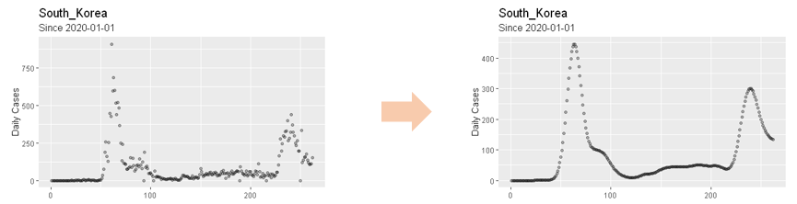

**Fig. 6. Daily new confirmed cases before and after smoothing using Nadaraya-Watson kernel regression**.

Peak detection (Algorithm 1) utilizes the first and second derivative test to find local maxima on convex function. $\hat{f}(t)$ has convexity when $t$ is around peak due to the nature of population dynamics. Considering daily new confirmed cases being discrete time series data, we find the location where the first difference is zero and second difference is negative (Since f(t) is not differentiable, we used difference operator instead of derivative):

$∆\hat{f}(t)=0$, $∆^{2}\hat{f}(t)<0$ (3)

where $∆\hat{f}(t)=\hat{f}(t+1)-\hat{f}(t)$ and $∆^{2}\hat{f}(t)= ∆\hat{f}(t+1)-∆\hat{f}(t)$.

And for discontinuity and small variances of $\hat{f}(t)$, we used following condition:

$∆\hat{f}(t)∆\hat{f}(t+1)≤0$, $∆^{2}\hat{f}(t)<-c∙{argmax}_{t∈ T}|∆^{2}\hat{f}(t)|$ (4)

where $c∈(0, 1)$ is sensitivity level and $T$ is set of time indices from January 1, 2020 to August 31, 2020 (Figure 2). And 3 additional conditions ((a) Exclusion of small peaks, (b) Resolution criteria and (c) Exclusion of peaks which are vibrations on increasing trend) are used in peak detection to enhance robustness. After all the peaks are found, breakpoints (Algorithm 2) are selected either as timestamps which have the smallest daily new confirmed cases between two consecutive peaks or the timestamp where the cumulative confirmed case of the last segment saturates (that is the last stage of the s-curve of last segment*).* Figure 7 visualizes the segmentation process. Blue line represents the peak and dotted sky-blue line represents breakpoint. In the 1st plot, black solid line represents and black dotted line represents . The 2nd plot represents cumulative confirmed cases of (black dotted line), (black solid line). 3rd, 4th plots are graphs of . In 4th plot, green dotted line represents sensitivity level. If $∆^{2}\hat{f}(t)$ is above the upper green dotted line, $\hat{f}(t)$ is concave. On the other hand, if $∆^{2}\hat{f}(t)$ is below the lower green dotted line, $\hat{f}(t)$ is convex. With 3rd, 4th plot, Equation (5) can be validated.

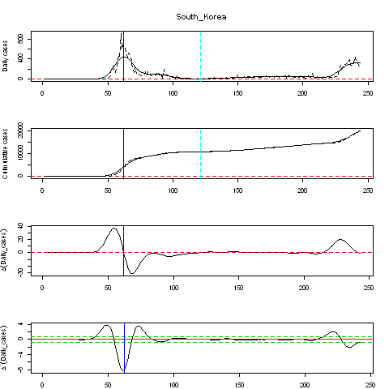

**Fig. 7. Segmentation algorithm on South Korea’s COVID-19 daily new confirmed cases.**

The segmentation algorithm was successfully applied to 134 countries from the 213 countries in the ECDC dataset which met $\max_{t ∈ T}\left(\hat{f}(t)\right)≥50$. If $\max_{t ∈ T}\left(\hat{f}(t)\right)$ is too small, segmentation algorithm would be difficult to apply due to small variances in $∆^{2}\hat{f}(t)$. The pseudo code of Segmentation and result of Segmentation on main countries are added in the Supplementary materials.

**Segmented growth curve models**

Segmented growth curve models (segmented Logistic model and segmented Gompertz model) fit the above-mentioned growth curve models ((1) and (2)) for each segment independently. These new models do not preserve continuity at breakpoints, but this does not matter since the objective of our analysis is to condense daily new confirmed cases into several parameters ($α, β,γ$) of the growth curves, not to accurately predict daily new confirmed cases.

$Q(t)=\sum_{i=1}^{n}{(\frac{α_{i}}{1+e^{β_{i}-γ_{i}t}}+q_{i}})I_{{Seg}_{i}}(t)$ (5)

$Q(t)=\sum_{i=1}^{n}{({α_{i}e}^{{-β}_{i}e^{{-γ}_{i}t}}+q_{i}})I_{{Seg}_{i}}(t)$ (6)

where, $q_{i}(i≥2)$ is the number of cumulative cases at $({i-1)}^{th}$ breakpoint, $I_{{Seg}_{i}}(t)$ is indicator function where ${Seg}_{i}$ is the set of indices of $i^{th}$ segment and $q_{1}=0$.

In this analysis, we considered 1st and 2nd segments only since most countries have 1 or 2 segments (1 segment: 62, 2 segments: 65, 3 segments: 7) The number of countries with three segments were very few making comparison analysis insignificant to use in the linear regression analysis. For countries with more than 2 segments, the analysis period was therefore cut off at the 2nd breakpoint. For countries with 2 segments, segmented growth curve model then produces two sets of parameters one set from each segment.

In addition, correlation analysis for segmented Logistic and Gompertz models with the log-scaled of parameters are performed to determine the similarity between parameters of the two models.

**Linear regression analysis**

The above segmented growth curve models summarize the spread of the pandemic as three parameters ($α_{1}$, $β_{1}$, $γ_{1}$) for countries with one segment and into six parameters ($α_{1}$, $β_{1}$, $γ_{1}$, $α_{2}$, $β_{2}$, $γ_{2}$) for countries with two segments. Each of the parameters from the two models was regressed against the national indicator variables shown in Table 1 as follows;

$Y_{ijk}=θ_{0}+θ_{1}x_{j}$ (7)

where Y is a segmented growth curve parameter ($α, β,γ$) for model $i ,$ segment $k$ and country $j$, $θ_{0}$ and $θ_{1}$ are regression coefficients, and $x$ is the time-independent variable. F- statistic is performed to test the significance of $θ_{1}$ for each major time-independent variable with the aim of finding out if the variables have any significant relationship with y, a measure of the spread dynamics of COVID-19 for a country.

After the segmentation algorithm was applied to 134 countries, these countries were fitted to segmented Logistic and Gompertz model respectively. To filter out poorly fitted countries, we exclude countries whose MSSE (Mean Squared Scaled Error) is higher than 0.4 as defined below:

MSSE = $\frac{1}{N}\sum_{t=1}^{N}{{(\frac{Y_{t}- \hat{Y_{t}}}{\overline{Y}})}^{2}}$ (8)

where $Y_{t}$ is the daily new confirmed cases is the, $\hat{Y_{t}}$ is the predicted value for $Y_{t}$ by segmented Logistic and Gompertz Model, and $\overline{Y}$ is the mean of $Y_{t}$ for t = 1, …, N.

MSSE is more suitable scale than MSE (Mean Squared Error) or MAPE (Mean Absolute Percentage Error) because the former cannot control different scales according to the cumulative confirmed cases of each country, while the latter overestimates its error when the number of daily cases $Y_{t}$ is small, especially approximating to zero. Of the 134 countries, only 124 using Logistic and 119 countries using Gompertz have fitted parameter values while the other countries returned NA values due to failure of converges in the fitting models. Among the fitted countries (124, 119), 5 countries are excluded due to failure of meeting the MSSE criteria of 0.4. Therefore, a total of 119 countries are used in the SLR model with only 114 countries using the Gompertz model, as shown in Fig. 8 below;

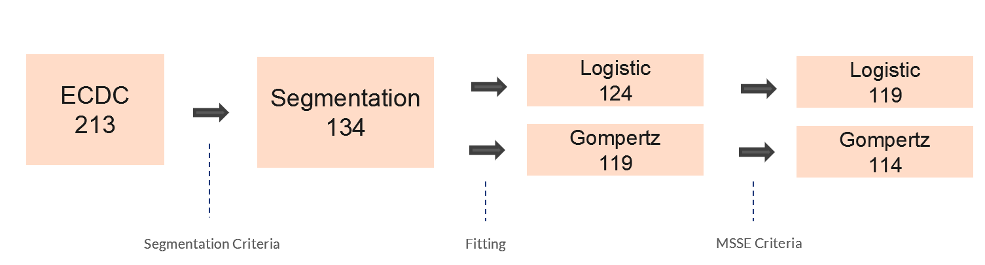

**Fig. 8. Variation of the number countries across segmentation, growth curve models and MSSE criteria**. For segmented logistic model, 124 countries were fitted and for segmented Gompertz model, 119 countries were fitted. To check(validate) the goodness of fit of above 2 models, MSSE (Mean Squared Scaled Error) criteria was employed(used?). For each of two models, 5 countries showed high MSSE, so those 5 countries were excluded in the subsequent analysis (Aruba, Equatorial Guinea, Krygyzstan, Rwanda, Thailand for segmented logistic model and China, Equatorial Guinea, Kyrgyzstan, Rwanda, Zambia for segmented Gompertz model).

**Pseudo-code of Segmentation Algorithm**

Here, we denote $\hat{f}\left(t\right)$ by $Y_{t}$.

|  |
| --- |
| **Algorithm 1** Peak Detection Algorithm |
| $Input: Y_{i} where i∈\{1, 2, ... , t_{max} =274\}$ $Output: I$ 1. (Initialization)  declare where $T=\{1, 2, ... , t_{max} -2\};$ 2. (Local maximum condition)  **while $t=t_{max}-4$** **do**  **if $∆Y_{t}∙∆Y_{t+1}≤0, ∆^{2}Y_{t}≤-c$** **then $I←I ⋃ \{t\}; t←t+1;$**    **end if**  **end while**  3. (Excluding small peaks)  **if $I=∅$** **then**    **end if**  4. (Resolution criteria)  **if $n(I)<2$** **then**  declare *p* = 1,  **while** *p $≤n(I)-1$* **do**  **if ${argmax}_{i ∈ A}Y_{i}≥0.8max\{Y_{k},Y_{k+1}\}$** **then**  **if $Y_{k}≤Y_{k+1}$** **then $I←I-\{I_{k}\};$**    **else $I←I-\{I_{k+1}\};$**    **end if**  **else $k←k+1$**    **end if**  *p $←$* *p+1*  **end if**  5. (Exclude peaks which are vibrations on increasing trend)  **if $n(I)≥1$** **then**  declare ;  **if $z≤{argmin}_{i ∈ L}Y_{i}$** **then $I←I-\{z\}$**    **end if**  **end if** |

|  |
| --- |
| **Algorithm 2** Breakpoint Detection Algorithm |
| $Input: Y_{i} where i∈\{1, 2, ... , t_{max} =274\}$ $Output: B$ 1. (Initialization)  declare  2. (Between peaks)  **if $n(I)≥2$** **then**  **for each $j ∈\{1, 2, ... , (n(I)-1)\}$** **do**  B;  **end do**  **end if**  3.(After the last peak)  declare U  **if $n(I)≥1, n(U)≥5$** **then**  B ;  **end if** |

|  |
| --- |
| **Algorithm 2** Breakpoint Detection Algorithm |
| $Input: Y_{i} where i∈\{1, 2, ... , t_{max} =274\}$ $Output: B$ 1. (Initialization)  declare  2. (Between peaks)  **if $n(I)≥2$** **then**  **for each $j ∈\{1, 2, ... , (n(I)-1)\}$** **do**  B;  **end do**  **end if**  3.(After the last peak)  declare U  **if $n(I)≥1, n(U)≥5$** **then**  B ;  **end if** |

**Fig. S1.** Pseudo-codes for the Segmentation Algorithm

**Segmentation Results**

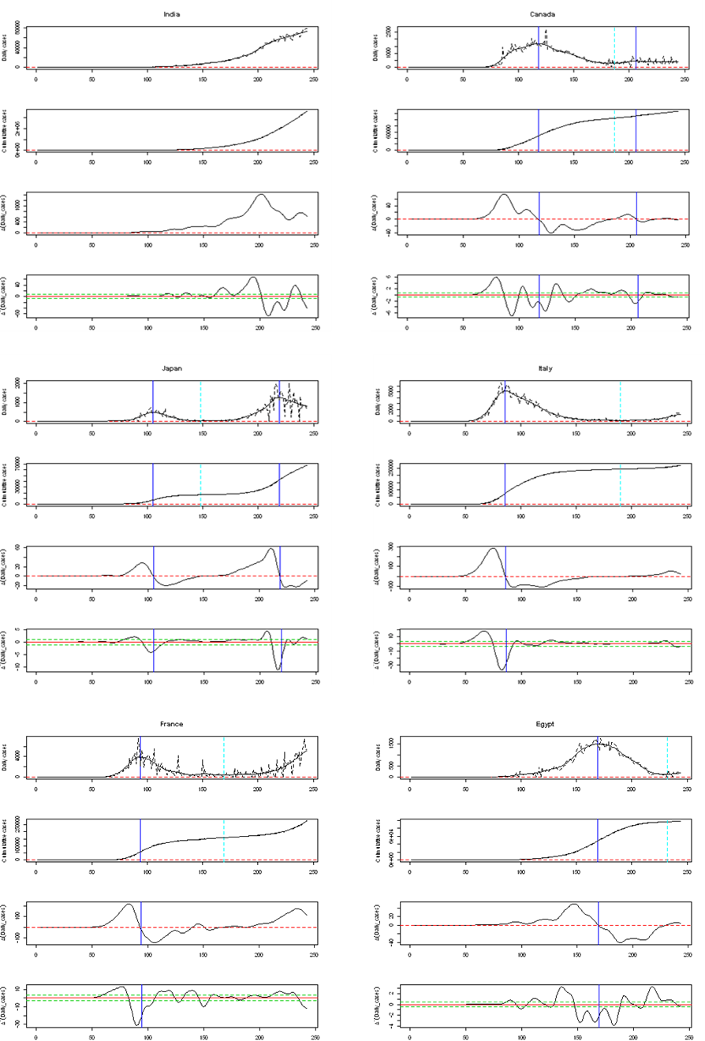

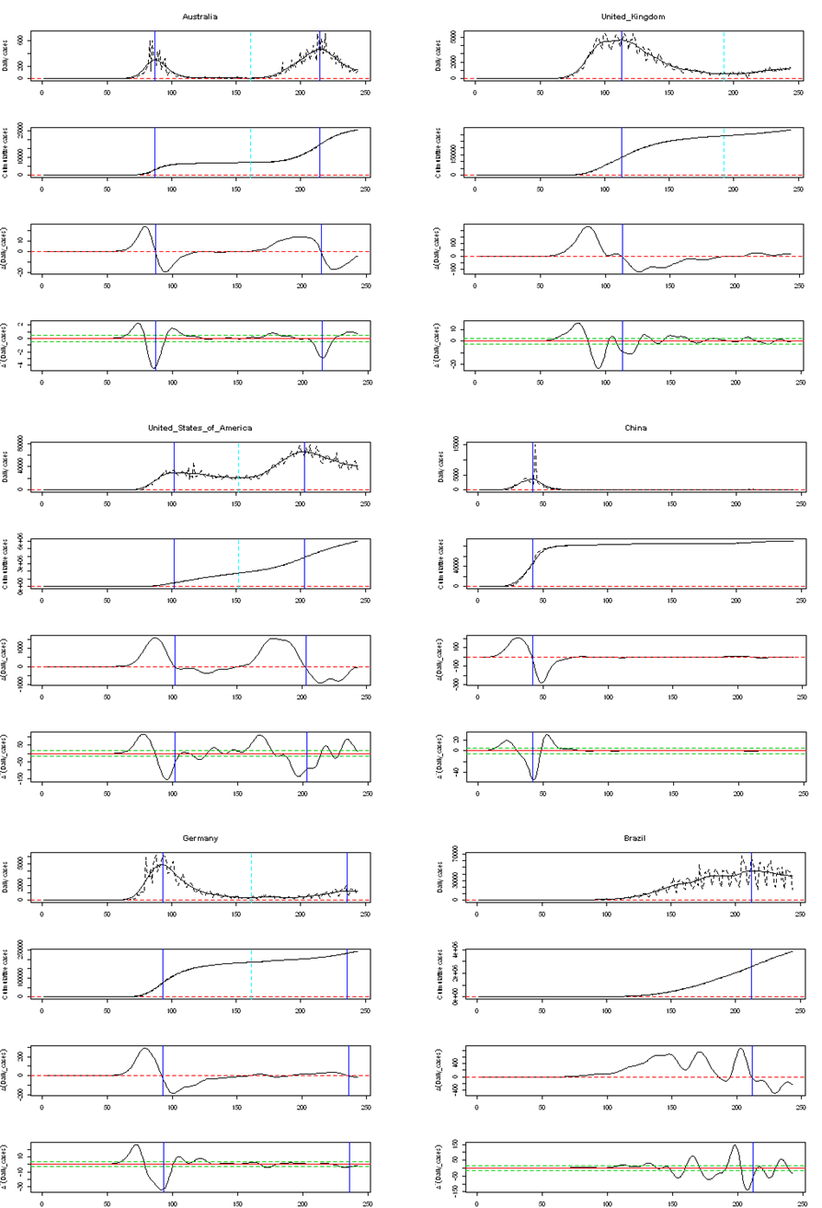

**Figure S2: The segmentation results for ten countries from the Segmentation Algorithm**. For each country, blue line represents the peak and dotted sky-blue line represents breakpoint. In the 1st plot, black solid line represents and black dotted line represents . The 2nd plot represents cumulative confirmed cases of (black dotted line), (black solid line). 3rd, 4th plots are graphs of . In 4th plot, green dotted line represents sensitivity level. If $∆^{2}\hat{f}(t)$ is above the upper green dotted line, $\hat{f}(t)$ is concave. On the other hand, if $∆^{2}\hat{f}(t)$ is below the lower green dotted line, $\hat{f}(t)$ is convex.

**Results from the segment growth curve models**

|  |  |  |  |  |  |  |  |  |
| --- | --- | --- | --- | --- | --- | --- | --- | --- |
| **Segmented Logistic Model** | | | | | | | | |
|  |  | **1st Segment** | | | **2nd Segment** | | |  |
| **Country** | **Maximum Cumulative cases** | $$α$$ | $$β$$ | $$γ$$ | $$α$$ | $$β$$ | $$γ$$ | **MSSE** |
| Afghanistan | 38162 | 37269.8509 | 5.6770 | 0.0743 | NA | NA | NA | 0.0285 |
| Albania | 9380 | 29521.2462 | 5.3078 | 0.0268 | NA | NA | NA | 0.0292 |
| Algeria | 44146 | 12006.8756 | 3.7504 | 0.0622 | 34805.8852 | 3.8383 | 0.0758 | 0.0296 |
| Angola | 2624 | 3210.7931 | 5.3484 | 0.0605 | NA | NA | NA | 0.1101 |
| Argentina | 401226 | 648605.7127 | 7.0822 | 0.0434 | NA | NA | NA | 0.0253 |
| Armenia | 43750 | 43766.2039 | 5.5276 | 0.0542 | NA | NA | NA | 0.0164 |
| Aruba | 1997 | 2036.3519 | 23.7171 | 0.1651 | NA | NA | NA | 0.4136 |
| Australia | 25670 | 6874.2219 | 5.5232 | 0.1993 | 19130.8848 | 5.7873 | 0.1019 | 0.0723 |
| Austria | 27218 | 15908.5183 | 4.2740 | 0.1596 | 16850.1551 | 3.8620 | 0.0498 | 0.1512 |
| Azerbaijan | 36309 | 39349.2968 | 5.7054 | 0.0523 | 2314.9887 | 3.1543 | 0.3069 | 0.0355 |
| Bahamas | 2167 | 2725.7862 | 11.5786 | 0.0902 | NA | NA | NA | 0.1529 |
| Bahrain | 51574 | 52482.2417 | 5.2532 | 0.0432 | NA | NA | NA | 0.0522 |
| Bangladesh | 310822 | 309918.2068 | 4.8411 | 0.0488 | NA | NA | NA | 0.0632 |
| Belarus | 71687 | 67674.9628 | 4.3724 | 0.0640 | 3143.6539 | 3.1136 | 0.2155 | 0.0513 |
| Belgium | 85442 | 59026.3230 | 4.1785 | 0.1002 | 25594.5256 | 4.4737 | 0.0989 | 0.0589 |
| Bolivia | 115968 | 136119.5696 | 5.7989 | 0.0465 | NA | NA | NA | 0.0150 |
| Bosnia and Herzegovina | 19789 | NA | NA | NA | NA | NA | NA | NA |
| Brazil | 3862311 | 4453662.2090 | 5.5266 | 0.0408 | NA | NA | NA | 0.0335 |
| Bulgaria | 16190 | 2847.4247 | 3.4207 | 0.0696 | 14226.6135 | 4.0922 | 0.0691 | 0.0347 |
| Cameroon | 19142 | 21027.7178 | 4.5991 | 0.0509 | 6228.8127 | 2.3642 | 0.1062 | 0.2697 |
| Canada | 127940 | 102198.2467 | 4.1626 | 0.0711 | 23205.5724 | 2.7602 | 0.0880 | 0.0676 |
| Cape Verde | 3852 | 451.6892 | 3.0462 | 0.1095 | 3709.0145 | 3.4858 | 0.0529 | 0.0886 |
| Central African Republic | 4700 | 4681.4703 | 4.6191 | 0.0867 | NA | NA | NA | 0.0584 |
| Chile | 409974 | 386213.7660 | 6.2397 | 0.0635 | NA | NA | NA | 0.1951 |
| China | 89868 | 84438.2778 | 5.2721 | 0.1958 | NA | NA | NA | 0.3252 |
| Colombia | 607938 | 1028559.6439 | 7.1185 | 0.0441 | NA | NA | NA | 0.0114 |
| Congo | 3979 | 4512.6300 | 5.1438 | 0.0508 | NA | NA | NA | 0.2155 |
| Costa Rica | 39699 | 53094.5266 | 8.5012 | 0.0555 | NA | NA | NA | 0.0682 |
| Cote’ d Ivoire | 17948 | 19182.4988 | 5.3947 | 0.0525 | 889.9903 | 3.0251 | 0.3372 | 0.0898 |
| Croatia | 10123 | 2171.0152 | 3.1237 | 0.1317 | 13184.8289 | 4.3545 | 0.0482 | 0.2648 |
| Cuba | 3973 | 1856.7584 | 3.4571 | 0.1238 | 424.2954 | 3.0161 | 0.1868 | 0.0354 |
| Czechia | 24367 | 8425.2168 | 3.4373 | 0.1147 | 20390.7458 | 3.6332 | 0.0476 | 0.1193 |
| Democratic Republic of the Congo | 10044 | 9704.1760 | 4.8552 | 0.0575 | 208.7552 | 3.3273 | 0.6117 | 0.0521 |
| Denmark | 16700 | 12229.4185 | 3.0248 | 0.0747 | 4665.2456 | 4.2840 | 0.1044 | 0.1107 |
| Djibouti | 5385 | 1051.5098 | 4.9399 | 0.3115 | 3980.2177 | 4.0720 | 0.1357 | 0.2622 |
| Dominican Republic | 94241 | 143968.8886 | 4.5142 | 0.0321 | NA | NA | NA | 0.0887 |
| Ecuador | 117639 | 41796.9588 | 5.4738 | 0.1175 | 84434.3146 | 3.0774 | 0.0511 | 0.2161 |
| Egypt | 98727 | 99949.4036 | 6.4644 | 0.0618 | NA | NA | NA | 0.0104 |
| El Salvador | 25729 | 34877.7380 | 5.4834 | 0.0438 | NA | NA | NA | 0.0450 |
| Equatorial Guinea | 4941 | 1692.8579 | 3.5291 | 0.0881 | 1949.5310 | 5.0940 | 0.2163 | 0.6387 |
| Estonia | 2373 | 1856.0023 | 2.6937 | 0.1019 | 534.2583 | 4.6425 | 0.0788 | 0.2039 |
| Eswatini | 4561 | 6353.9951 | 5.1505 | 0.0475 | NA | NA | NA | 0.0585 |
| Ethiopia | 51122 | NA | NA | NA | NA | NA | NA | NA |
| Finland | 8077 | 7134.7878 | 3.2117 | 0.0755 | 1033.3456 | 4.0422 | 0.0980 | 0.0628 |
| France | 278709 | 147092.5435 | 4.6031 | 0.1069 | NA | NA | NA | 0.1265 |
| Gabon | 8505 | 3546.9607 | 5.1536 | 0.1172 | 2908.7589 | 3.0856 | 0.1821 | 0.0465 |
| Gambia | 2963 | 3105.6876 | 6.4323 | 0.1387 | NA | NA | NA | 0.0751 |
| Georgia | 1487 | 175285.9159 | 4.7540 | 0.1159 | 152925.9558 | 3.6806 | 0.0373 | 0.0995 |
| Germany | 242381 | 9712.5829 | 5.4931 | 0.1023 | 41388.5308 | 3.5723 | 0.0616 | 0.1187 |
| Greece | 10134 | 2731.1379 | 3.3367 | 0.1120 | NA | NA | NA | 0.0929 |
| Guam | 1347 | NA | NA | NA | NA | NA | NA | NA |
| Guatemala | 73912 | 80489.4110 | 6.0005 | 0.0525 | NA | NA | NA | 0.0586 |
| Guinea | 9371 | 5303.4292 | 3.3438 | 0.0680 | 4510.1775 | 2.8192 | 0.0736 | 0.0819 |
| Haiti | 8209 | 7622.6502 | 4.7753 | 0.0824 | NA | NA | NA | 0.1544 |
| Honduras | 60174 | 56907.2114 | 6.3830 | 0.0564 | 11520.8129 | 3.0437 | 0.2570 | 0.0551 |
| Hungary | 5961 | 3964.0412 | 3.4650 | 0.0889 | 4036.5004 | 4.4656 | 0.0535 | 0.2645 |
| Iceland | 2105 | 1782.3982 | 4.3145 | 0.1763 | 478.7850 | 7.1262 | 0.0717 | 0.1771 |
| India | 3621245 | 6765888.4642 | 7.1224 | 0.0410 | NA | NA | NA | 0.0045 |
| Indonesia | 172053 | 245161.5902 | 4.7788 | 0.0316 | NA | NA | NA | 0.0201 |
| Iran | 373570 | 94307.3179 | 4.5510 | 0.1102 | 279269.4435 | 2.9052 | 0.0432 | 0.0531 |
| Iraq | 231177 | 286347.3795 | 7.2230 | 0.0466 | NA | NA | NA | 0.0971 |
| Ireland | 28760 | 25830.5125 | 4.2620 | 0.1063 | NA | NA | NA | 0.1508 |
| Honduras | 60174 | 16392.4036 | 4.3321 | 0.1391 | 81068.1196 | 6.1544 | 0.0895 | 0.0666 |
| Italy | 268366 | 234107.3748 | 4.0454 | 0.0874 | 152109.5321 | 4.8147 | 0.0551 | 0.1475 |
| Jamaica | 2357 | NA | NA | NA | NA | NA | NA | NA |
| Japan | 67865 | 16549.7588 | 7.8244 | 0.1231 | 58877.8030 | 6.7353 | 0.0859 | 0.0472 |
| Kazakhstan | 130673 | NA | NA | NA | NA | NA | NA | NA |
| Kenya | 34057 | 44506.1507 | 6.7577 | 0.0519 | NA | NA | NA | 0.0686 |
| Kosovo | 13334 | 19149.3567 | 5.9962 | 0.0424 | NA | NA | NA | 0.1251 |
| Kuwait | 84636 | 67873.6972 | 5.5275 | 0.0521 | 16566.5209 | 2.7567 | 0.1815 | 0.1562 |
| Kyrgyzstan | 43898 | 43306.2180 | 14.1798 | 0.1217 | NA | NA | NA | 1.0229 |
| Lebanon | 16870 | NA | NA | NA | NA | NA | NA | NA |
| Luxembourg | 8010 | 50974.5449 | 8.4007 | 0.0547 | NA | NA | NA | 0.0772 |
| Madagascar | 14843 | 3849.0711 | 3.0137 | 0.1560 | 3829.1249 | 5.4731 | 0.1022 | 0.1072 |
| Malawi | 5536 | 15669.2011 | 9.1087 | 0.0789 | NA | NA | NA | 0.0803 |
| Malaysia | 9334 | 427.7014 | 7.2719 | 0.2915 | 5118.5363 | 3.6000 | 0.0826 | 0.0599 |
| Maldives | 7667 | 6372.3634 | 3.9217 | 0.1149 | 2242.5502 | 2.1243 | 0.0925 | 0.2918 |
| Luxembourg | 8010 | 2220.3578 | 3.0390 | 0.0913 | 6468.6466 | 4.3292 | 0.0850 | 0.1165 |
| Mauritania | 7022 | 6640.6373 | 3.9054 | 0.0898 | NA | NA | NA | 0.1372 |
| Mexico | 641442 | 718779.9196 | 5.0133 | 0.0393 | NA | NA | NA | 0.0171 |
| Moldova | 36700 | 30054.5755 | 3.7987 | 0.0377 | 21681.3023 | 2.9687 | 0.0787 | 0.0713 |
| Montenegro | 4790 | 5040.4658 | 9.0828 | 0.0713 | 555.1335 | 3.0227 | 0.4366 | 0.3103 |
| Morocco | 61399 | NA | NA | NA | NA | NA | NA | NA |
| Mozambique | 3821 | 8769.4296 | 4.7192 | 0.0336 | NA | NA | NA | 0.0722 |
| Namibia | 7365 | 19752.6493 | 4.6521 | 0.0557 | NA | NA | NA | 0.0369 |
| Nepal | 38561 | 18780.2065 | 6.6411 | 0.1098 | 30689.6636 | 4.1320 | 0.1019 | 0.0727 |
| Netherlands | 70071 | 47727.8050 | 3.8502 | 0.0920 | 21992.4891 | 4.7197 | 0.1103 | 0.0793 |
| New Zealand | 1387 | 1117.4873 | 3.3022 | 0.2346 | NA | NA | NA | 0.0959 |
| Nicaragua | 4494 | 4483.4442 | 2.0435 | 0.0494 | NA | NA | NA | 0.2250 |
| Niger | 1176 | 56771.2201 | 4.7597 | 0.0449 | NA | NA | NA | 0.0283 |
| Nigeria | 53865 | 1555.4972 | 3.4741 | 0.1320 | 12680.0369 | 3.8436 | 0.0549 | 0.0639 |
| Norway | 10543 | 8479.5156 | 3.2578 | 0.1023 | 1761.7727 | 4.5090 | 0.1300 | 0.1522 |
| Oman | 85544 | 89246.7641 | 6.5958 | 0.0616 | NA | NA | NA | 0.0878 |
| Pakistan | 295849 | 294439.8470 | 6.1567 | 0.0648 | NA | NA | NA | 0.0493 |
| Palestine | 29063 | 30248.6952 | 9.1084 | 0.0669 | NA | NA | NA | 0.1613 |
| Panama | 92065 | 117314.2780 | 4.9029 | 0.0364 | NA | NA | NA | 0.0192 |
| Paraguay | 17195 | NA | NA | NA | NA | NA | NA | NA |
| Peru | 647166 | 314970.4317 | 5.4482 | 0.0677 | 452678.9916 | 3.2689 | 0.0727 | 0.0345 |
| Philippines | 217396 | 7709617.3043 | 8.6352 | 0.0295 | NA | NA | NA | 0.1425 |
| Poland | 66870 | 37617.3841 | 3.2568 | 0.0471 | 37253.0201 | 3.3748 | 0.0810 | 0.0678 |
| Portugal | 57929 | 27725.1980 | 3.9706 | 0.1185 | 24053.6845 | 2.7848 | 0.0663 | 0.0624 |
| Puerto Rico | 32848 | 13037.7613 | 3.5594 | 0.0398 | 30810.2729 | 3.9246 | 0.0771 | 0.0734 |
| Qatar | 118575 | 114154.2700 | 5.3173 | 0.0617 | NA | NA | NA | 0.0291 |
| Romania | 86785 | 18736.0502 | 3.8730 | 0.0867 | 88299.9668 | 4.3176 | 0.0575 | 0.0456 |
| Russia | 990326 | 944933.9504 | 4.0525 | 0.0441 | NA | NA | NA | 0.1218 |
| Rwanda | 4020 | 8246.7708 | 4.9188 | 0.0283 | NA | NA | NA | 0.7079 |
| Saudi Arabia | 314821 | 320470.6504 | 5.0217 | 0.0474 | NA | NA | NA | 0.0383 |
| Senegal | 13556 | 14520.3585 | 3.8986 | 0.0356 | NA | NA | NA | 0.0869 |
| Serbia | 31365 | 10889.8012 | 4.6659 | 0.1250 | 20573.9984 | 4.3379 | 0.0792 | 0.0281 |
| Singapore | 56771 | 43064.6037 | 6.9493 | 0.0763 | 12182.6864 | 3.2260 | 0.1319 | 0.1479 |
| Slovakia | 3876 | 1502.3267 | 3.6374 | 0.1185 | 5628.8348 | 4.9385 | 0.0493 | 0.1520 |
| South Africa | 625056 | 657770.4040 | 8.8676 | 0.0697 | NA | NA | NA | 0.0165 |
| South Korea | 19947 | 10142.9519 | 3.1675 | 0.1737 | NA | NA | NA | 0.3329 |
| South Sudan | 2519 | 2034.9156 | 3.9351 | 0.1254 | 357.7103 | 3.2445 | 0.1936 | 0.1939 |
| Spain | 463943 | 232080.0683 | 4.5993 | 0.1206 | 519213.3489 | 5.8299 | 0.0646 | 0.1405 |
| Sudan | 13189 | 11334.2564 | 3.7113 | 0.0706 | 1447.2698 | 3.2426 | 0.2058 | 0.0992 |
| Suriname | 4009 | 6441.6655 | 4.3439 | 0.0529 | NA | NA | NA | 0.0399 |
| Sweden | 84233 | 88955.5267 | 3.6997 | 0.0388 | 9247.8436 | 2.9268 | 0.1461 | 0.0963 |
| Switzerland | 41906 | 30089.0565 | 4.3551 | 0.1421 | 16542.9808 | 4.3765 | 0.0534 | 0.0856 |
| Syria | 2703 | NA | NA | NA | NA | NA | NA | NA |
| Tajikistan | 8550 | 7809.6500 | 2.2830 | 0.0596 | NA | NA | NA | 0.2877 |
| Thailand | 3412 | 3129.1627 | 4.0437 | 0.1363 | NA | NA | NA | 0.4098 |
| Trinidad and Tobago | 1683 | NA | NA | NA | NA | NA | NA | NA |
| Tunisia | 3685 | 994.4882 | 2.9592 | 0.1432 | NA | NA | NA | 0.0916 |
| Turkey | 268546 | 198451.0508 | 2.9024 | 0.0638 | 50313.2130 | 2.8069 | 0.1128 | 0.2541 |
| Uganda | 3044 | 1077.7651 | 5.6711 | 0.0898 | NA | NA | NA | 0.2300 |
| Ukraine | 119074 | 202167.8426 | 3.9370 | 0.0252 | NA | NA | NA | 0.1084 |
| United Arab Emirates | 69690 | 60073.5725 | 4.2690 | 0.0514 | 8839.0863 | 3.0765 | 0.1818 | 0.0853 |
| United Kingdom | 334467 | 277495.8516 | 4.2224 | 0.0742 | 56759.8300 | 2.9675 | 0.0747 | 0.0735 |
| United States of America | 5997163 | 1683559.9636 | 5.2804 | 0.0846 | 4524204.7065 | 3.5090 | 0.0614 | 0.0656 |
| Uzbekistan | 41651 | 71893.9253 | 5.8737 | 0.0390 | NA | NA | NA | 0.0910 |
| Venezuela | 45868 | 101429.9411 | 7.4504 | 0.0446 | NA | NA | NA | 0.1045 |
| Zambia | 12025 | 25961.2086 | 6.1123 | 0.0441 | NA | NA | NA | 0.2871 |
| Zimbabwe | 6412 | 7030.4941 | 6.1792 | 0.0805 | NA | NA | NA | 0.1369 |

**Table S1: Parameter values estimated from segmented Logistic model**. $α$ is the maximum number of predicted cumulative confirmed cases, $β$ is the time when we start to see a rise in the number of confirmed cases, $γ$ is the increase rate of the number of confirmed cases. NA indicates no values returned due to failure of the model to converge.

|  |  |  |  |  |  |  |  |  |
| --- | --- | --- | --- | --- | --- | --- | --- | --- |
|  | **Segmented Gompertz Model** | | | | | | | |
|  |  | **1st Segment** | | | **2nd Segment** | | |  |
| **Country** | **Maximum Cumulative cases** | $$α$$ | $$β$$ | $$γ$$ | $$α$$ | $$β$$ | $$γ$$ | **MSSE** |
| Afghanistan | 38162 | 38658.2222 | 25.0726 | 0.0471 | NA | NA | NA | 0.0609 |
| Albania | 9380 | NA | NA | NA | NA | NA | NA | NA |
| Algeria | 44146 | 18438.6969 | 5.2016 | 0.0253 | 44055.5472 | 5.8284 | 0.0364 | 0.0254 |
| Angola | 2624 | 8050.2783 | 8.3479 | 0.0185 | NA | NA | NA | 0.0974 |
| Argentina | 401226 | 4066522.7272 | 12.0418 | 0.0096 | NA | NA | NA | 0.0173 |
| Armenia | 43750 | 49098.8425 | 16.6368 | 0.0300 | NA | NA | NA | 0.0340 |
| Aruba | 1997 | NA | NA | NA | NA | NA | NA | NA |
| Australia | 25670 | 6951.4440 | 25.7079 | 0.1324 | 23230.6065 | 15.4190 | 0.0505 | 0.0557 |
| Austria | 27218 | 16155.0090 | 11.0045 | 0.1050 | 52770.0104 | 5.5194 | 0.0142 | 0.0947 |
| Azerbaijan | 36309 | 57315.1635 | 11.6912 | 0.0219 | 3083.2804 | 4.2461 | 0.1430 | 0.1164 |
| Bahamas | 2167 | 5701.9544 | 75.2460 | 0.0308 | NA | NA | NA | 0.1588 |
| Bahrain | 51574 | 66098.9116 | 11.4035 | 0.0207 | NA | NA | NA | 0.0264 |
| Bangladesh | 310822 | 382000.1473 | 9.6930 | 0.0240 | NA | NA | NA | 0.0181 |
| Belarus | 71687 | 71550.0996 | 10.0480 | 0.0389 | 5377.0525 | 4.1283 | 0.0834 | 0.0226 |
| Belgium | 85442 | 60644.2641 | 9.9910 | 0.0647 | 36686.9561 | 7.1235 | 0.0421 | 0.0271 |
| Bolivia | 115968 | 227156.0219 | 11.1086 | 0.0177 | NA | NA | NA | 0.0234 |
| Bosnia and Herzegovina | 19789 | NA | NA | NA | NA | NA | NA | NA |
| Brazil | 3862311 | 7198325.5242 | 10.3171 | 0.0160 | NA | NA | NA | 0.0094 |
| Bulgaria | 16190 | 4232.8425 | 4.5593 | 0.0290 | 17992.4458 | 6.4959 | 0.0330 | 0.0421 |
| Cameroon | 19142 | 108707.0966 | 6.8335 | 0.0119 | 6516.6774 | 3.3445 | 0.0703 | 0.2447 |
| Canada | 127940 | 109946.6392 | 8.5150 | 0.0420 | 27876.8064 | 3.6582 | 0.0460 | 0.0235 |
| Cape Verde | 3852 | 833.7525 | 4.0029 | 0.0399 | 5158.9832 | 4.8344 | 0.0235 | 0.0685 |
| Central African Republic | 4700 | 4833.5213 | 12.9590 | 0.0555 | NA | NA | NA | 0.0936 |
| Chile | 409974 | 415001.2049 | 29.4866 | 0.0376 | NA | NA | NA | 0.1943 |
| China | 89868 | 84708.4919 | 21.1560 | 0.1299 | NA | NA | NA | 0.5822 |
| Colombia | 607938 | 7084799.4030 | 11.9798 | 0.0094 | NA | NA | NA | 0.0533 |
| Congo | 3979 | 6520.0095 | 8.7962 | 0.0208 | NA | NA | NA | 0.3839 |
| Costa Rica | 39699 | 136895.5602 | 22.2936 | 0.0170 | NA | NA | NA | 0.0329 |
| Cote’ d Ivoire | 17948 | 26535.0293 | 10.5070 | 0.0226 | 1163.2906 | 4.0580 | 0.1612 | 0.2006 |
| Croatia | 10123 | 2224.6337 | 5.2293 | 0.0869 | 35557.9695 | 6.2427 | 0.0144 | 0.2303 |
| Cuba | 3973 | 2044.3069 | 5.4702 | 0.0707 | 464.3771 | 4.3821 | 0.1089 | 0.0218 |
| Czechia | 24367 | 8766.2736 | 6.1152 | 0.0727 | 47008.7555 | 5.0086 | 0.0155 | 0.0728 |
| Democratic Republic of the Congo | 10044 | 10736.4218 | 11.8301 | 0.0324 | 274.5472 | 4.6493 | 0.2899 | 0.0508 |
| Denmark | 16700 | 12688.0788 | 4.8168 | 0.0481 | 8468.0207 | 6.0552 | 0.0374 | 0.0926 |
| Djibouti | 5385 | 1128.0306 | 13.5460 | 0.1842 | 4055.6841 | 8.8338 | 0.0856 | 0.2978 |
| Dominican Republic | 94241 | 494048.5687 | 6.4591 | 0.0086 | NA | NA | NA | 0.1698 |
| Ecuador | 117639 | 48988.1455 | 13.5407 | 0.0597 | 118443.9190 | 4.0637 | 0.0228 | 0.2421 |
| Egypt | 98727 | 112100.7245 | 27.5626 | 0.0341 | 3048.1640 | 3.8200 | 0.1437 | 0.0843 |
| El Salvador | 25729 | 84767.4806 | 8.6124 | 0.0134 | NA | NA | NA | 0.1306 |
| Equatorial Guinea | 4941 | 2947.6606 | 4.7078 | 0.0329 | 2242.6633 | 11.3615 | 0.1124 | 0.6882 |
| Estonia | 2373 | 1898.7892 | 4.0019 | 0.0674 | 2204.7769 | 6.8346 | 0.0199 | 0.1693 |
| Eswatini | 4561 | 19034.0804 | 7.6768 | 0.0133 | NA | NA | NA | 0.1214 |
| Ethiopia | 51122 | NA | NA | NA | NA | NA | NA | NA |
| Finland | 8077 | 7383.6402 | 5.3518 | 0.0485 | 2396.7520 | 5.6497 | 0.0314 | 0.0416 |
| France | 278709 | 151791.8661 | 12.8923 | 0.0683 | NA | NA | NA | 0.0523 |
| Gabon | 8505 | 6670.3765 | 8.3496 | 0.0416 | 3268.2183 | 4.3985 | 0.1016 | 0.0552 |
| Gambia | 2963 | 4460.8609 | 16.3888 | 0.0590 | NA | NA | NA | 0.0822 |
| Georgia | 1487 | 180590.9806 | 14.3623 | 0.0745 | 1399965.8160 | 6.0875 | 0.0076 | 0.0475 |
| Germany | 242381 | 43428.0235 | 8.2229 | 0.0245 | 50878.8766 | 5.1497 | 0.0303 | 0.1860 |
| Greece | 10134 | 2850.2120 | 5.6666 | 0.0705 | NA | NA | NA | 0.0592 |
| Guam | 1347 | NA | NA | NA | NA | NA | NA | NA |
| Guatemala | 73912 | 120849.4230 | 12.8995 | 0.0215 | NA | NA | NA | 0.0557 |
| Guinea | 9371 | 6276.1720 | 4.8603 | 0.0356 | 5896.6630 | 3.6876 | 0.0353 | 0.0422 |
| Haiti | 8209 | 7919.9844 | 14.2064 | 0.0522 | NA | NA | NA | 0.0596 |
| Honduras | 60174 | 94977.9591 | 13.7684 | 0.0214 | 16635.0074 | 4.0325 | 0.1127 | 0.0782 |
| Hungary | 5961 | 4158.2722 | 6.0539 | 0.0554 | 90891.8764 | 7.8593 | 0.0089 | 0.2417 |
| Iceland | 2105 | 1815.9673 | 11.4017 | 0.1168 | 6308.7422 | 11.2834 | 0.0124 | 0.2764 |
| India | 3621245 | 87187036.6787 | 11.8631 | 0.0075 | NA | NA | NA | 0.0204 |
| Indonesia | 172053 | 798318.0620 | 7.0186 | 0.0087 | NA | NA | NA | 0.0084 |
| Iran | 373570 | 118567.0986 | 7.9497 | 0.0523 | 348087.8281 | 3.8623 | 0.0216 | 0.0349 |
| Iraq | 231177 | 565000.6425 | 17.3186 | 0.0163 | NA | NA | NA | 0.0389 |
| Ireland | 28760 | 26103.4687 | 11.1085 | 0.0707 | NA | NA | NA | 0.1597 |
| Honduras | 60174 | 17138.7762 | 10.4599 | 0.0872 | 125660.9635 | 13.5198 | 0.0359 | 0.0430 |
| Italy | 268366 | 239477.4394 | 9.4656 | 0.0574 | NA | NA | NA | 0.0219 |
| Jamaica | 2357 | NA | NA | NA | NA | NA | NA | NA |
| Japan | 67865 | 17531.5024 | 89.4251 | 0.0760 | 98622.3568 | 15.6933 | 0.0325 | 0.0955 |
| Kazakhstan | 130673 | NA | NA | NA | NA | NA | NA | NA |
| Kenya | 34057 | 99124.7710 | 13.0280 | 0.0165 | NA | NA | NA | 0.1973 |
| Kosovo | 13334 | 79700.2167 | 9.2221 | 0.0103 | NA | NA | NA | 0.2460 |
| Kuwait | 84636 | 82441.1292 | 14.3643 | 0.0264 | 20197.2297 | 3.6386 | 0.0935 | 0.0725 |
| Kyrgyzstan | 43898 | 45547.7268 | 5355.3572 | 0.0766 | NA | NA | NA | 1.2727 |
| Lebanon | 16870 | NA | NA | NA | NA | NA | NA | NA |
| Luxembourg | 8010 | NA | NA | NA | NA | NA | NA | NA |
| Madagascar | 14843 | 3911.1573 | 5.0182 | 0.1050 | 4326.7213 | 15.6462 | 0.0556 | 0.0534 |
| Malawi | 5536 | 18617.7675 | 91.9470 | 0.0405 | NA | NA | NA | 0.2242 |
| Malaysia | 9334 | 560.8286 | 29.4977 | 0.1370 | 5847.5530 | 5.6631 | 0.0448 | 0.0626 |
| Maldives | 7667 | 6865.9962 | 7.4158 | 0.0678 | 2302.4141 | 2.8881 | 0.0620 | 0.2145 |
| Luxembourg | 8010 | 2481.8562 | 4.3299 | 0.0516 | 13064.4175 | 6.1831 | 0.0290 | 0.0949 |
| Mauritania | 7022 | 6952.5768 | 7.9523 | 0.0559 | NA | NA | NA | 0.1181 |
| Mexico | 641442 | 1078940.7137 | 8.7075 | 0.0161 | NA | NA | NA | 0.0054 |
| Moldova | 36700 | 89476.8616 | 5.3770 | 0.0109 | 33783.2559 | 3.8986 | 0.0326 | 0.0632 |
| Montenegro | 4790 | 7276.4251 | 58.9567 | 0.0315 | 764.5359 | 4.0296 | 0.1998 | 0.3762 |
| Morocco | 61399 | NA | NA | NA | NA | NA | NA | NA |
| Mozambique | 3821 | 87202.3592 | 7.5356 | 0.0066 | NA | NA | NA | 0.0683 |
| Namibia | 7365 | 333497.1922 | 7.8533 | 0.0098 | NA | NA | NA | 0.0363 |
| Nepal | 38561 | 23759.6419 | 21.5334 | 0.0521 | 114201.0768 | 5.9905 | 0.0269 | 0.1086 |
| Netherlands | 70071 | 49107.7894 | 7.9913 | 0.0590 | 38774.5904 | 7.2102 | 0.0405 | 0.0432 |
| New Zealand | 1387 | 1127.1035 | 6.1202 | 0.1598 | NA | NA | NA | 0.0097 |
| Nicaragua | 4494 | 4915.0570 | 2.6343 | 0.0300 | NA | NA | NA | 0.1603 |
| Niger | 1176 | 73615.8370 | 8.6526 | 0.0208 | NA | NA | NA | 0.0222 |
| Nigeria | 53865 | 1874.5592 | 4.9774 | 0.0664 | 15364.7097 | 6.1098 | 0.0278 | 0.0358 |
| Norway | 10543 | 8618.0392 | 5.7781 | 0.0680 | 2843.9925 | 6.8781 | 0.0507 | 0.0812 |
| Oman | 85544 | 100763.2996 | 28.3321 | 0.0334 | NA | NA | NA | 0.1751 |
| Pakistan | 295849 | 313983.3281 | 28.4530 | 0.0386 | NA | NA | NA | 0.1366 |
| Palestine | 29063 | 42050.0663 | 59.6946 | 0.0299 | NA | NA | NA | 0.0633 |
| Panama | 92065 | 260971.5242 | 7.2872 | 0.0116 | NA | NA | NA | 0.0598 |
| Paraguay | 17195 | NA | NA | NA | NA | NA | NA | NA |
| Peru | 647166 | 446214.4655 | 10.7987 | 0.0290 | 846683.9627 | 4.3642 | 0.0264 | 0.0321 |
| Philippines | 217396 | NA | NA | NA | NA | NA | NA | NA |
| Poland | 66870 | 47514.4286 | 4.5190 | 0.0231 | 64104.7074 | 4.5054 | 0.0308 | 0.0361 |
| Portugal | 57929 | 29936.8951 | 7.6538 | 0.0699 | 29015.3918 | 3.6595 | 0.0343 | 0.0215 |
| Puerto Rico | 32848 | 65040.0602 | 5.4168 | 0.0096 | 50324.6920 | 5.5172 | 0.0301 | 0.0745 |
| Qatar | 118575 | 120095.6164 | 18.2530 | 0.0378 | NA | NA | NA | 0.0333 |
| Romania | 86785 | 21563.1947 | 6.5107 | 0.0466 | 216103.4983 | 6.0951 | 0.0177 | 0.0318 |
| Russia | 990326 | 1057244.6747 | 7.5490 | 0.0247 | NA | NA | NA | 0.0380 |
| Rwanda | 4020 | 160397.3892 | 8.3458 | 0.0048 | NA | NA | NA | 0.6512 |
| Saudi Arabia | 314821 | 375527.3377 | 11.0682 | 0.0244 | NA | NA | NA | 0.0589 |
| Senegal | 13556 | 19817.4519 | 5.8206 | 0.0161 | NA | NA | NA | 0.0395 |
| Serbia | 31365 | 11544.5233 | 11.9676 | 0.0755 | 24299.8019 | 7.8757 | 0.0408 | 0.0301 |
| Singapore | 56771 | 46555.2356 | 44.9176 | 0.0451 | 13163.0862 | 4.8592 | 0.0772 | 0.0811 |
| Slovakia | 3876 | 1564.7214 | 6.4994 | 0.0733 | 74539.1570 | 8.0670 | 0.0091 | 0.1994 |
| South Africa | 625056 | 787210.6110 | 75.3165 | 0.0351 | NA | NA | NA | 0.1231 |
| South Korea | 19947 | 10364.8855 | 5.4689 | 0.1147 | NA | NA | NA | 0.1889 |
| South Sudan | 2519 | 2147.1872 | 7.8644 | 0.0767 | 373.3645 | 5.1459 | 0.1199 | 0.2220 |
| Spain | 463943 | 237938.9846 | 13.3300 | 0.0784 | NA | NA | NA | 0.0279 |
| Sudan | 13189 | 12339.0733 | 6.4342 | 0.0410 | 1902.2561 | 4.4326 | 0.0969 | 0.0612 |
| Suriname | 4009 | 29831.0627 | 6.3839 | 0.0128 | NA | NA | NA | 0.0792 |
| Sweden | 84233 | 124252.7248 | 5.2176 | 0.0170 | 11067.5839 | 3.9308 | 0.0759 | 0.1109 |
| Switzerland | 41906 | 30687.3318 | 11.6364 | 0.0936 | 56221.8662 | 6.3637 | 0.0146 | 0.0491 |
| Syria | 2703 | NA | NA | NA | NA | NA | NA | NA |
| Tajikistan | 8550 | 8127.3560 | 3.2065 | 0.0399 | NA | NA | NA | 0.1665 |
| Thailand | 3412 | 3154.1186 | 9.3739 | 0.0897 | NA | NA | NA | 0.2209 |
| Trinidad and Tobago | 1683 | NA | NA | NA | NA | NA | NA | NA |
| Tunisia | 3685 | 1038.2063 | 4.5857 | 0.0915 | NA | NA | NA | 0.0306 |
| Turkey | 268546 | 207933.5885 | 4.5240 | 0.0409 | 68974.9480 | 3.6475 | 0.0517 | 0.1452 |
| Uganda | 3044 | 1188.0377 | 19.7095 | 0.0514 | NA | NA | NA | 0.1800 |
| Ukraine | 119074 | NA | NA | NA | NA | NA | NA | NA |
| United Arab Emirates | 69690 | 67678.3664 | 8.2582 | 0.0283 | 13578.4568 | 4.0506 | 0.0756 | 0.0398 |
| United Kingdom | 334467 | 291405.6852 | 9.4917 | 0.0458 | 99004.9490 | 3.9148 | 0.0286 | 0.0251 |
| United States of America | 5997163 | 1987478.8437 | 13.0915 | 0.0439 | 5952114.1576 | 4.8924 | 0.0284 | 0.0231 |
| Uzbekistan | 41651 | 788275.6765 | 9.1565 | 0.0072 | NA | NA | NA | 0.2148 |
| Venezuela | 45868 | 3551978.5884 | 12.7690 | 0.0067 | NA | NA | NA | 0.1627 |
| Zambia | 12025 | 31660320.7299 | 13.1480 | 0.0038 | NA | NA | NA | 0.4628 |
| Zimbabwe | 6412 | 10189.0969 | 14.4420 | 0.0338 | NA | NA | NA | 0.1983 |

**Table S2: Parameter values estimated from the segmented Gompertz model**. $α$ is the maximum number of predicted cumulative confirmed cases, $β$ is the time when we start to see a rise in the number of confirmed cases, $γ$ is the increase rate of number of confirmed cases. NA indicates no values returned due to failure of the model to converge.

**Correlation analysis between the log-scaled parameters of the Growth curve models.**

Correlation analysis for segmented Logistic and Gompertz models with the log-scaled of parameters are performed to determine the similarity between the parameters across the two models. Before performing the simple linear regression for the growth curve model parameters and the national indicator variables, we interpret the correlation coefficients between model parameters and across segments. The points of focus are whether the tendency of parameter variation is maintained in both Logistic and Gompertz models, and whether the parameters $α,$ $β$ and $γ$ are correlated across segments.

For Logistic models (Figure S3), correlation analysis between parameters $α_{1}$ and $α_{2}$, the maximum number of predicted cumulative confirmed cases in the 1st segment and 2nd segment respectively, have a strong positive correlation of 0.7. On the other hand, it was found that there was little correlation between the parameters $β_{1}$ and $β_{2}$ (-0.089) and in $γ_{1}$ and $γ_{2}$ (-0.32). While for Gompertz models (Figure S4), similar with Logistic model, two parameters $a_{1}$ and $a_{2}$, the maximum number of predicted cumulative confirmed cases in the 1st segment and 2nd segment respectively, have a strong positive correlation (0.57) while there was no correlation between the coefficients $β_{1}$ and $β_{2}$ (0.15), also in $γ_{1}$ and $γ_{2}$ (-0.34).

The parameters $β_{2}$ and $γ_{2}$ have little correlation (-0.069 and 0.077 in the 1st segment, -0.27 and -0.31 in the 2nd segment for Logistic and Gompertz models) that is negligible when analyzing correlation coefficients. However, in the 1st segment, the correlation coefficients between parameters $α_{1}$ and $γ_{1}$ for both Logistic (-0.52) and Gompertz (-0.66) models show that the relationship between the cumulative confirmed cases and the slope of the model has a negative correlation. It is same with the parameters $α_{2}$ and $γ_{2}$ (-0.55 for Logistic model and -0.7 for Gompertz model) in the 2nd segment (Figure S5 and S6).

We can interpret the negative correlation between $α$ and $γ$ with two aspects. The first reason for this correlation is because of social distancing policies that the countries where the pandemic situation had been serious quickly implemented. In other words, when COVID-19 had out broken at first in February and March in 2020, the policies was valid to reduce daily cases. The second one is the opposite case of the above reason. In the countries having had slight incline for COVID-19, they dealt with it relatively easily, so the level of social distancing policies was lower. It caused bad results that the cumulative cases had been continuously increasing.

Therefore, in all the analysis confirms that the parameters have similar interpretation across models.

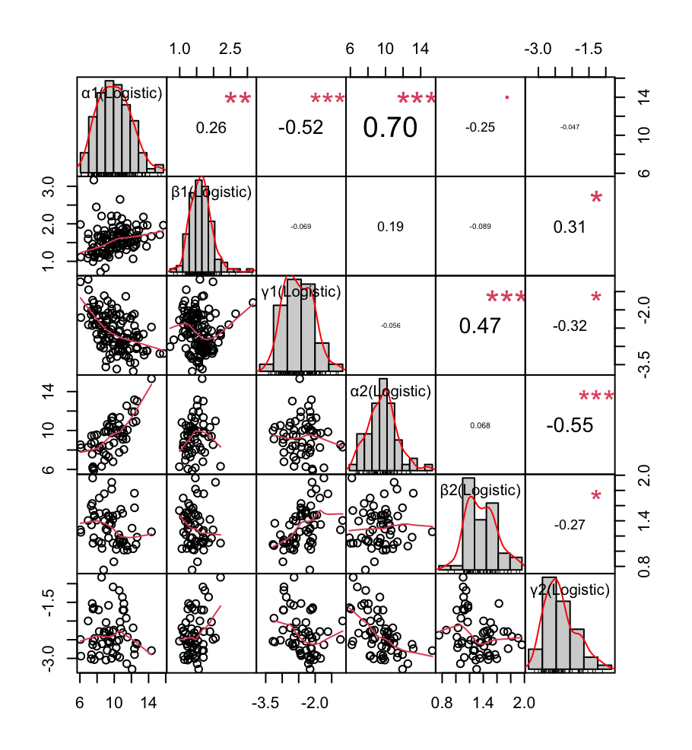

**Figure S3. Comparison of Logistic Model (log-scaled) parameters $α$, $β$, and $γ$ in the 1st and 2nd segments.**

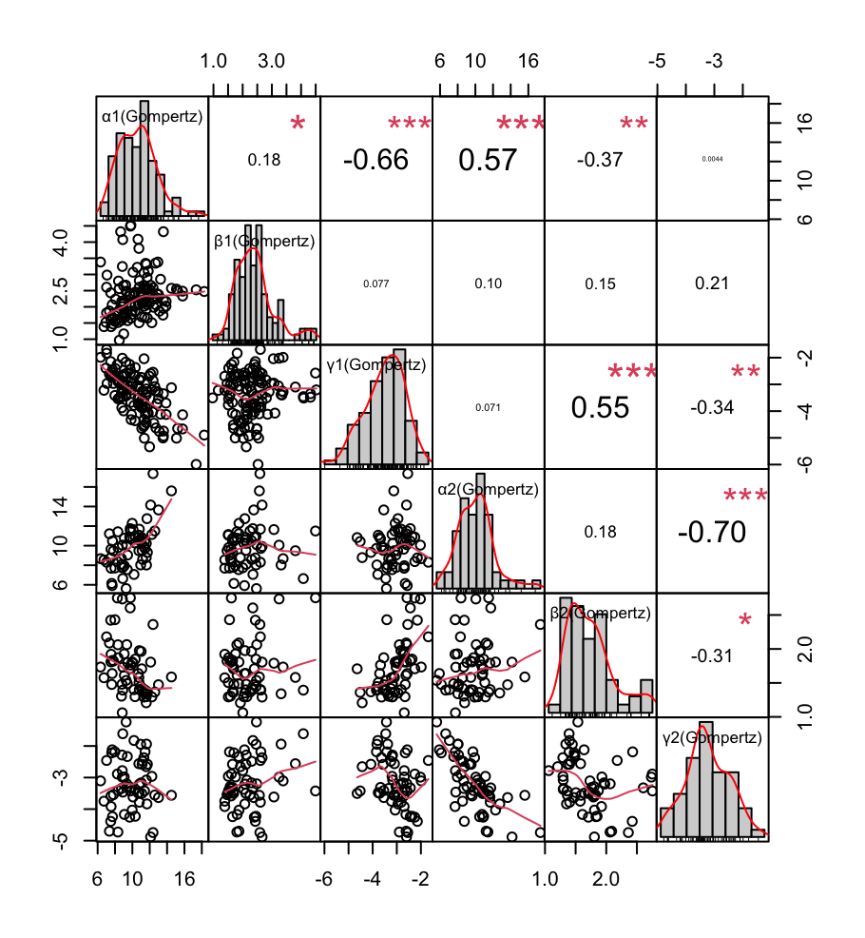

**Figure S4. Comparison of Gompertz Model (log-scaled) parameters $α$, $β$, and $γ$ in the 1st and 2nd segments.**

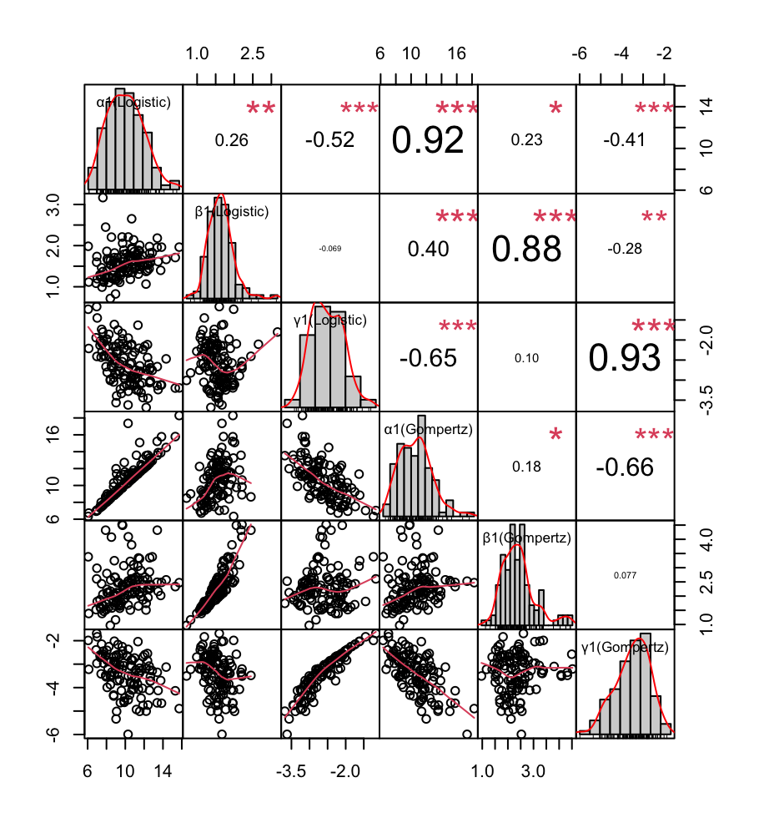

**Figure S5. Comparison of Logistic and Gompertz Model (log-scaled) parameters $α$, $β$, and $γ$ in the 1st segment.**

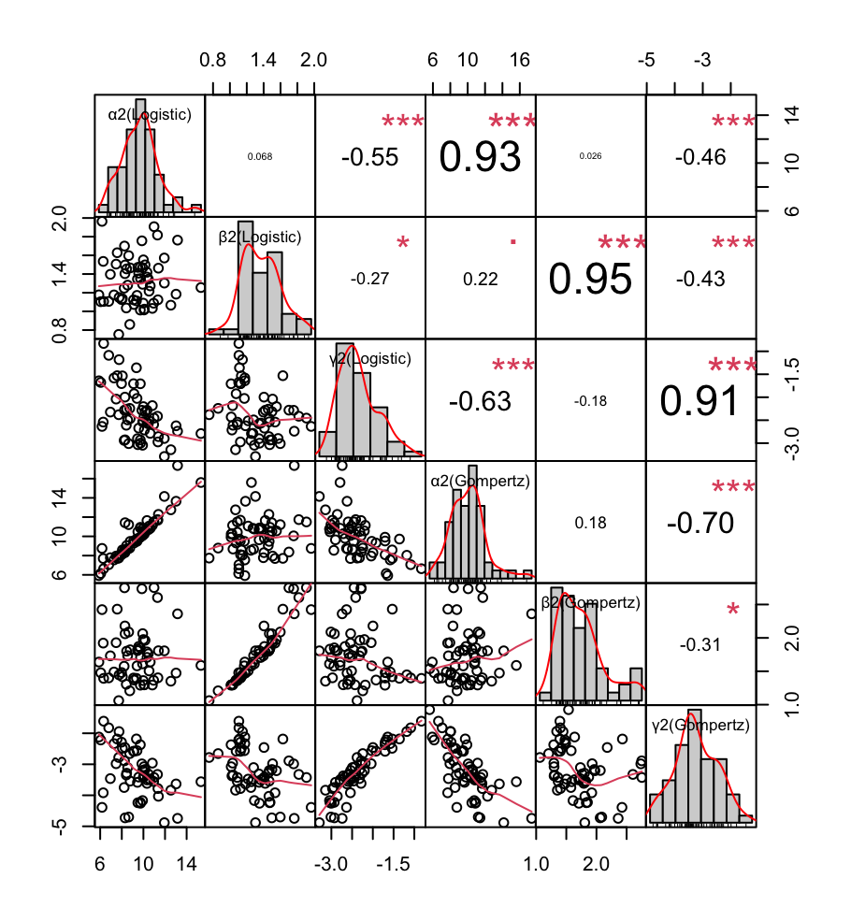

**Figure S6. Comparison of Logistic and Gompertz Model (log-scaled) parameters $α$, $β$, and $γ$ in the 2nd** **segment.**

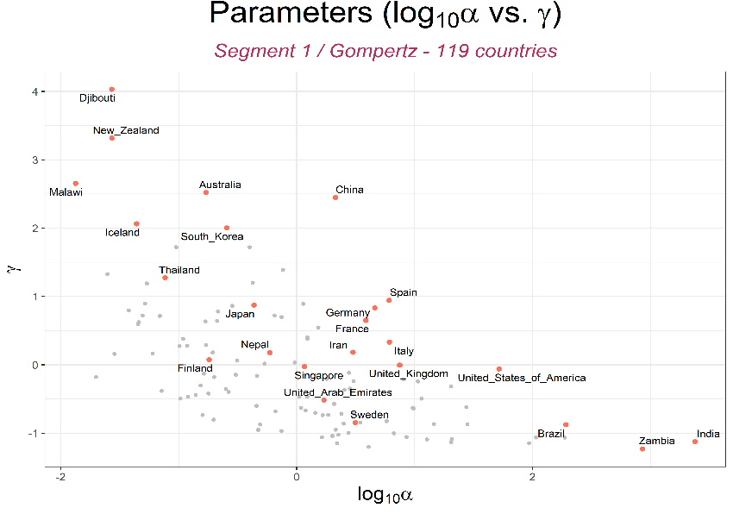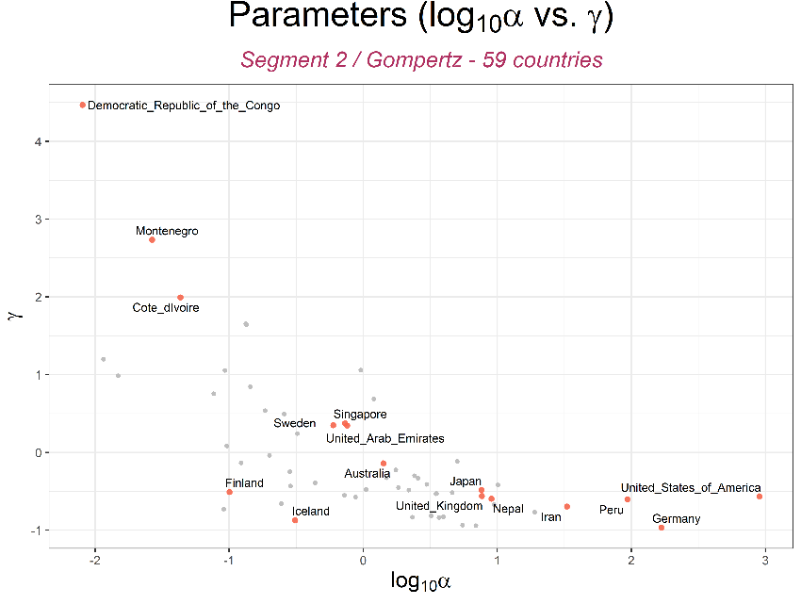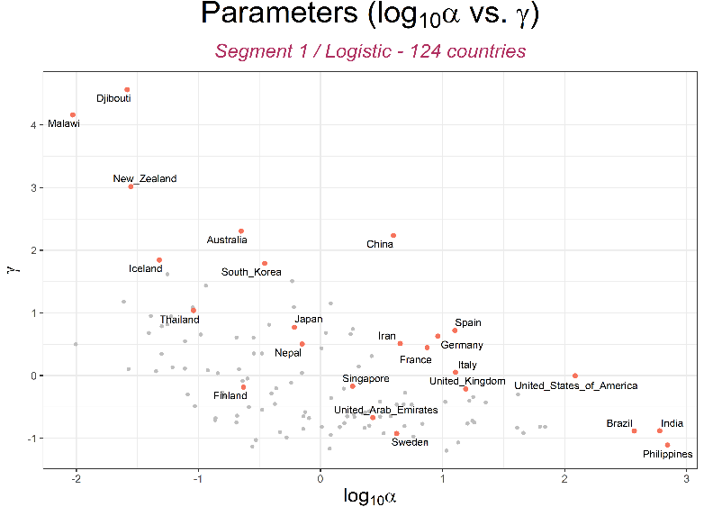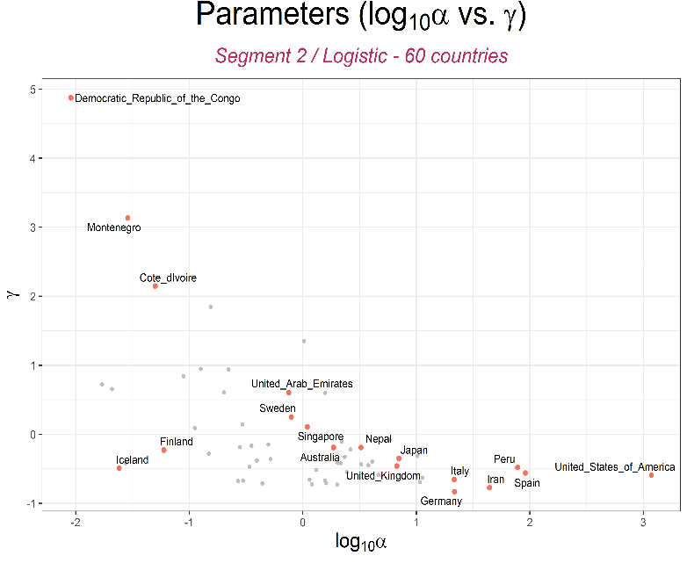

**a**

**b**

**c**

**d**

**Fig. S7. Variation of log10 maximum predicted cumulative cases ($α$) and rate of spread of COVID-19 among countries ($γ$).**

|  |  |  |  |  |  |  |
| --- | --- | --- | --- | --- | --- | --- |
| **Results of Linear regression of parameters of growth curve models and national indicator variables** | | | | | | |
| **Sample size** | **Indicator\Parameter** | | **1st Segment** | | **2nd Segment** | |
| **Logistic** | **Gompertz** | **Logistic** | **Gompertz** |
| 113 | Child Vaccination rate | $$α$$ | -162866.78  (0.1007) | -87309.168  (0.9204) | 22766.7187  (0.8298) | 25628.9405  (0.8583) |
| $$β$$ | -0.2525  (0.099) | -1.7217  (0.2962) | 0.3063  (0.0962) | 0.8224  (0.1163) |
| $$γ$$ | 0.0092  (0.0474) | 0.0063  (0.0646) | -0.0242  (0.1748) | -0.0126  (0.1667) |
| 81 | Malnutrition rate | $$α$$ | 148742.297  (0.2794) | 1106109.04  (0.3232) | -94847.6759  (0.6724) | -140310.632  (0.6461) |
| $$β$$ | 0.6544  (8.18E-05) | 4.7293  (0.0103) | -0.6739  (0.0723) | -1.6175  (0.1359) |
| $$γ$$ | -0.0135  (0.0046) | -0.01125  (0.0013) | 0.0398  (0.1189) | 0.0241  (0.0793) |
| 114 | Migration rate | $$α$$ | -24299.073  (0.8057) | -198330.74  (0.8031) | 14085.0612  (0.8577) | 36207.377  (0.7335) |
| $$β$$ | 0.016  (0.9168) | 0.9332  (0.5355) | 0.0952  (0.4904) | 0.5389  (0.1661) |
| $$γ$$ | 0.0055  (0.2363) | 0.0054  (0.0806) | -0.0037  (0.7824) | -0.0022  (0.7476) |
| 110 | Proportion of urban population | $$α$$ | -76419.969  (0.4555) | -1091047.7  (0.1873) | 61101.784  (0.4972) | 80948.5367  (0.499) |
| $$β$$ | -0.1491  (0.331) | 0.0504  (0.9734) | 0.2846  (0.0661) | 0.9605  (0.0251) |
| $$γ$$ | 0.0043  (0.3689) | 0.0048  (0.1402) | -0.0015  (0.875) | -0.0021  (0.6895) |
| 21 | Public Social Welfare  (2018) | $$α$$ | 30467.2057  (0.062) | 32787.2884  (0.0529) | 26122.6436  (0.4085) | 58126.9043  (0.5323) |
| $$β$$ | 0.02383  (0.8547) | 0.0074  (0.9919) | -0.348  (0.1826) | -0.7516  (0.3451) |
| $$γ$$ | -0.0133  (0.1745) | -0.0092  (0.1876) | 0.0082  (0.2895) | 0.0089  (0.0866) |
| 46 | National Competitiveness  (2020) | $$α$$ | 430277.632  (0.0667) | 1872125.73  (0.3459) | 37310.1995  (0.1115) | 36555.3449  (0.5367) |
| $$β$$ | 0.03348  (0.1389) | 0.589  (0.8188) | 0.0733  (0.7601) | -0.1454  (0.8468) |
| $$γ$$ | -0.0162  (0.0184) | -0.0126  (0.0148) | -0.019  (0.0015) | -0.0106  (0.0073) |
| 89 | Temperature | $$α$$ | 197487.26  (0.1151) | 699067.536  (0.509) | -21204.8904  (0.1513) | -36660.1652  (0.2723) |
| $$β$$ | 0.3798  (0.0165) | 1.537  (0.3739) | -0.2805  (0.0689) | -0.5364  (0.2332) |
| $$γ$$ | -0.0069  (0.2258) | -0.0076  (0.051) | 0.0181  (0.0471) | 0.0092  (0.0712) |
| 89 | Rain | $$α$$ | 271748.495  (0.0284) | -20108.621  (0.9856) | -29052.6804  (0.081) | -45051.5504  (0.2293) |
| $$β$$ | 0.339  (0.0321) | 2.1164  (0.2413) | -0.2067  (0.2422) | -0.2352  (0.6443) |
| $$γ$$ | -0.003  (0.6056) | -0.003  (0.465) | 0.0145  (0.1653) | 0.0069  (0.2324) |
| 24 | Pharmacy Sales  (2018) | $$α$$ | 27315.7182  (0.2034) | 27408.8334  (0.2288) | 43759.1067  (0.0733) | 175788.3545  (0.0066) |
| $$β$$ | 0.7456  (0.0004) | 12.2806  (0.0001) | 0.2278  (0.3962) | 0.9545  (0.2885) |
| $$γ$$ | -0.0033  (0.7381) | -0.0028  (0.6785) | -0.006  (0.3619) | -0.0016  (0.7302) |
| 89 | Exportation  (2016) | $$α$$ | -185522.7  (0.1413) | -1013900.6  (0.322) | -106962.981  (0.212) | -123682.78  (0.2838) |
| $$β$$ | -0.337587  (0.0467) | -0.9287  (0.5576) | -0.0232  (0.8736) | -0.0896  (0.8287) |
| $$γ$$ | 0.0064  (0.1579) | 0.0068  (0.0377) | -0.0034  (0.6923) | -0.0042  (0.3716) |
| 89 | Importation  (2016) | $$α$$ | -93249.215  (0.4609) | -1272023.9  (0.219) | -193259.914  (0.0496) | -249104.359  (0.0621) |
| $$β$$ | -0.4066  (0.0158) | -2.9847  (0.0602) | -0.1065  (0.529) | -0.3803  (0.432) |
| $$γ$$ | -0.0013  (0.7728) | 0.0016  (0.626) | -0.0037  (0.7123) | -0.0063  (0.253) |
| 113 | Total GDP  (2018) | $$α$$ | -21693.095  (0.8283) | -88251.311  (0.9139) | -70033.5848  (0.3859) | -76160.8968  (0.4931) |
| $$β$$ | 0.0277  (0.8578) | -0.501  (0.7455) | 0.094  (0.5079) | 0.3571  (0.3822) |
| $$γ$$ | -0.0018  (0.708) | 0.0007  (0.8238) | 0.0212  (0.1171) | 0.0074  (0.2968) |
| 46 | Travel In  (2017) | $$α$$ | 188185.298  (0.4312) | -1212922.4  (0.5466) | 239740.8481  (0.1434) | 288980.8722  (0.1988) |
| $$β$$ | 0.1928  (0.3844) | -0.367  (0.8885) | 0.1355  (0.5094) | 0.4249  (0.4799) |
| $$γ$$ | 0.0058  (0.3608) | 0.003  (0.497) | 0.0041  (0.5463) | 0.0115  (0.0378) |
| 46 | Travel Out  (2017) | $$α$$ | 166194.703  (0.4904) | 986646.17  (0.6203) | 204980.2878  (0.1889) | 345861.2615  (0.0987) |
| $$β$$ | -0.0916  (0.6826) | -0.6687  (0.7962) | -0.2364  (0.2201) | -0.5431  (0.3354) |
| $$γ$$ | -0.0126  (0.0422) | -0.0088  (0.04) | -0.0004  (0.9499) | -0.0029  (0.5968) |
| 114 | Aging Index  (2020) | $$α$$ | -87431.181  (0.3755) | -529763.62  (0.5089) | 19947.5993  (0.7873) | 50389.1524  (0.6239) |
| $$β$$ | -0.5072  (0.0007) | 0.0891  (0.9533) | 0.4186  (0.0007) | 0.9256  (0.0121) |
| $$γ$$ | 0.0119  (0.0094) | 0.0121  6.83E-05) | -0.0335  (0.0058) | -0.0201  (0.0014) |
| 112 | GDP per Capita  (2019) | $$α$$ | -3.8816  (0.3797) | -28.9139  (0.4185) | 4.5781  (0.1479) | 6.4778  (0.1279) |
| $$β$$ | -1.49E-05  (0.0278) | 4.27E-06  (0.9497) | 1.81E-05  (0.0006) | 5.48E-05  (0.0002) |
| $$γ$$ | 6.36E-07  (0.0018) | 5.86E-07  (1.38E-05) | -9.13E-07  (0.0851) | -5.27E-07  (0.0482) |
| 114 | Birth Rate  (2020) | $$α$$ | -71328.528  (0.471) | -301881.37  (0.7092) | -42729.883  (0.6268) | -69051.085  (0.562) |
| $$β$$ | 0.2595  (0.0886) | 0.323  (0.8332) | -0.3307  (0.0291) | -0.674  (0.1215) |
| $$γ$$ | -0.0059  (0.2088) | -0.0072  (0.0235) | 0.0529  (0.0002) | 0.0298  (2.38E-05) |
| 112 | Population Density | $$α$$ | 16491.3143  (0.9336) | 324103.636  (0.8381) | -35295.5568  (0.7692) | -47977.7212  (0.7685) |
| $$β$$ | 0.3404  (0.2862) | 5.7412  (0.0636) | -0.057  (0.7877) | -0.0689  (0.9088) |
| $$γ$$ | -0.0026  (0.7878) | -0.0006  (0.9235) | -0.0013  (0.9509) | 0.0017  (0.869) |
| 114 | Population | $$α$$ | 144085.33  (5.13E-08) | 30147994.4  (4.07E-48) | 5718315.169  (9.58E-18) | 7460122.241  (1.33E-16) |
| $$β$$ | 0.565  (0.2136) | 0.8402  (0.8906) | -0.2749  (0.8613) | -1.1855  (0.7871) |
| $$γ$$ | 0.0053  (0.6978) | -0.0218  (0.082) | -0.0211  (0.8894) | 0.0233  (0.7626) |
| 118 | Median Age | $$α$$ | -40858.707  (0.6693) | -293347.94  (0.7069) | 36156.7095  (0.6451) | 70324.4081  (0.5157) |
| $$β$$ | -0.5119  (0.0007) | -1.0658  (0.4869) | 0.3978  (0.0029) | 0.8141  (0.0381) |
| $$γ$$ | 0.0103  (0.0233) | 0.0112  (0.0002) | -0.0394  (0.0022) | -0.0239  (0.0003) |
| 117 | Aged 65 older | $$α$$ | -69195.517  (0.4445) | -444210.9  (0.5464) | 35926.7119  (0.6034) | 69689.3055  (0.4656) |
| $$β$$ | -0.5127  (0.0003) | -0.6779347  (0.6398) | 0.4287  (0.0002) | 0.9415  (0.0058) |
| $$γ$$ | 0.01183  (0.0058) | 0.01193  (3.24E-05) | -0.0324  (0.0045) | -0.0199  (0.0007) |
| 116 | Aged 70 older | $$α$$ | -76963.694  (0.395) | -490243.82  (0.5058) | 33132.9659  (0.6302) | 72072.3096  (0.4525) |
| $$β$$ | -0.5203  (0.0003) | -0.7467  (0.6064) | 0.4236  (0.0002) | 0.0345  (0.0063) |
| $$γ$$ | 0.0114  (0.0076) | 0.0118  (4.04E-05) | -0.0318  (0.0051) | -0.0198  (0.0008) |
| 117 | GDP per Capita | $$α$$ | -72600.451  (0.4153) | -578839.61  (0.4211) | 81960.1179  (0.2553) | 118502.3014  (0.2222) |
| $$β$$ | -0.2912  (0.0411) | -0.1546  (0.913) | 0.2956  (0.0171) | 0.9188  (0.0084) |
| $$γ$$ | 0.0074  (0.0823) | 0.0083  (0.004) | -0.0197  (0.1047) | -0.0114  (0.066) |
| 83 | Extreme poverty | $$α$$ | -20797.551  (0.8536) | 621679.112  (0.6259) | -76235.7429  (0.5732) | -97505.2165  (0.5896) |
| $$β$$ | 0.529  (0.0059) | 5.5029  (0.0038) | -0.2832  (0.1732) | -0.5634  (0.3393) |
| $$γ$$ | 0.0013  (0.8401) | -0.0022  (0.6292) | 0.0697  (0.0004) | 0.0341  (0.0007) |
| 117 | Cardiovascular Death | $$α$$ | 35364.2112  (0.7108) | 151720.751  (0.8419) | -76655.7457  (0.3483) | -107128.767  (0.3143) |
| $$β$$ | 0.1663  (0.2642) | 0.6245  (0.6763) | -0.3666  (0.0091) | -0.9235  (0.0164) |
| $$γ$$ | -0.0111  (0.0111) | -0.0082  (0.0066) | 0.0389  (00039) | 0.0203  (0.0022) |
| 117 | Diabetes prevalence | $$α$$ | 83615.5532  (0.4938) | 774400.837  (0.4333) | 101926.4412  (0.3388) | 112135.2213  (0.4086) |
| $$β$$ | 0.2144  (0.277) | 1.3588  (0.4846) | -0.4435  (0.016) | -1.069  (0.0298) |
| $$γ$$ | -0.0106  (0.0704) | -0.0065  (0.1028) | 0.0126  (0.49) | 0.0128  (0.143) |
| 95 | Female Smokers | $$α$$ | -80878.09  (0.4724) | -843124.81  (0.3531) | 24766.822  (0.7737) | 54577.83  (0.6384) |
| $$β$$ | -0.4377  (0.0044) | -0.5464  (0.7142) | 0.2858  (0.0442) | 0.5133  (0.2174) |
| $$γ$$ | 0.0087  (0.0932) | 0.0095  (0.0057) | -0.0025  (0.7954) | -0.0056  (0.2825) |
| 93 | Male Smokers | $$α$$ | -65256.249  (0.6028) | -1056404.7  (0.3089) | -89380.7136  (0.4668) | -109773.08  (0.4962) |
| $$β$$ | -0.2687  (0.1202) | -0.5804  (0.7338) | -0.2111  (0.3013) | -0.7053  (0.2217) |
| $$γ$$ | -0.0042  (0.468) | -0.0004  (0.9236) | 0.0319  (0.0139) | 0.0176  (0.0109) |
| 52 | Handwashing Facilities | $$α$$ | 204992.594  (0.325) | 467873.18  (0.7988) | 6579.7371  (0.2045) | 7136.3648  (0.4027) |
| $$β$$ | 0.0679  (0.7639) | -0.3347  (0.887) | 0.1928  (0.1339) | 0.2958  (0.2666) |
| $$γ$$ | -0.0066  (0.2888) | -0.001  (0.7875) | -0.041  (0.2382) | -0.0172  (0.2845) |
| 105 | Hospital Beds per Thousand | $$α$$ | -144568.79  (0.157) | -947703.31  (0.2634) | -41472.5662  (0.6042) | -13167.3972  (0.9029) |
| $$β$$ | -0.4366  (0.0052) | 0.1302  (0.9351) | 0.3215  (0.0182) | 0.9459  (0.0141) |
| $$γ$$ | 0.0091  (0.0592) | 0.009  (0.0061) | -0.0047  (0.6166) | -0.0065  (0.2003) |
| 117 | Life Expectancy | $$α$$ | -26753.176  (0.7852) | -410006.48  (0.6054) | 50338.9611  (0.5402) | 79085.338  (0.4844) |
| $$β$$ | -0.3501  (0.0257) | -0.5765  (0.7119) | 0.4937  (0.0003) | 1.1331  (0.005) |
| $$γ$$ | 0.0096  (0.0401) | 0.0102  (0.0012) | -0.0447  (0.0008) | -0.0265  (0.0001) |
| 116 | Human Development Index | $$α$$ | -11471.282  (0.9091) | -452191.27  (0.5758) | 85588.3356  (0.2845) | 131772.9588  (0.2257) |
| $$β$$ | -0.3341  (0.0372) | -0.6506  (0.682) | 0.4132  (0.0024) | 0.9193  (0.0197) |
| $$γ$$ | 0.0062  (0.1997) | 0.008  (0.0124) | -0.0401  (0.0022) | -0.0238  (0.0004) |

**Table S3**: **Results of the Simple Linear Regression**. The values are the coefficients ($β_{1}$) for the time-independent variables. The *p*-values are written in the brackets.

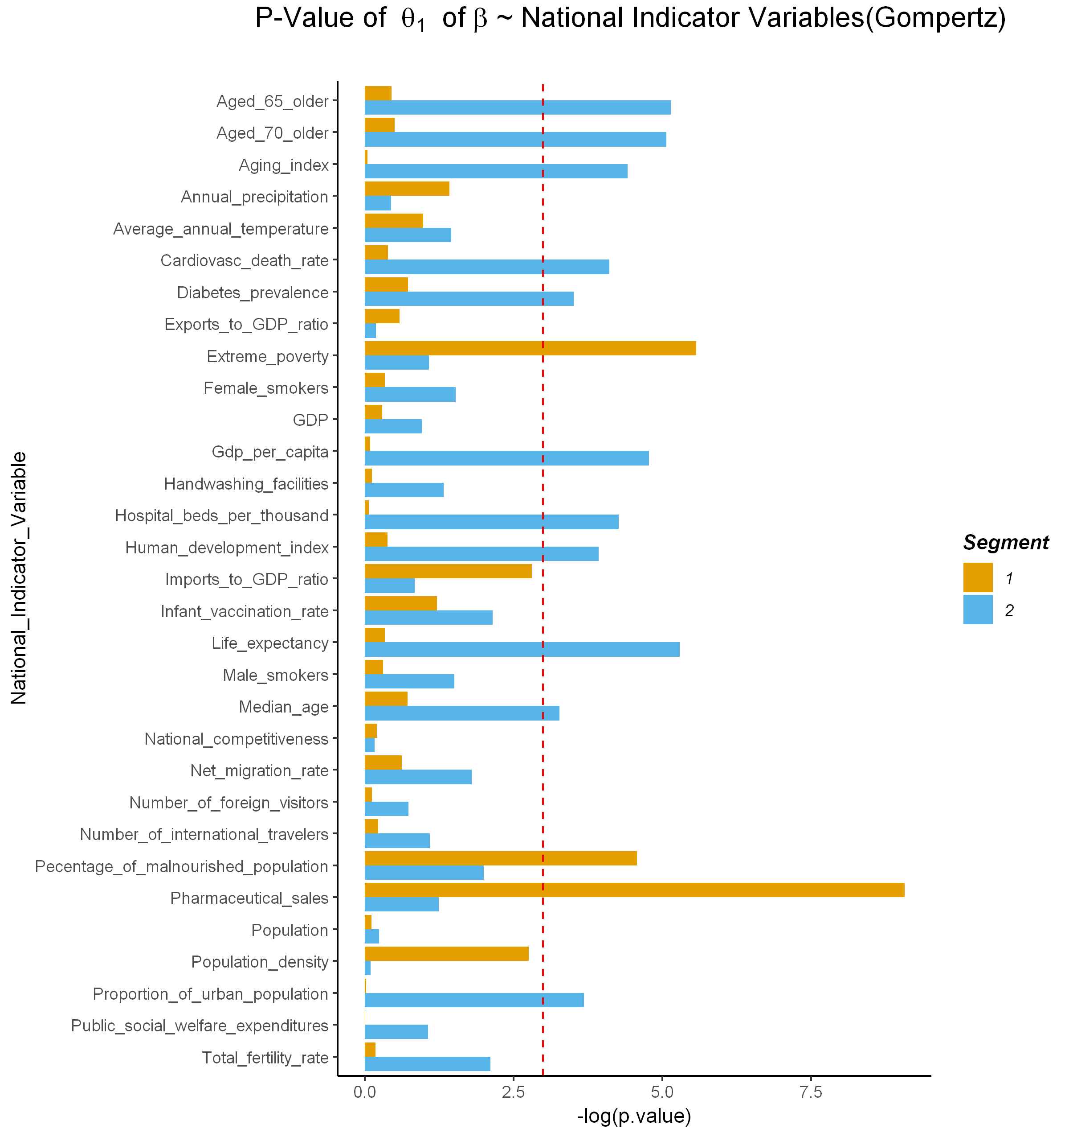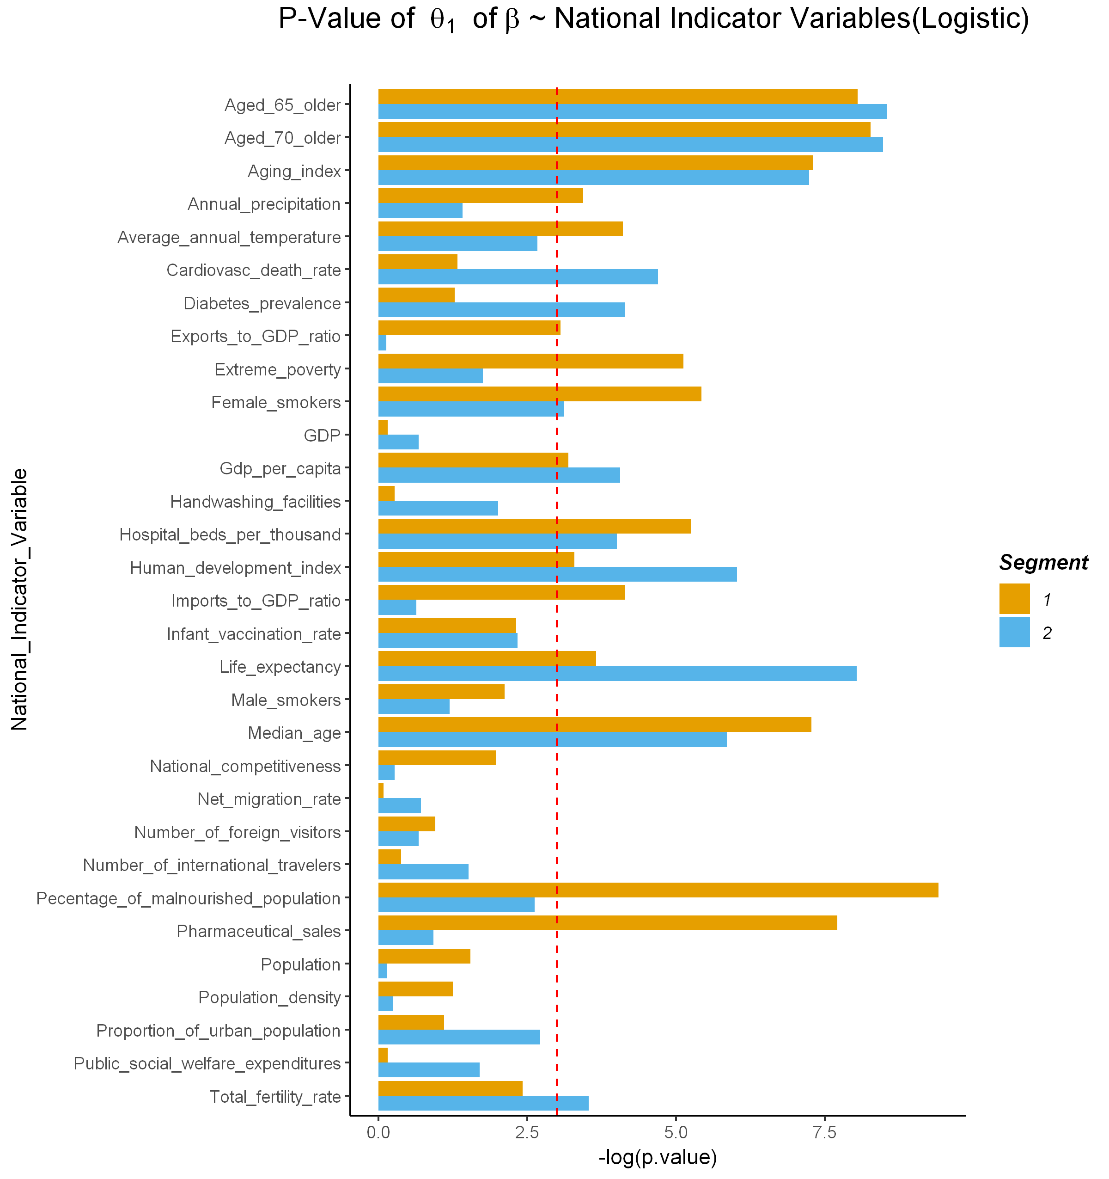

**a**

**b**

**Fig. S8. *P*-values of the relationship between global indicator variables and $β$.**

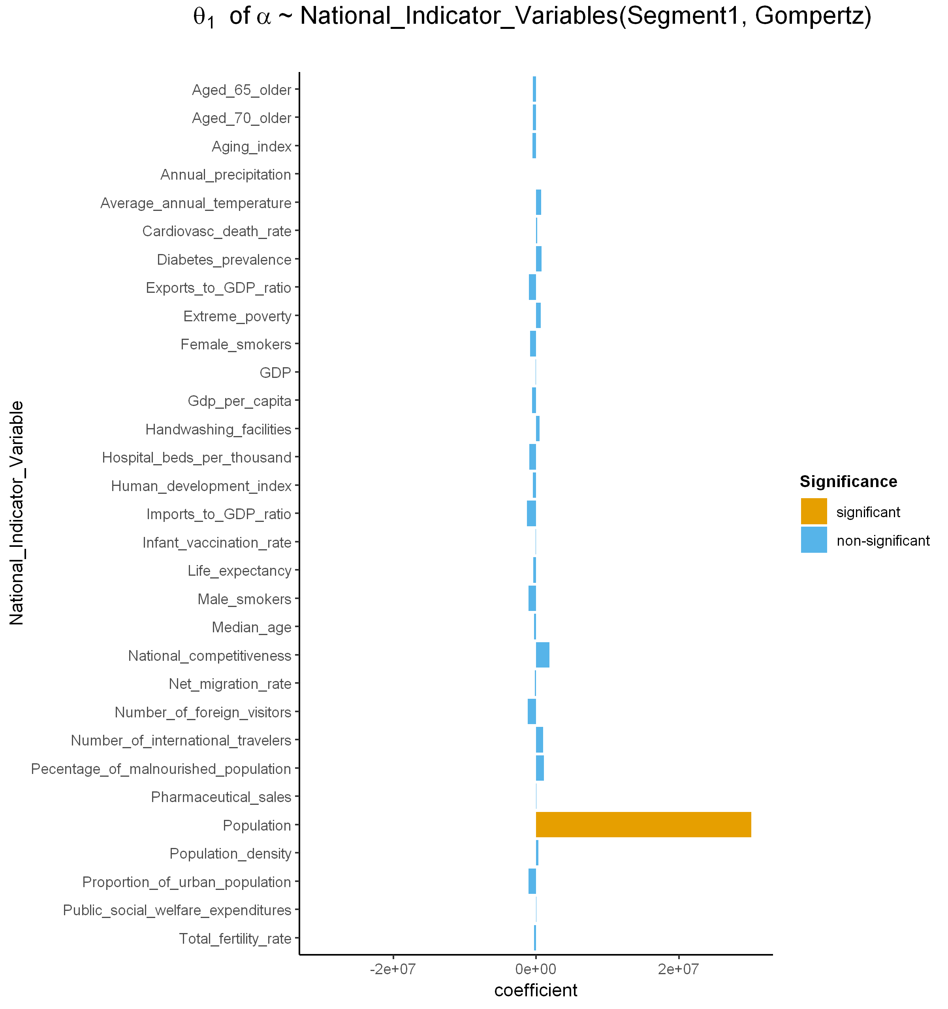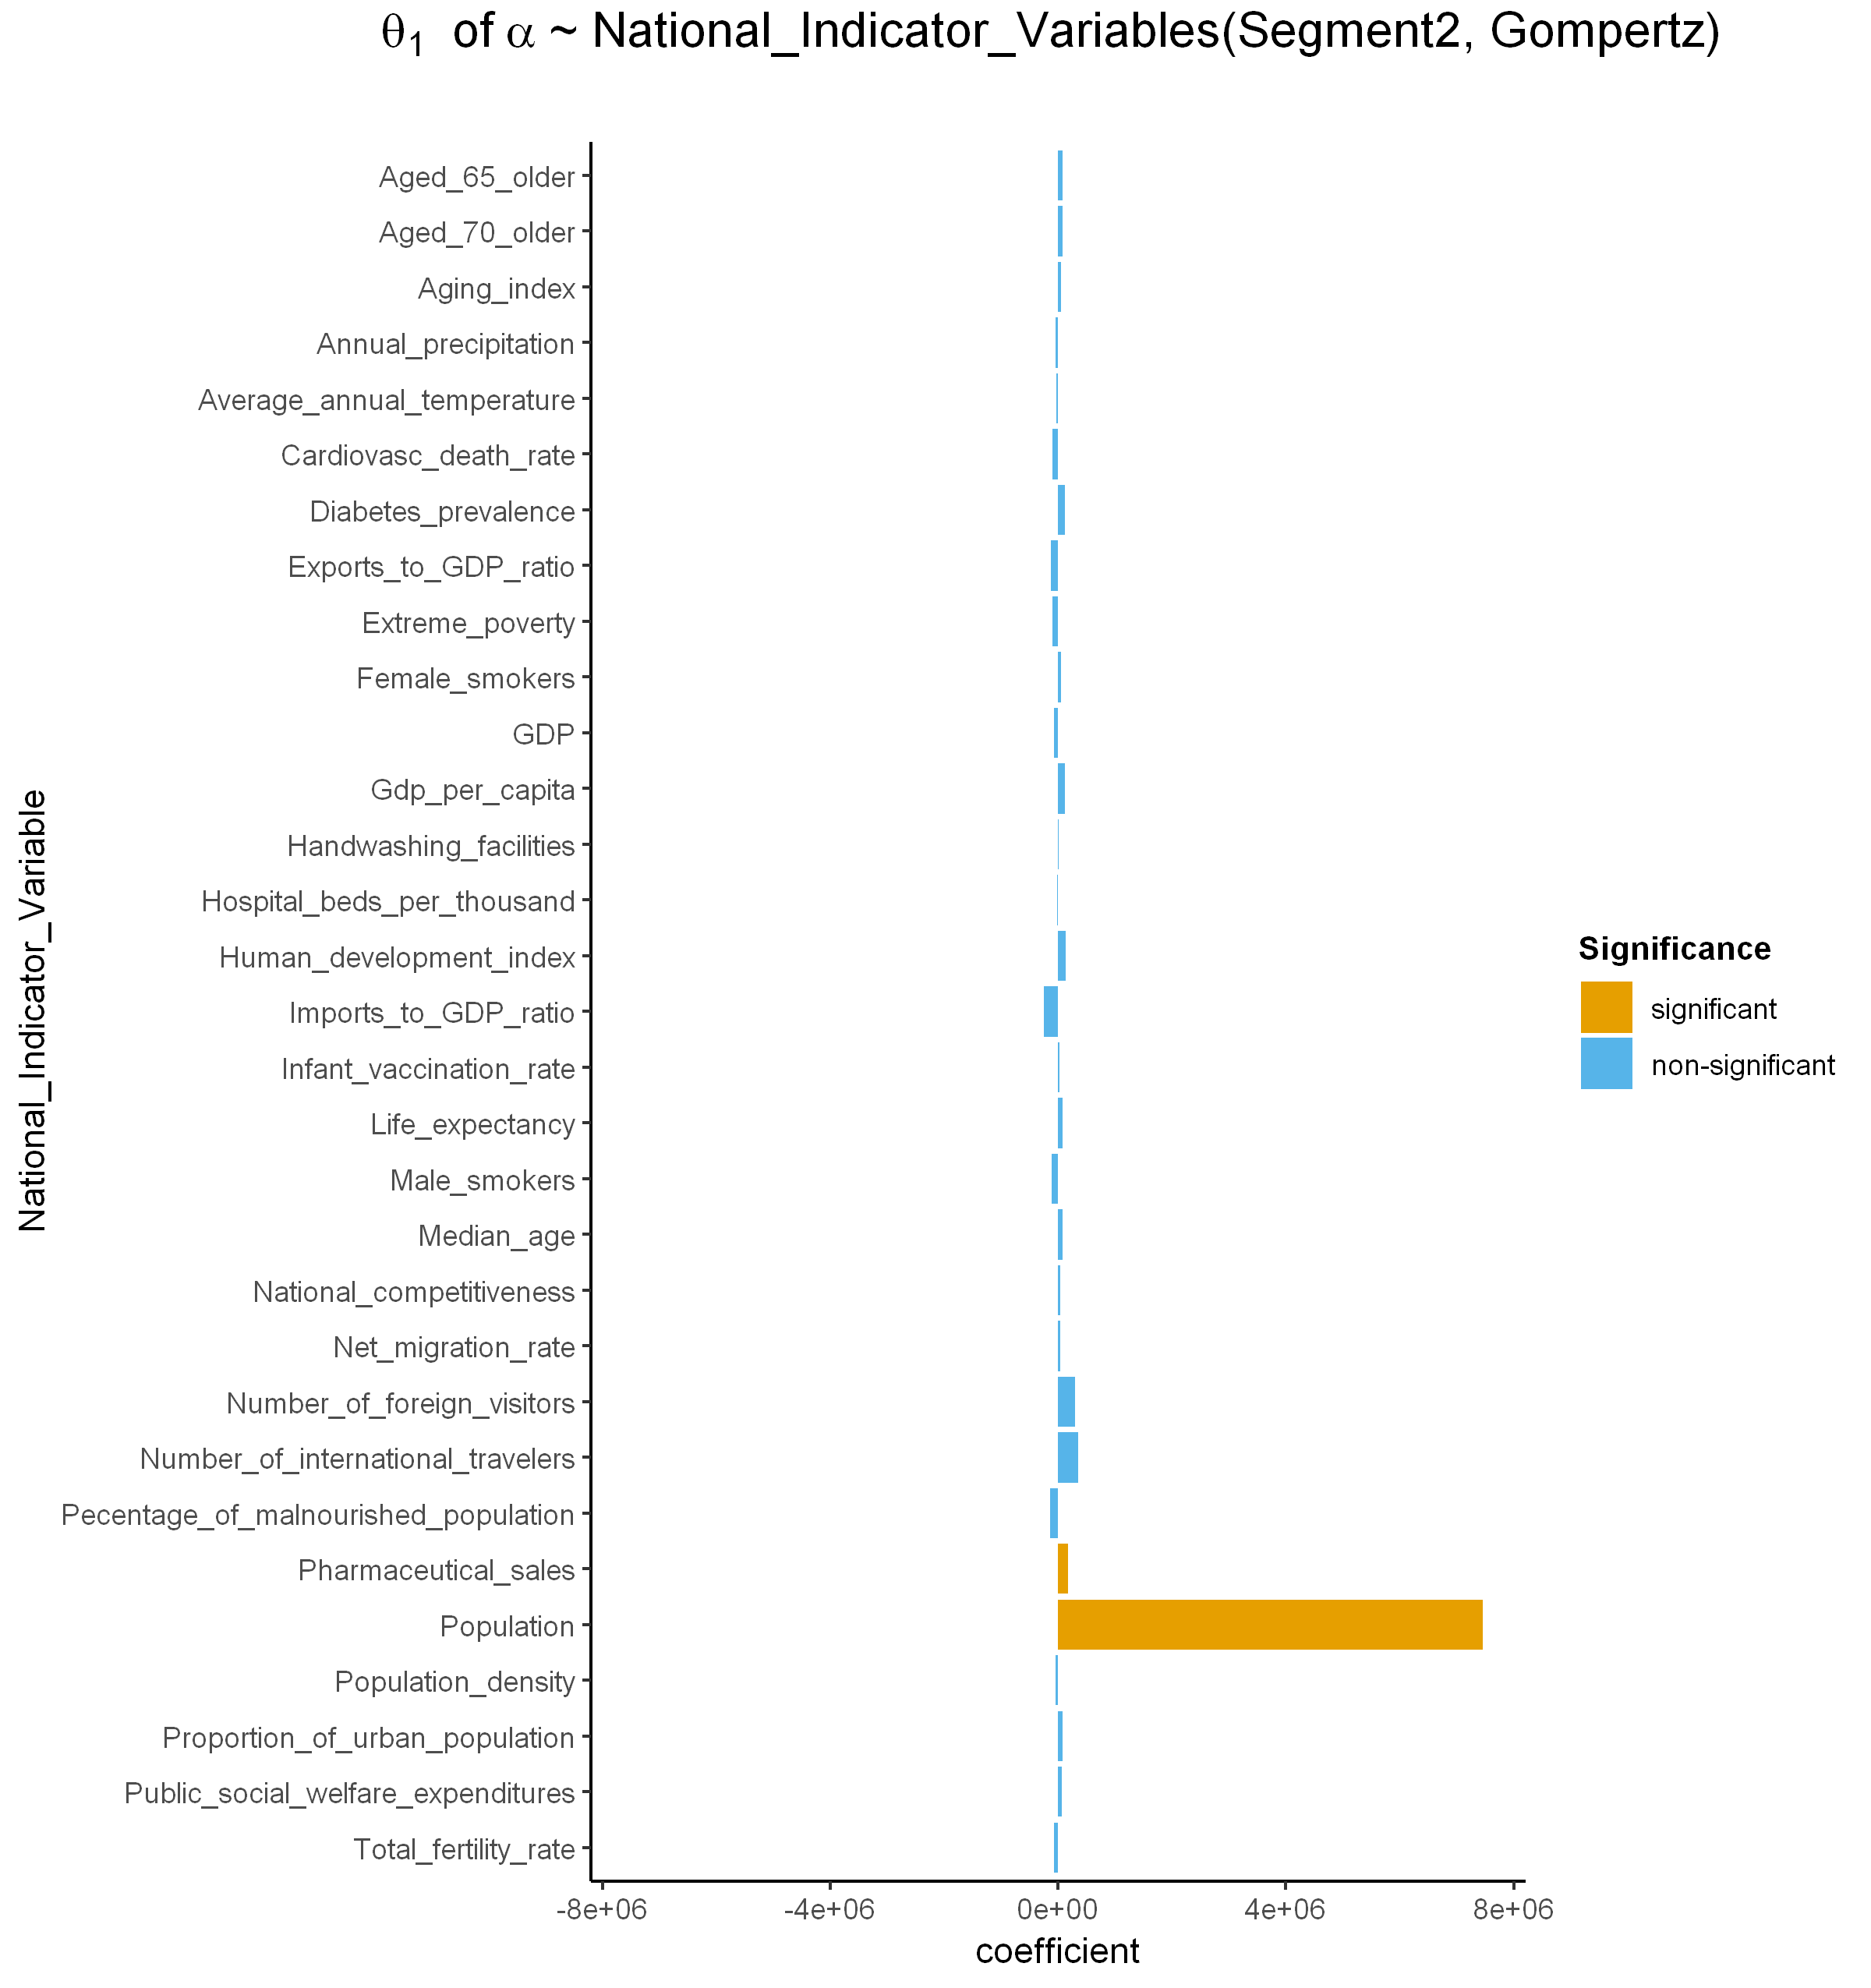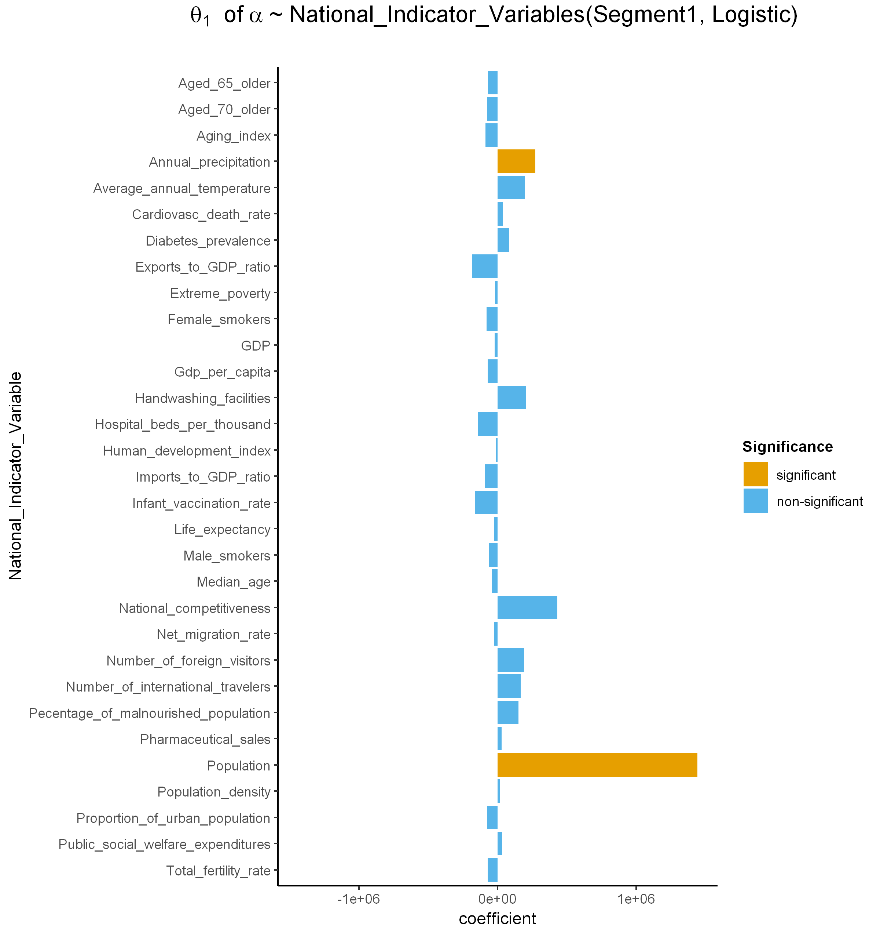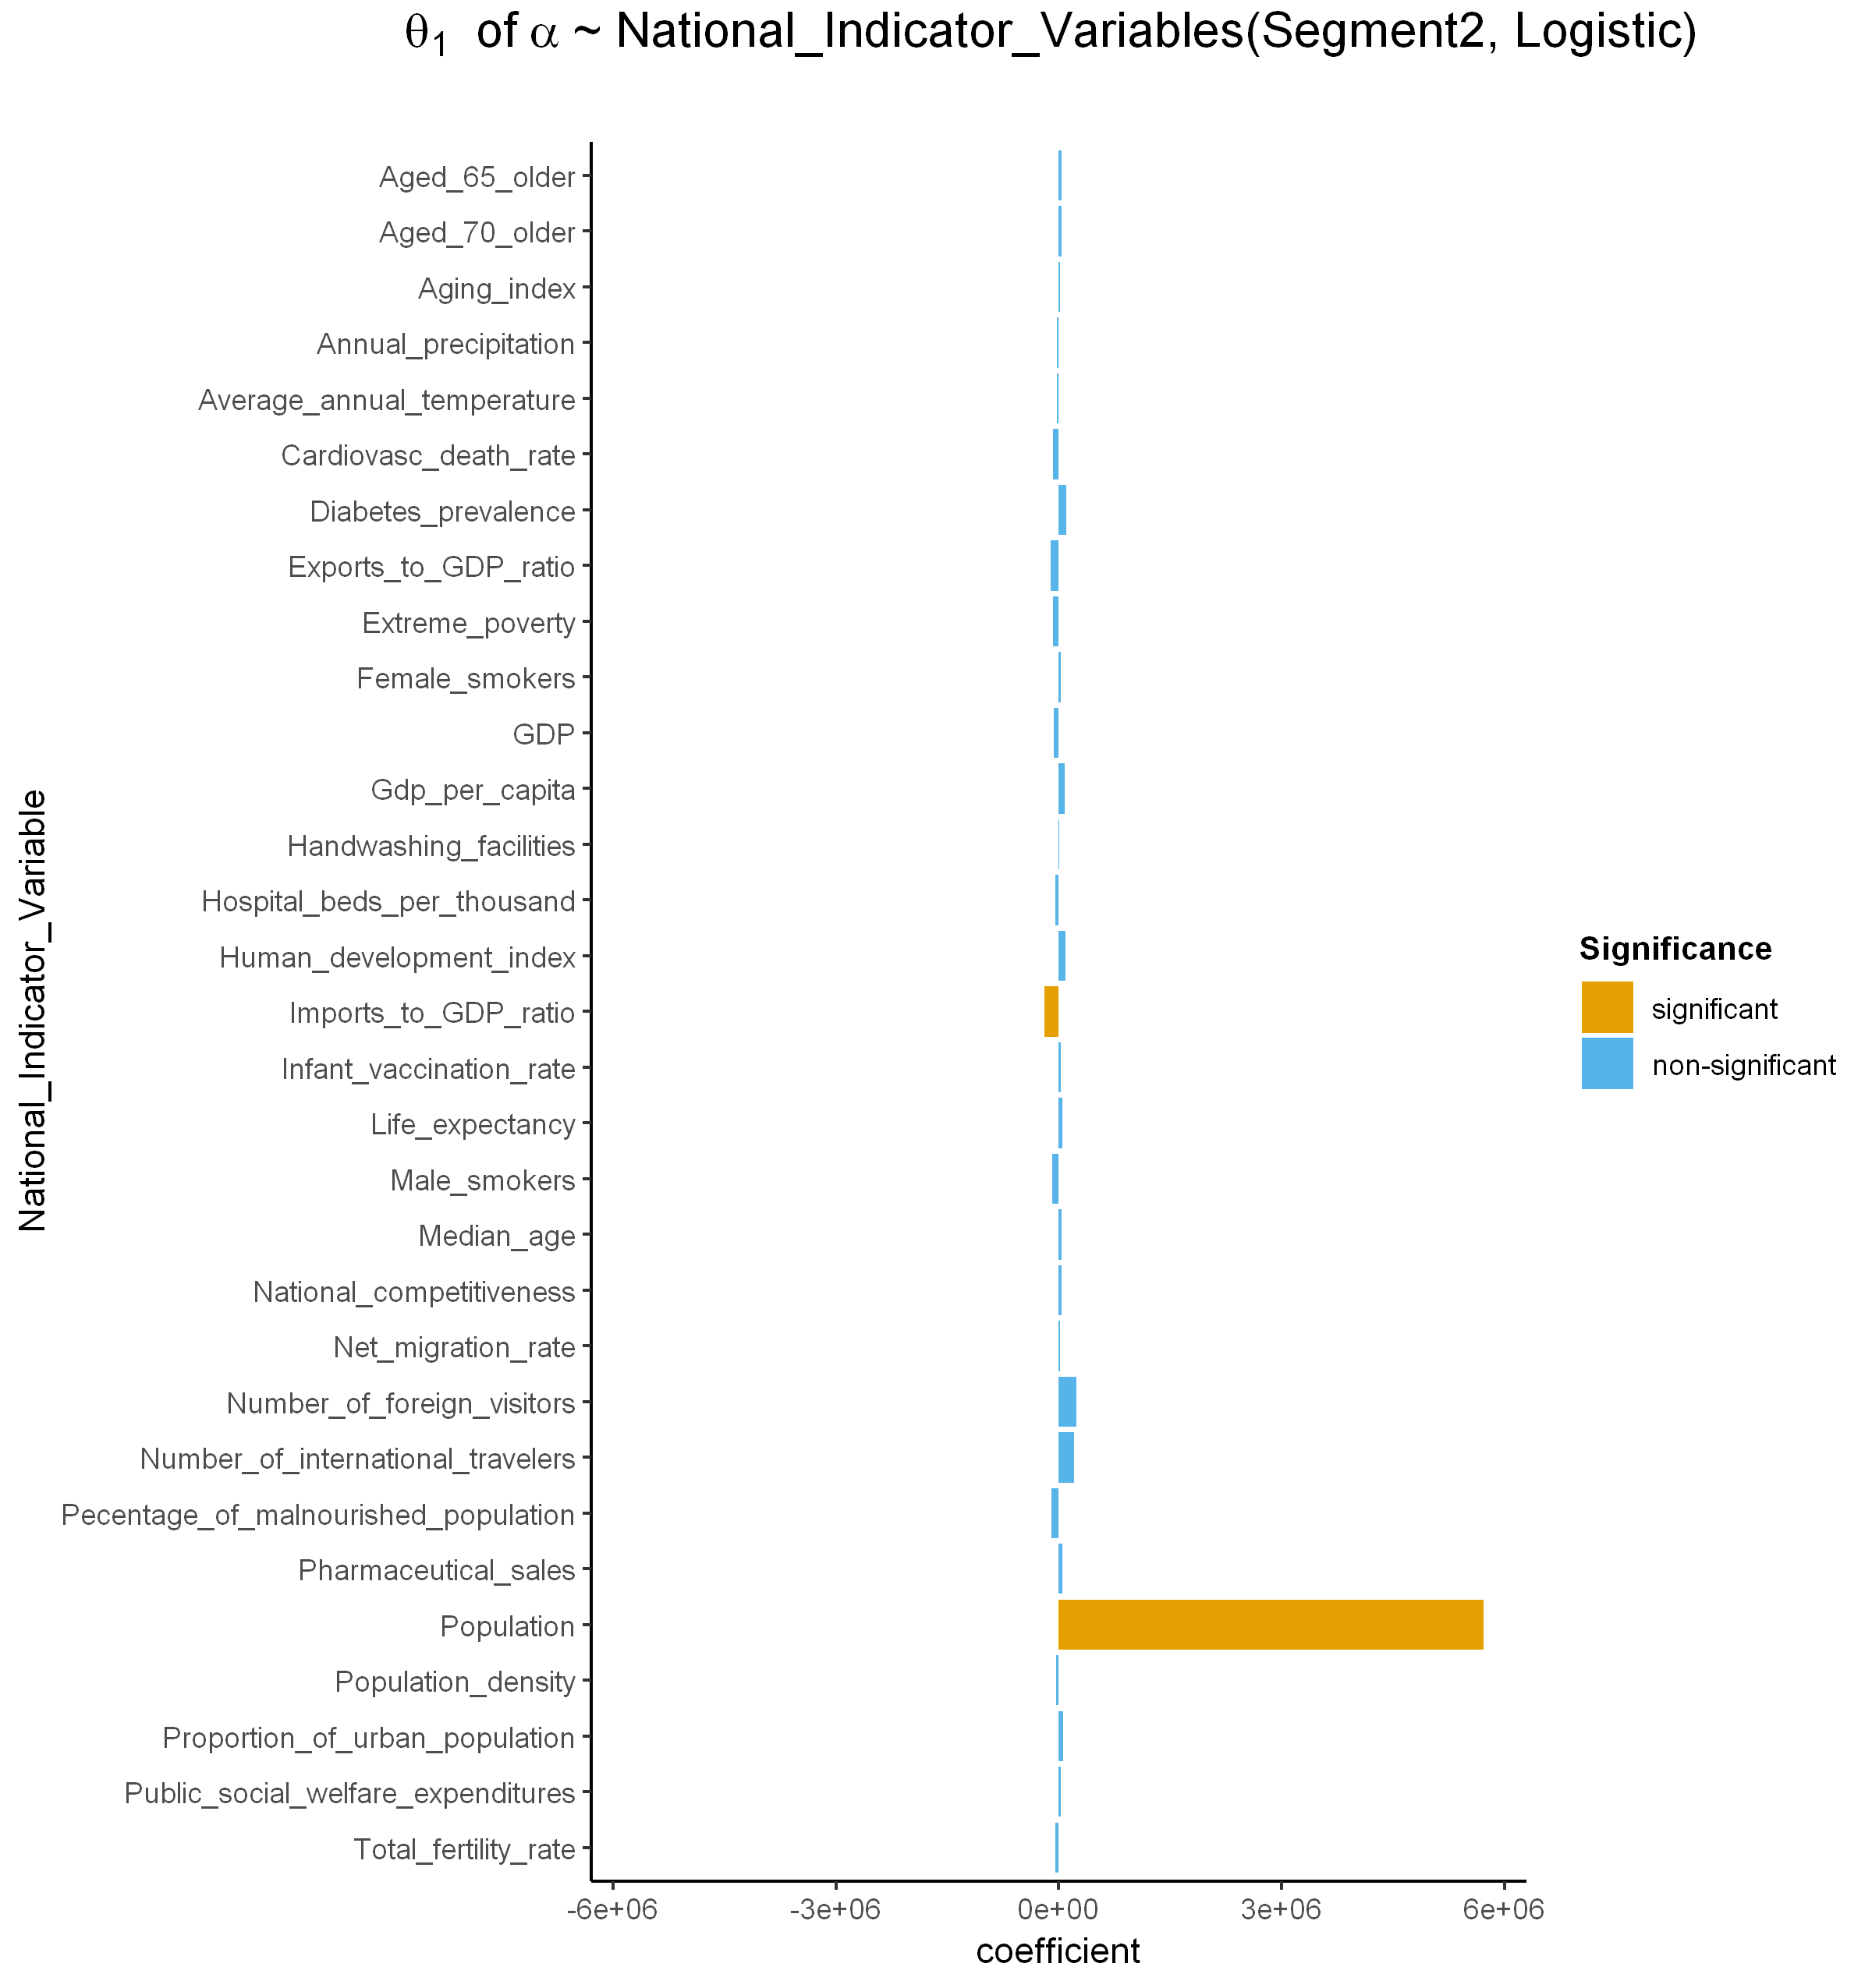

**a**

**b**

**c**

**d**

**Fig. S9. Coefficients of the relationship between global indicator variables and $α$.**

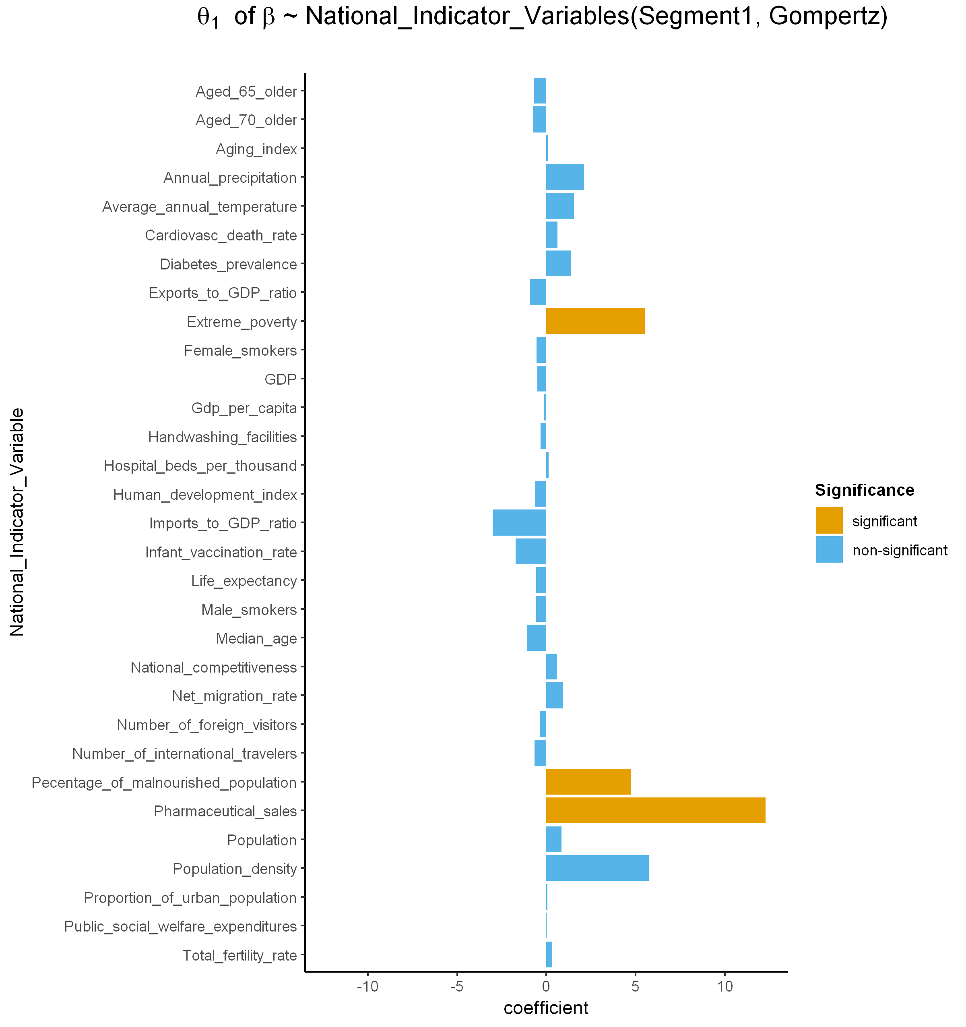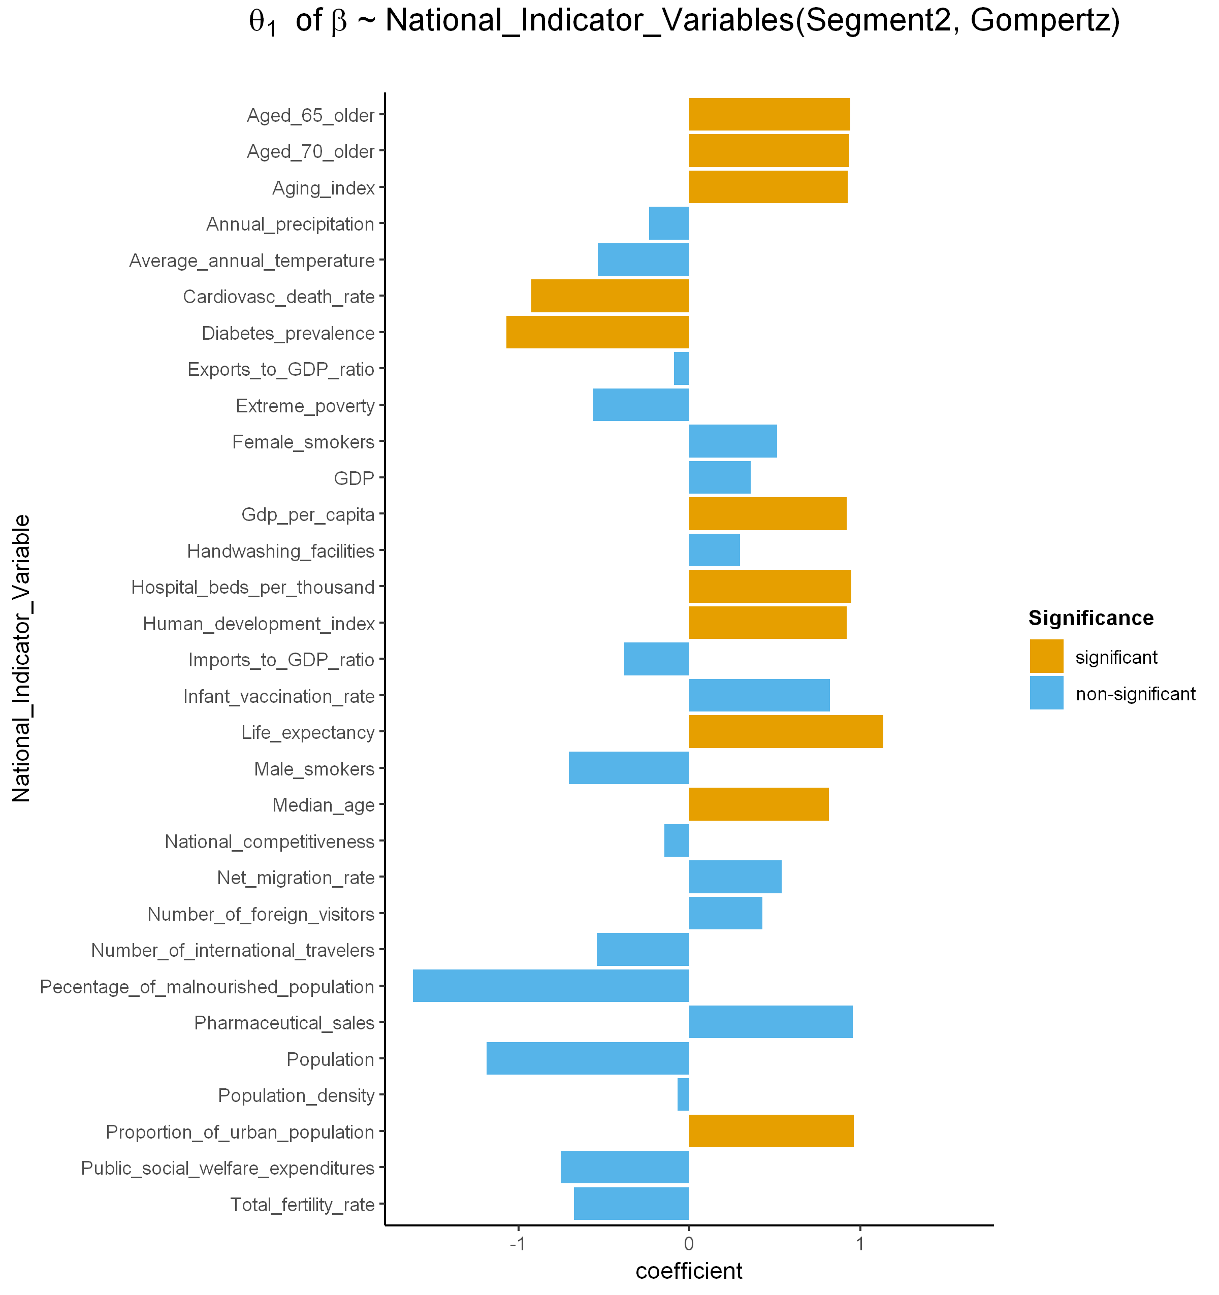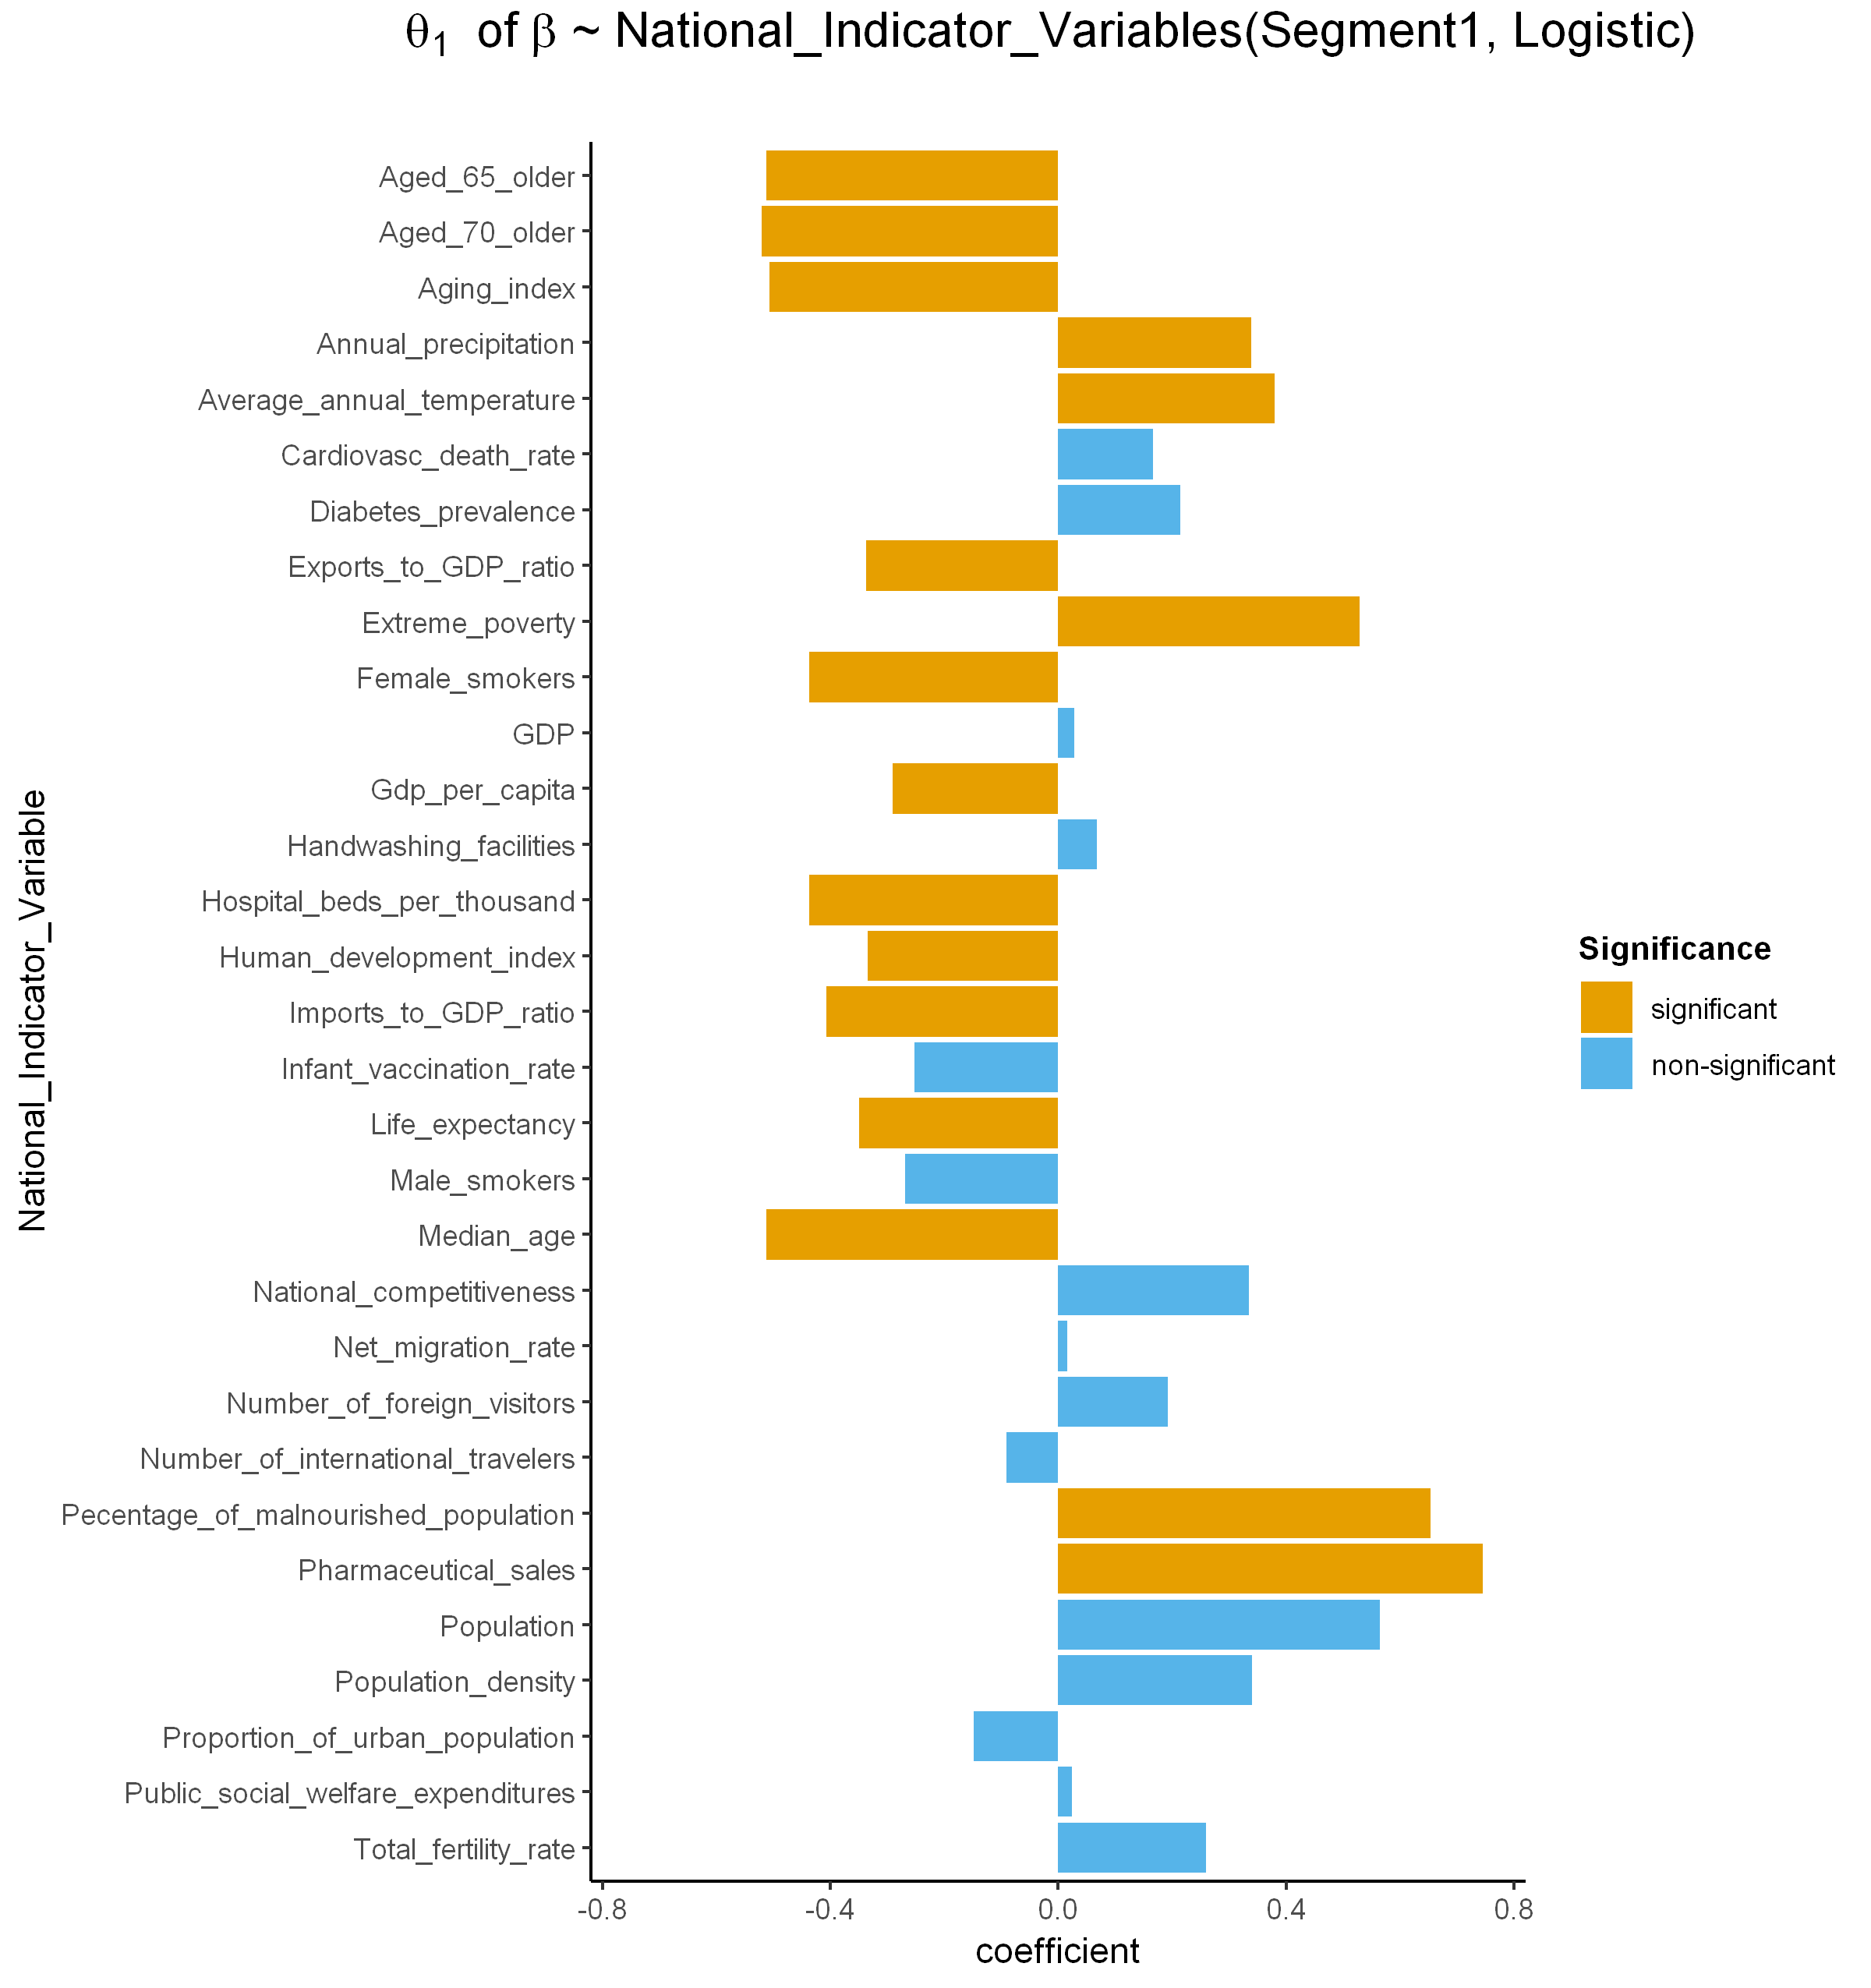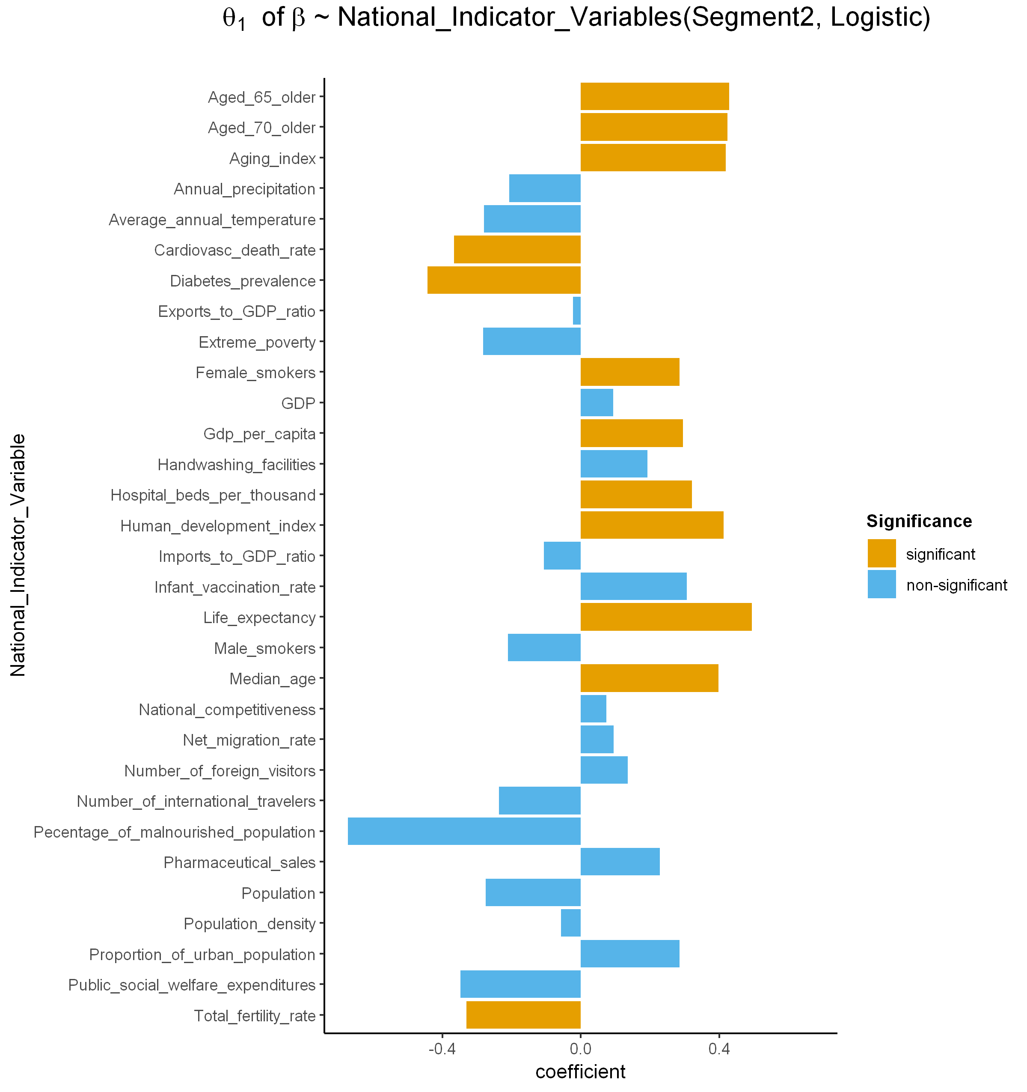

**c**

**d**

**b**

**a**

**Fig. S10. Coefficients of the relationship between national indicator variables and $β$.**

**Logistic ($α$)/ Segment 1**

Annual precipitation

**Gompertz ($α$)/ Segment 1**

**Logistic ($α$)/ Segment 2**

**Gompertz ($α$)/ Segment 2**

Imports to GDP ratio

Pharmaceutical sales

Population

**Fig. S11. Significant national indicator variables with maximum predicted cumulative confirmed cases $\left(α\right).$**

Proportion of urban population

Percentage of malnourished population

Pharmaceutical sales

Extreme poverty

Average annual temperature

Annual precipitation

Exports to GDP ratio

Imports to GDP ratio

Total fertility rate

Aging index

Median age

Aged 65 older

Aged 70 older

GDP per capita

Hospital beds per thousand

Life expectancy

Human development index

**Logistic ($β$)/ Segment 1**

**Gompertz ($β$)/ Segment 1**

**Logistic ($β$)/ Segment 2**

**Gompertz ($β$)/ Segment 2**

Female smokers

Cardiovasc death rate

Diabetes prevalence

**Fig. S12. Significant national indicator variables with $β.$**